Moduldokumentation

Modul Verteilte Systeme (vesys)

Simon Wächter

2017

Inhalt

1 Einleitung 8

1.1 Einleitung 8

1.2 Lernziele 8

1.3 Prüfungen 8

2 Woche 1 9

2.1 Definition of Distributed Systems 9

2.1.1 Definitions 9

2.1.2 Classification 9

2.1.3 Pros and Cons 10

2.1.4 Interaction Models 10

2.1.5 Client/Server Model 11

2.1.6 Communication Models 11

2.1.7 Communication Styles 12

2.2 Challenges of Distributed Systems 13

2.2.1 Heterogeneity 13

2.2.2 Latency 13

2.2.3 Security 13

2.2.4 Scalability 14

2.2.5 Failures 14

2.2.6 Concurrency 15

2.2.7 Consistency 15

2.3 Networking 15

2.3.1 Protocol & Network Levels 15

2.3.2 IP Socket Connections 16

2.3.3 IP Addressing 16

2.3.4 TCP/UDP Common Port Numbers 17

2.3.5 InetAddress 17

2.3.6 Network Interfaces 18

2.4 Sockets 18

2.4.1 Sockets 18

2.4.2 TCP Sockets 19

2.4.3 Java Socket 19

2.4.4 Sample Client (Echo) 21

2.4.5 Sample Client (Mailer) 21

2.4.6 ServerSocket 22

2.4.7 Echo Server 23

2.4.8 Concurrent Echo Server 23

2.4.9 Concurrent Echo Server (Threaded) 23

2.4.10 Concurrent Echo Server (Limitierter Threadpool) 24

2.4.11 Concurrent Echo Server (Dynamischer Threadpool) 25

3 Woche 2 27

3.1 Input and Output Streams 27

3.1.1 OutputStream 27

3.1.2 InputStream 27

3.2 Filter Streams 28

3.2.1 FilterOutputStream 28

3.2.2 DataOutputStream 29

3.2.3 DataOutputStream with writeInt 29

3.2.4 DataOutputStream with writeUTF 29

3.2.5 PrintStream 30

3.2.6 FilterInputStream 30

3.2.7 DataInputStream 30

3.2.8 DataInputStream with readFully 31

3.2.9 Filter Streams 31

3.3 Object Streams & Serialization 31

3.3.1 ObjectStream 31

3.3.2 Serialization with ObjectStream 32

3.3.3 Serial Version Number 33

3.3.4 Serialization Customization 34

3.3.5 Serialization Hints 34

3.4 Sending and Receiving Data 35

3.4.1 Framing 35

3.4.2 Example of Framing 35

3.5 Summary 35

3.5.1 Whole Picture of Input Streams 35

3.5.2 Whole Picture of Output Streams 36

3.5.3 Reading and Writing Text (Unicode Strings) 37

3.5.4 Whole Picture of Reader 37

3.5.5 Whole Picture of Writer 37

3.6 Controlling Socket Behaviors 38

3.6.1 Blocking and Timeouts 38

3.6.2 Send and Receive Buffer Size 39

3.6.3 Package Delay 39

3.7 Closing Connections 39

3.7.1 Closing Connections 39

3.7.2 Example of a Close Test 40

3.7.3 Example of a Compression Server 41

3.8 UDP Sockets 41

3.8.1 UDP (User Datagram Protocol) 41

3.8.2 Java Classes for Datagram 42

3.8.3 DatagramSocket 42

3.8.4 DatagramPacket 43

3.8.5 Example of a UDP Server and Client 44

3.8.6 UDP Implementation 44

3.8.7 Reliable UDP 45

4 Woche 3 46

4.1 HTTP Protocol 46

4.1.1 IETF RFC 46

4.1.2 HTTP Protocol 46

4.1.3 HTTP Request 46

4.1.4 HTTP Response 47

4.1.5 HTTP Protocol 47

4.1.6 HTTP Sample 47

4.1.7 HTTP 1.0 Request Methods 49

4.1.8 HTTP Response Codes 49

4.1.9 HTTP Request Headers 49

4.1.10 HTTP Response Headers 50

4.1.11 MIME Types 50

4.1.12 HTTP Request/Response Sample 51

4.1.13 HTTP 1.1 Enhancements 51

4.2 HTTP Web Server 52

4.2.1 A simple Web Server 52

4.2.2 Java internal Web Server 54

4.3 HTML Forms & URL Encoding 55

4.3.1 HTML GET Form 55

4.3.2 URL Encoding 56

4.3.3 HTML POST Form 56

4.4 HTTP Requests from Java 57

4.4.1 URL 57

4.4.2 Sending GET Requests from within Java 57

4.4.3 URLConnection 57

4.4.4 URLConnection Tips & Tricks 58

4.4.5 Sample 1: URLConnection GET 58

4.4.6 Sample 2: URLConnection POST 59

4.4.7 Sample 3: Currency Converter 59

4.4.8 Other Libraries 61

5 Woche 4 62

5.1 Servlets 62

5.1.1 Dynamic Content 62

5.1.2 Servlets 62

5.1.3 Servlet Packages 62

5.1.4 Servlet Life-Cycle Methods 63

5.1.5 HttpServlet 63

5.1.6 HttpServletRequest 64

5.1.7 HttpServletResponse 64

5.1.8 Servlet Example 64

5.1.9 Webapplication Structure 65

5.1.10 Annotation WebServlet 66

5.1.11 Webapplication Structure 66

5.2 Tomcat Servlet Server 67

5.2.1 Tomcat 67

5.2.2 Tomcat Directory Structure 67

5.2.3 Tomcat Scripts 67

5.2.4 Tomcat Startup Screen 68

5.2.5 Tomcat Managers 68

5.2.6 Debugging 68

5.2.7 Tomcat Architecture 69

5.2.8 Configuration of a Host 69

5.2.9 Configuration of a Context 70

5.2.10 Deployment while development 71

5.2.11 Eclipse and Servlets (JEE Eclipse Version) 71

6 Woche 5 73

6.1 Motivation XML-RPX 73

6.1.1 Services over HTTP (Currency Converter) 73

6.1.2 XML-Remote Procedure Calls 74

6.2 SOAP und JAX-WS 74

6.2.1 SOAP 74

6.2.2 JAX-WS 75

6.2.3 JAX-WS HTTP Request 81

6.2.4 JAX-WS HTTP Response 81

6.2.5 SOAP Message Structure 82

6.2.6 Tools for SOAP 82

6.3 WSDL 83

6.3.1 WSDL 83

6.3.2 WSDL Examples 83

6.3.3 WSDL Structure 83

6.3.4 WSDL Definitions 84

6.3.5 Message Exchange Patterns (MEP) 85

6.3.6 WSDL Definitions 86

6.3.7 Web Service Styles 86

6.3.8 RPC/Encoded 87

6.3.9 RPC/Literal 88

6.3.10 Document/Literal/Bare 89

6.3.11 Document/Literal/Wrapped 90

6.3.12 Web Service Styles 91

6.4 Resources 91

7 Woche 6 92

7.1 REST Concepts 92

7.1.1 Representational State Transfer (REST) 92

7.1.2 REST Principles 92

7.1.3 REST Short Primer 94

7.1.4 SOAP versus REST 94

7.1.5 REST Common Patterns 94

7.1.6 Example Doodle 95

7.1.7 REST versus SOAP 96

7.1.8 Client Side 96

7.1.9 Web Client Plugins 96

7.1.10 Client Side via curl 97

7.2 REST Server Implementations 97

7.2.1 Server Side 97

7.2.2 JAX-RS Services 98

7.2.3 JAX-RS HTTP Methods 98

7.2.4 JAX-RS Injection 98

7.2.5 JAX-RS Content Negotoation 100

7.2.6 JAX-RS Content Handlers 101

7.2.7 JAX-RS Responses 101

7.2.8 JAX-RS Conditional GET 102

7.2.9 JAX-RS Cache Control 103

7.2.10 JAX-RS Optimistic Locking 104

7.2.11 JAX-RS Deployment 104

7.2.12 Deploy Stand Alone via Jersey 105

7.3 REST Clients 106

7.3.1 JAX-RS Client API 106

7.4 Resources 108

8 Woche 7 109

8.1 REST Data Binding 109

8.1.1 JAX-RS Data Binding 109

8.1.2 XStream Provider (Reader) 109

8.1.3 XStream Provider (Writer) 109

8.1.4 XStream Example 110

8.2 Java Spark 111

8.2.1 Java Spark 111

8.3 JAXB 113

8.3.1 JAXB Java Architecture for XML Binding 113

8.3.2 XML Schema 114

8.3.3 Schema Compiler & Generator 114

8.3.4 JAXB Marshaller 115

8.3.5 JAXB Unmarshaller 115

8.4 REST API Description Languages 115

8.4.1 Swagger 115

8.4.2 Swagger Doodle 116

8.4.3 Swagger Java Annotations 117

8.4.4 Swagger GUI 117

8.5 REST Easy Client Proxy Framework 117

8.5.1 RestEasy Client Proxy Framework 117

8.5.2 RestEasy Example 118

8.6 Resources 118

9 Woche 8 119

# Einleitung

## Einleitung

Dieses Dokument stellt die Moduldokumentation für das Modul vesys dar. Allfällige Unterlagen sind im Modulordner zu finden.

## Lernziele

Das Modul beinhaltet folgende Lernziele:

* Erstellen einer Verbindung zwischen zwei Rechnern mittels Sockets
* Wissen über http Protokoll und Webserver
* Implementieren einfacher Servlets
* Prinzipien und Programmierung von RMI
* Prinzipien von Webservices und Programmierung mittels JAXWS
* Verwendung von Webservices mittels WSDL
* Prinzipien und Programmierung von REST und deren Unterschiede zu SOA und ROA
* Prinzipien der asynchronen Programmierung mittels JMS und Akka
* Entscheidung, welche der Technologien für eine Situation geeignet ist

## Prüfungen

Die Modulnote setzt sich aus einer Semesterprüfung zu 50% und einer Modulschlussprüfung zu 50% zusammen. Zusätzlich müssen 4 von 8 Übungen erfüllt werden.

# Woche 1

## Definition of Distributed Systems

### Definitions

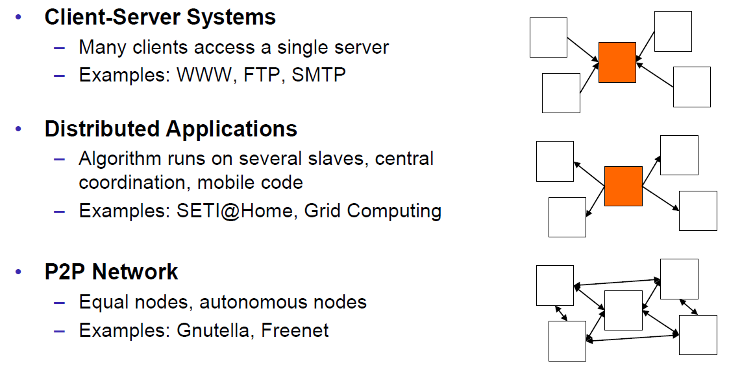

### Classification

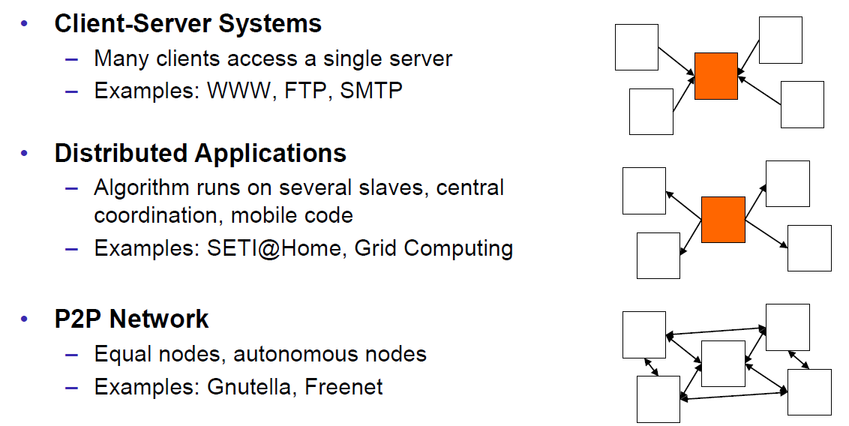

### Pros and Cons

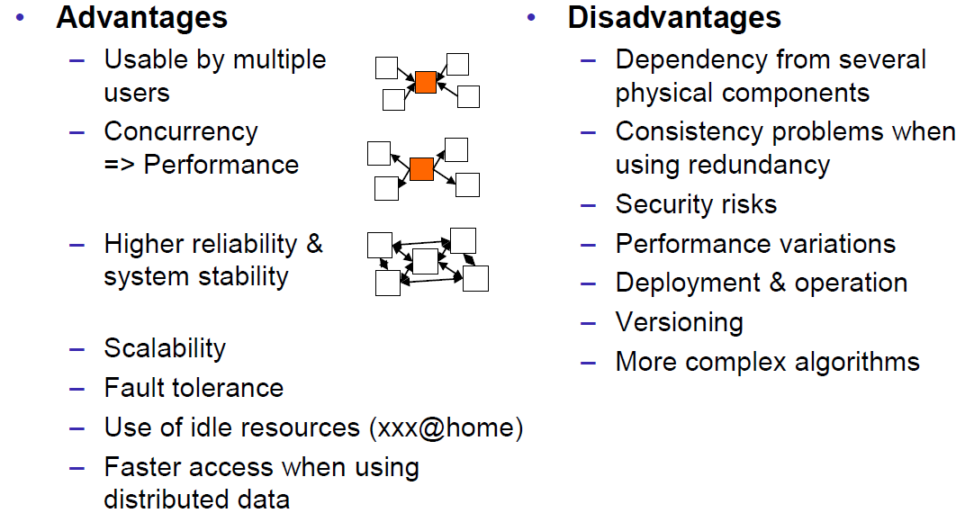

### Interaction Models

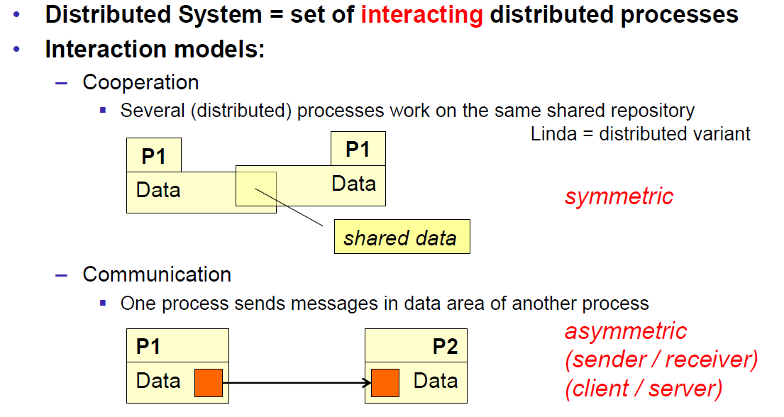

### Client/Server Model

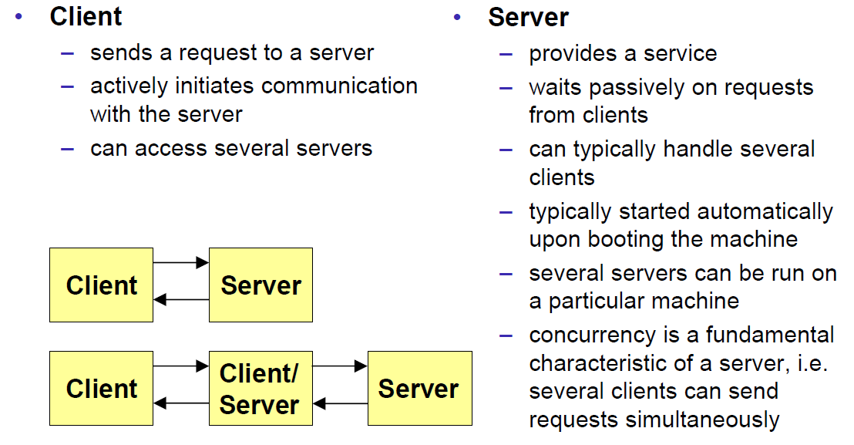

### Communication Models

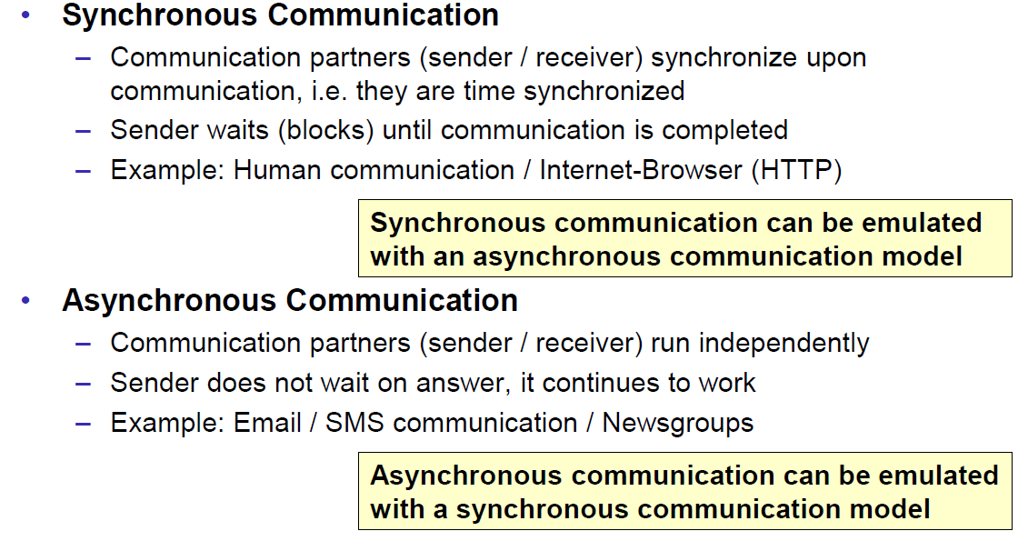

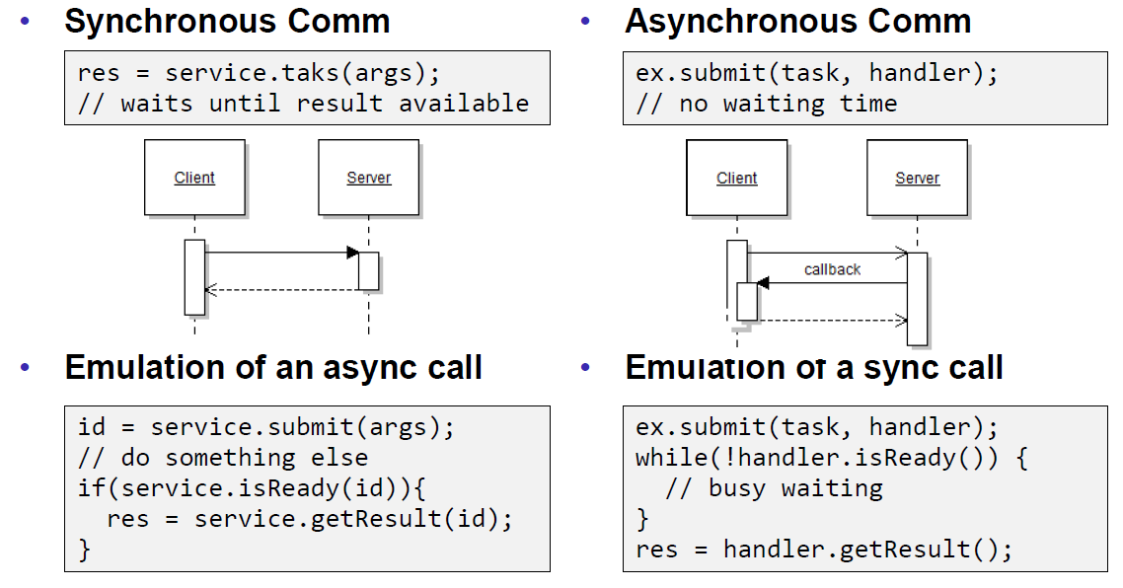

### Communication Styles

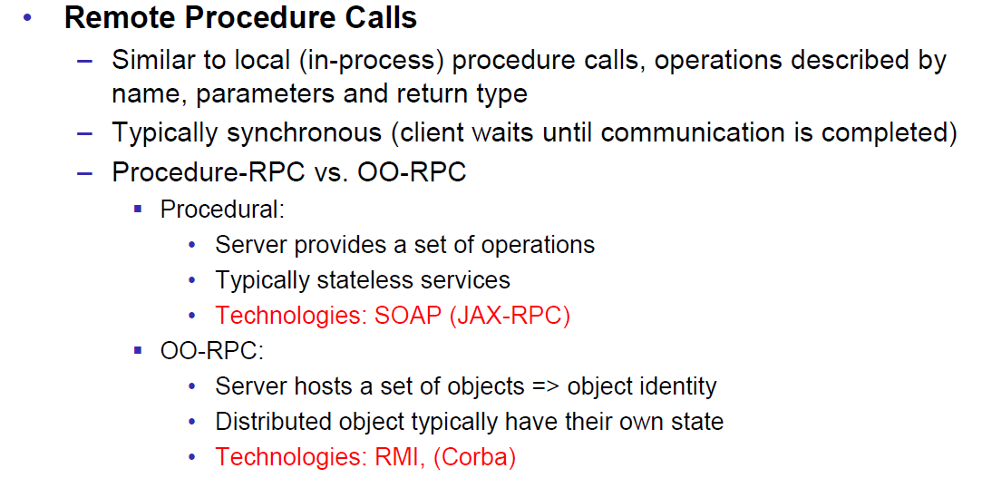

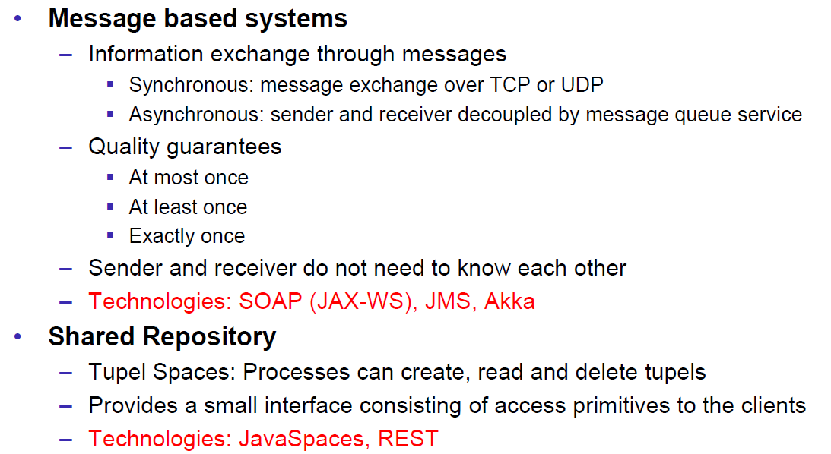

## Challenges of Distributed Systems

### Heterogeneity

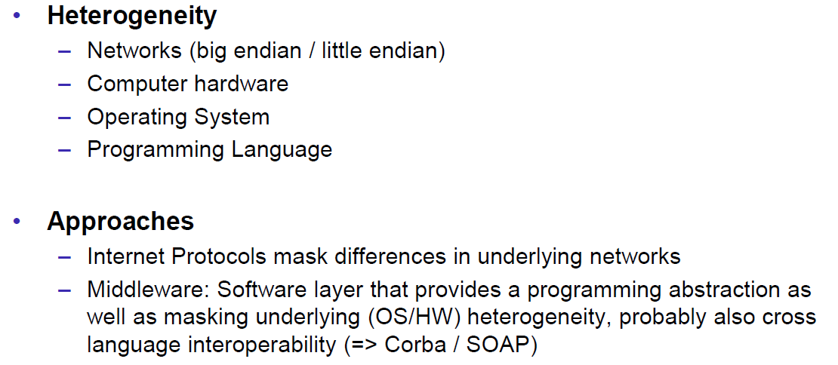

### Latency

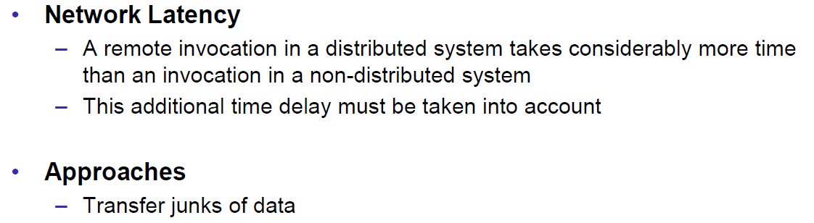

### Security

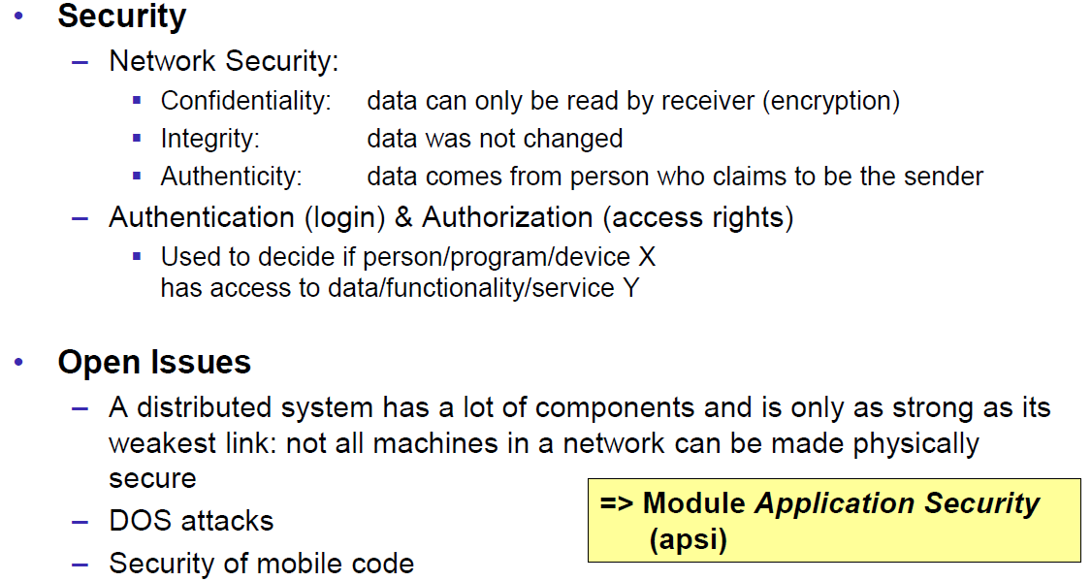

### Scalability

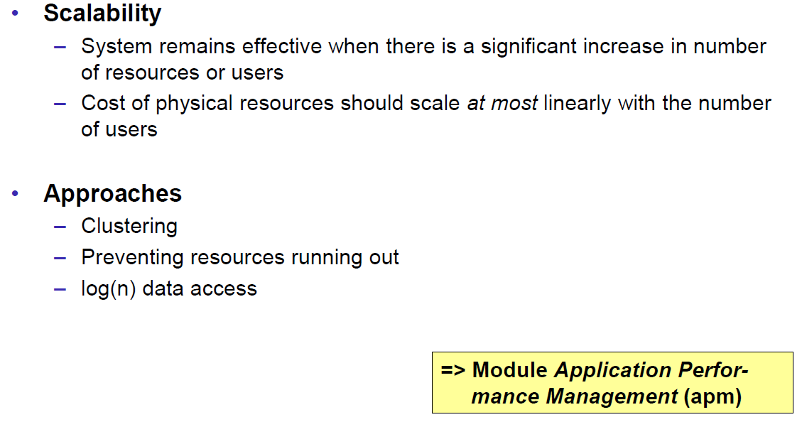

### Failures

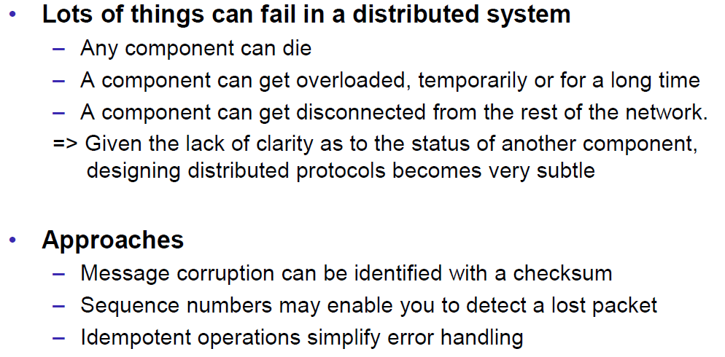

### Concurrency

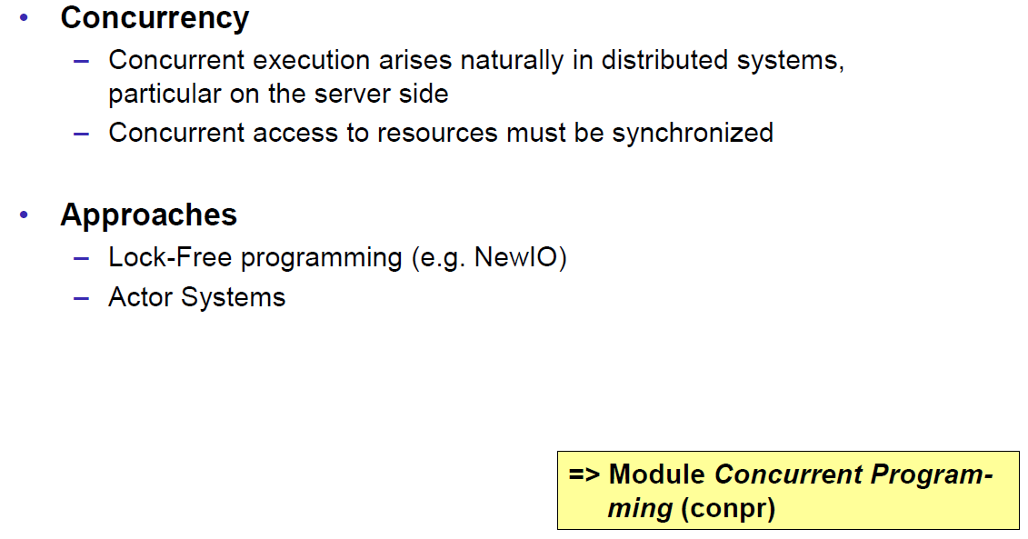

### Consistency

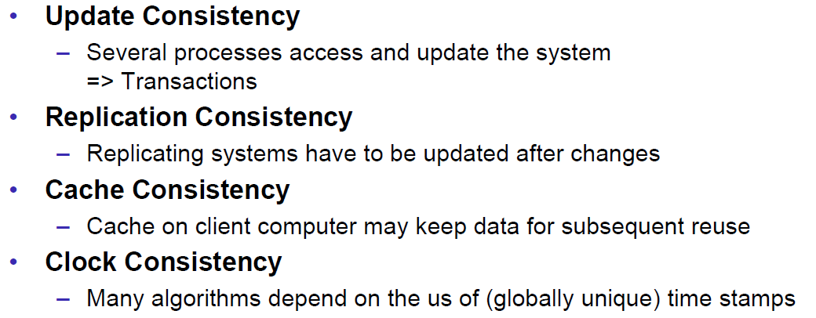

## Networking

### Protocol & Network Levels

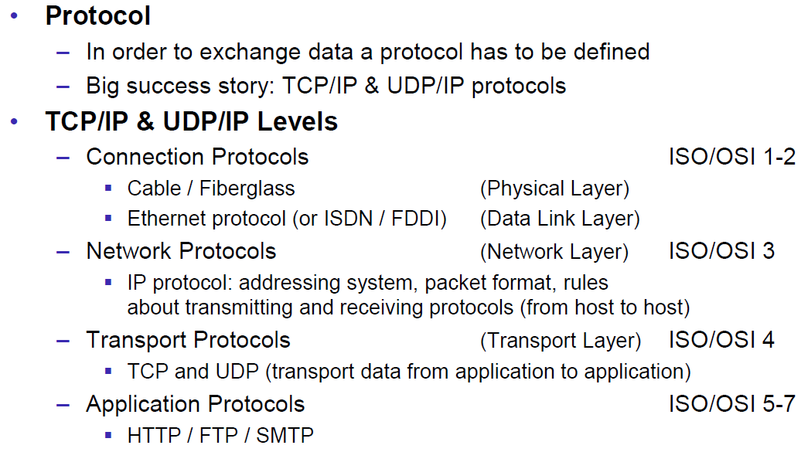

### IP Socket Connections

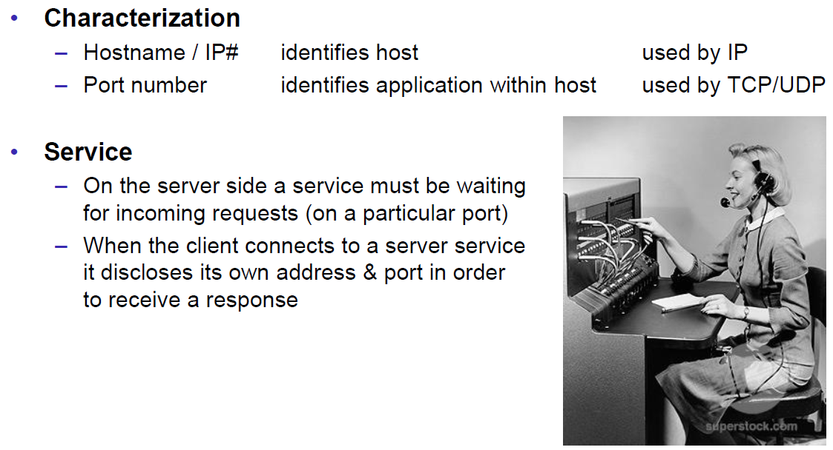

### IP Addressing

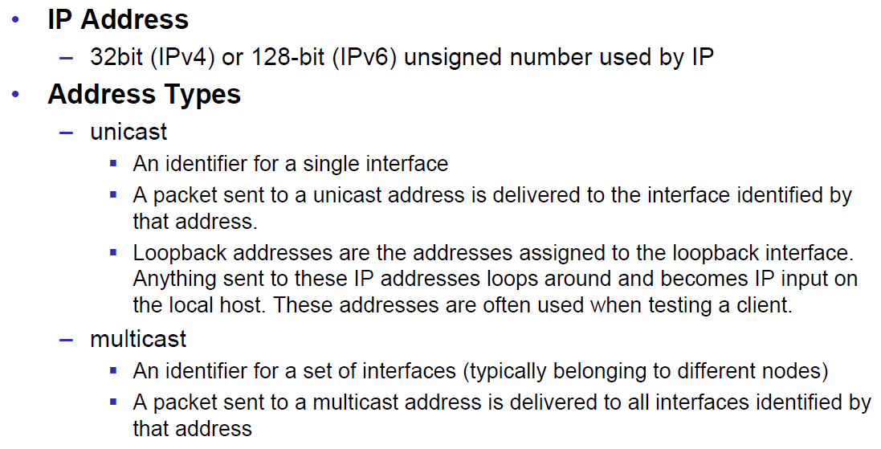

### TCP/UDP Common Port Numbers

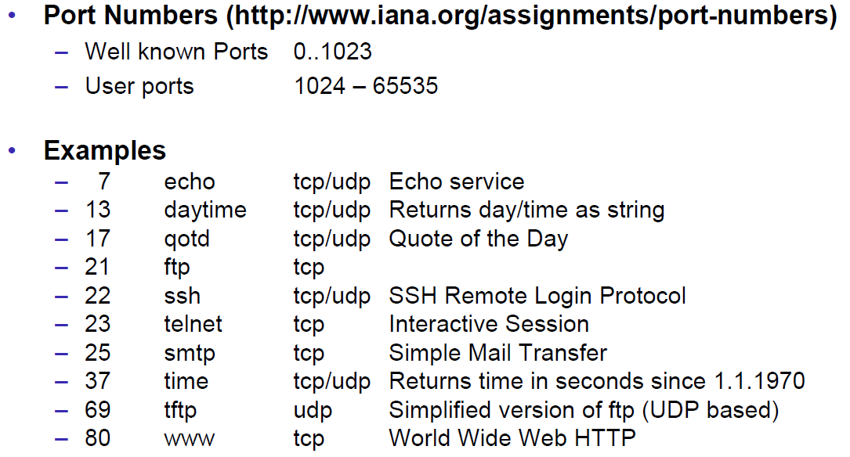

### InetAddress

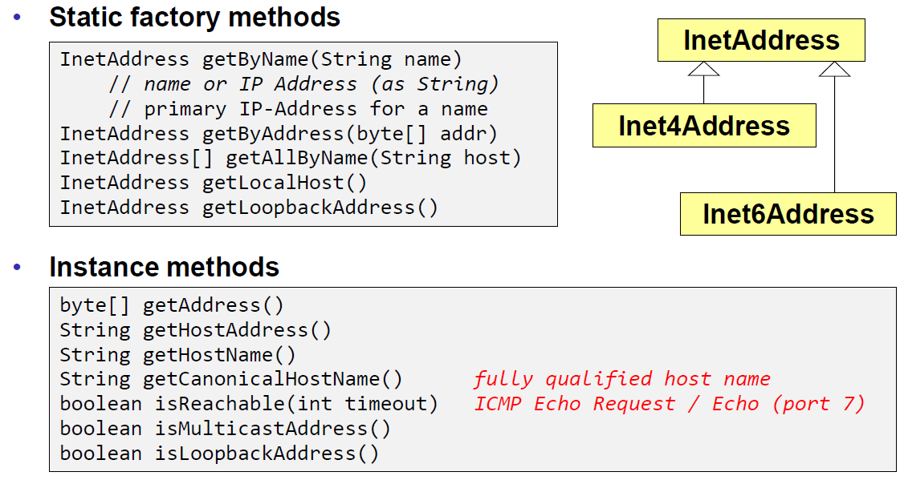

### Network Interfaces

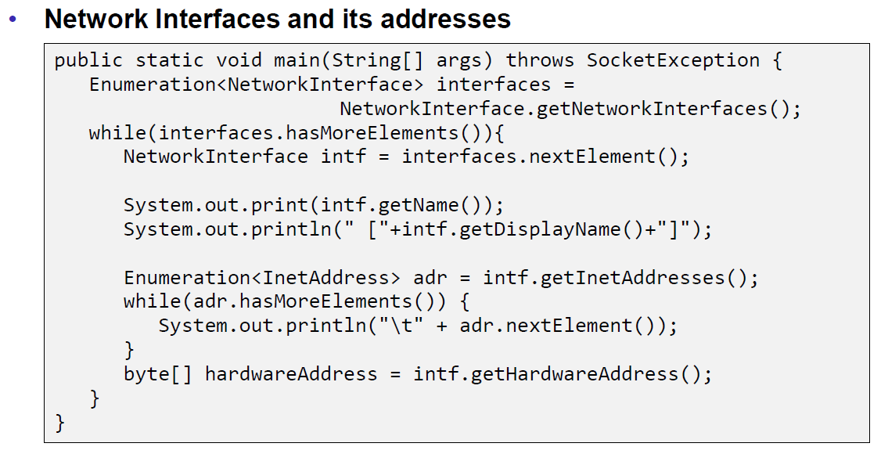

## Sockets

### Sockets

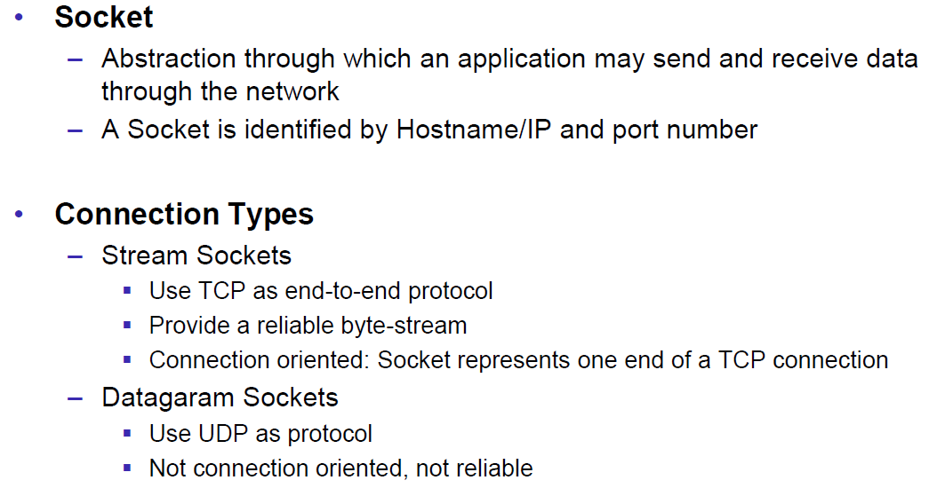

### TCP Sockets

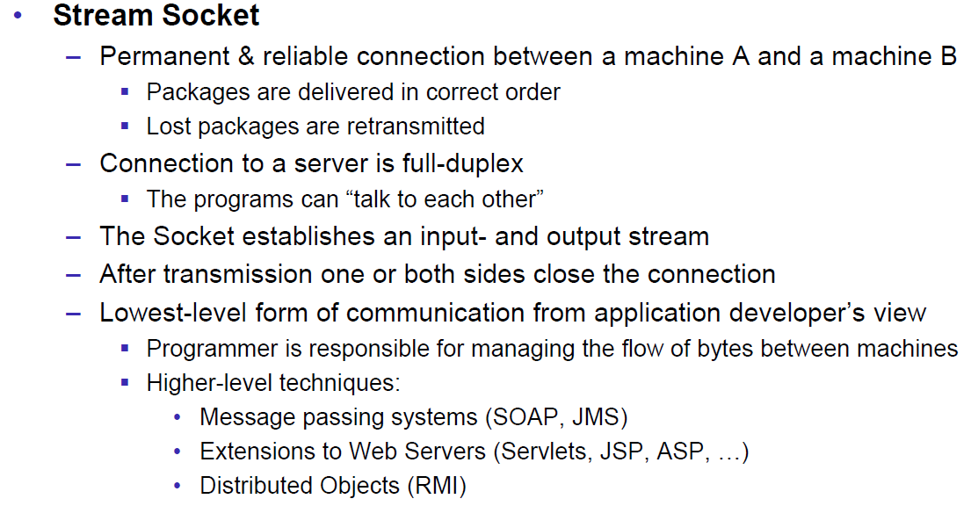

### Java Socket

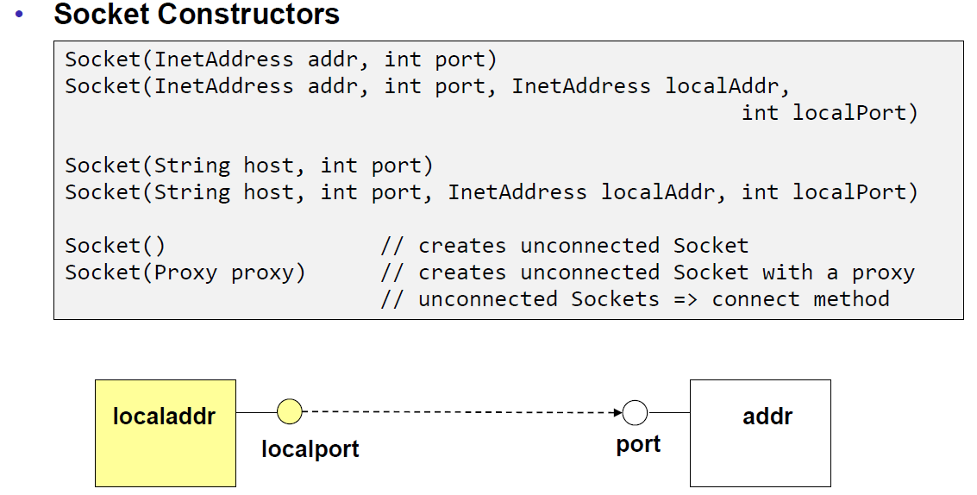

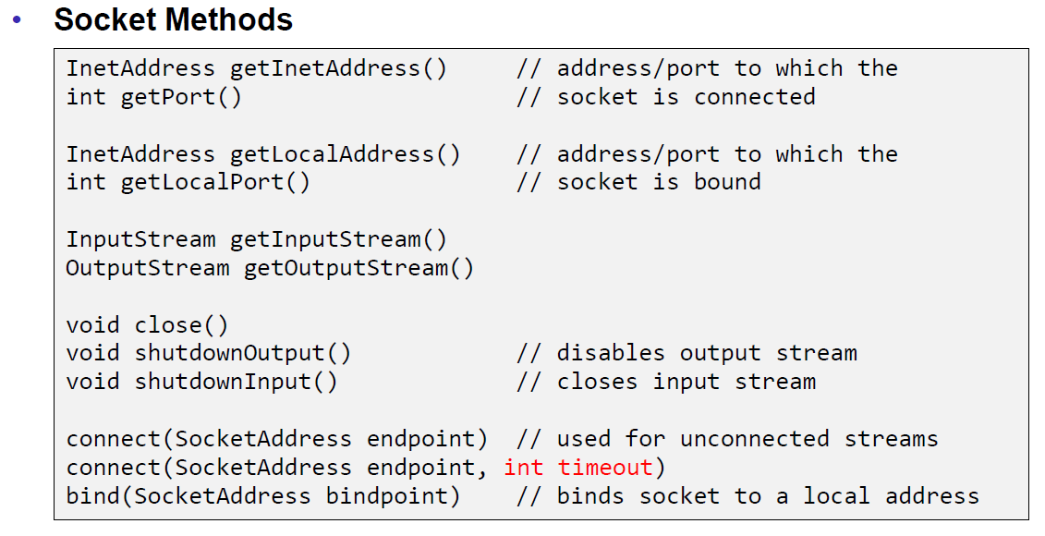

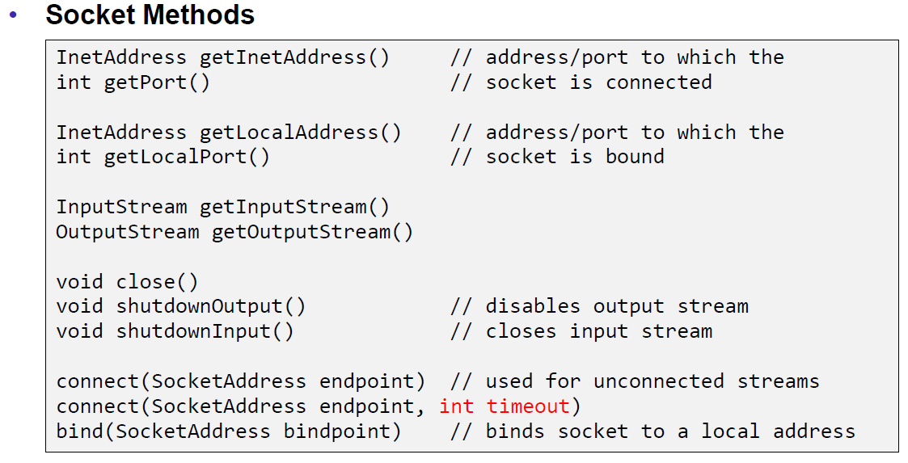

### Sample Client (Echo)

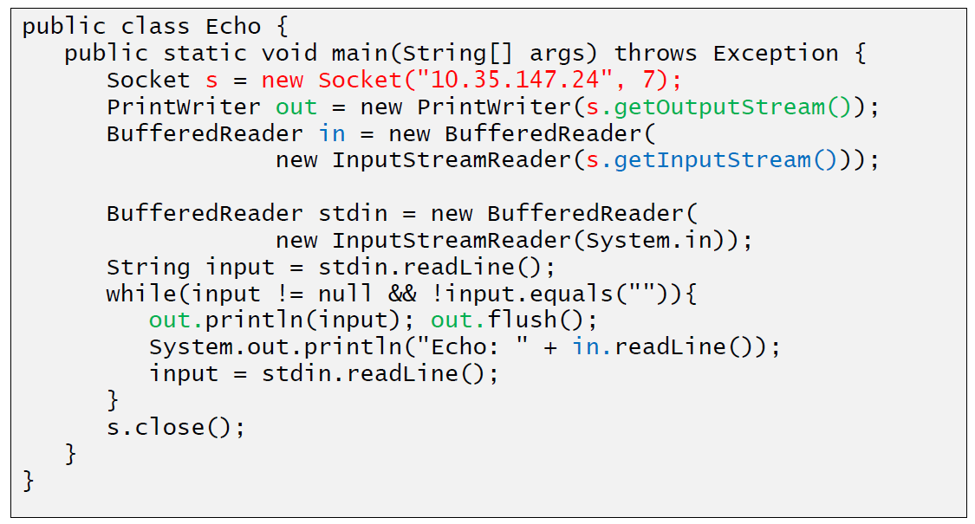

### Sample Client (Mailer)

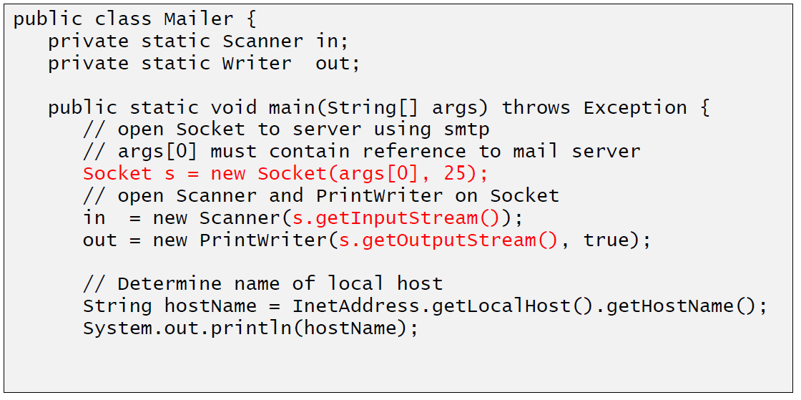

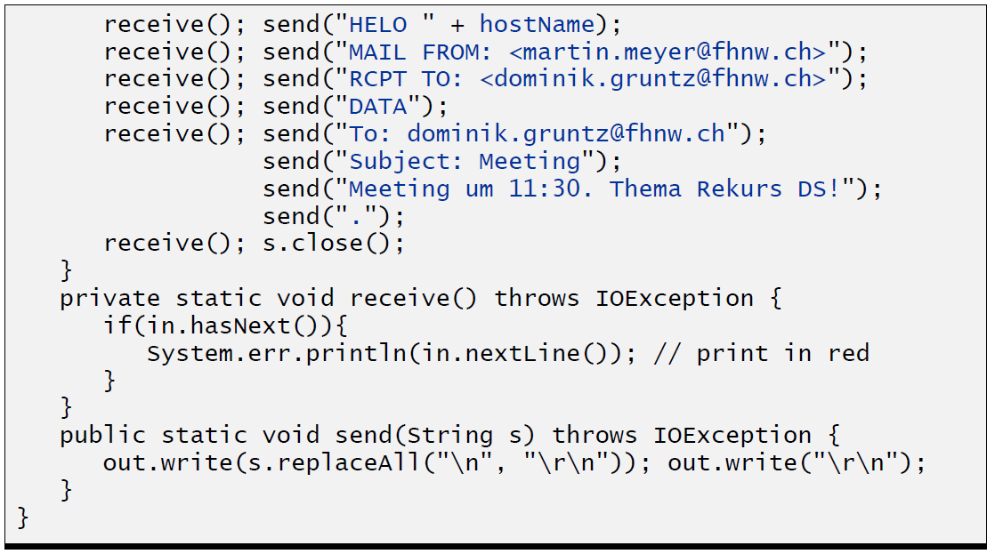

### ServerSocket

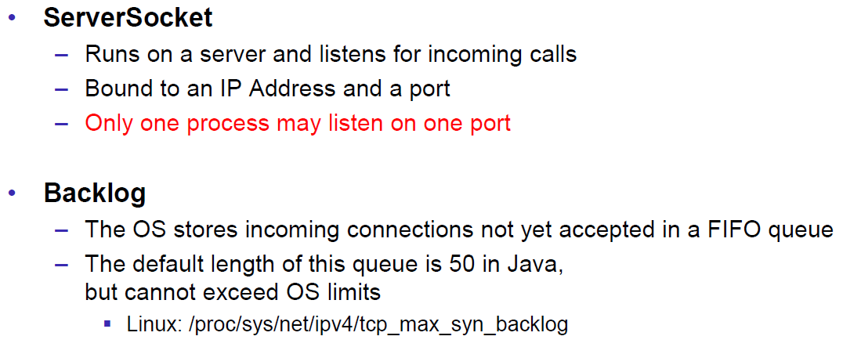

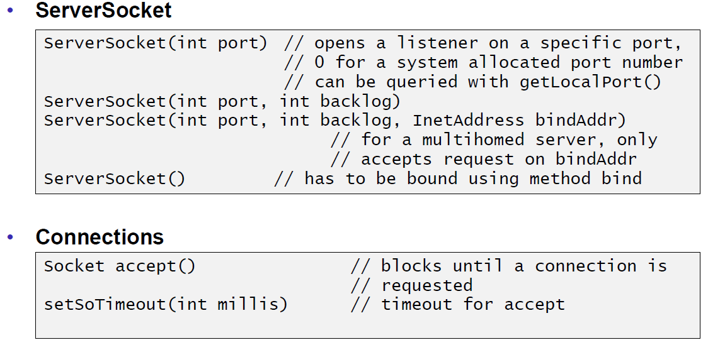

### Echo Server

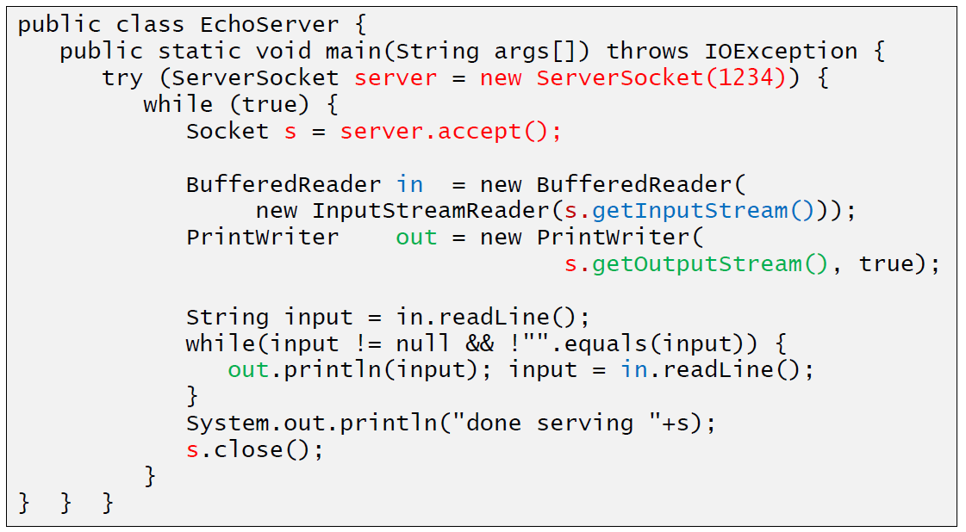

### Concurrent Echo Server

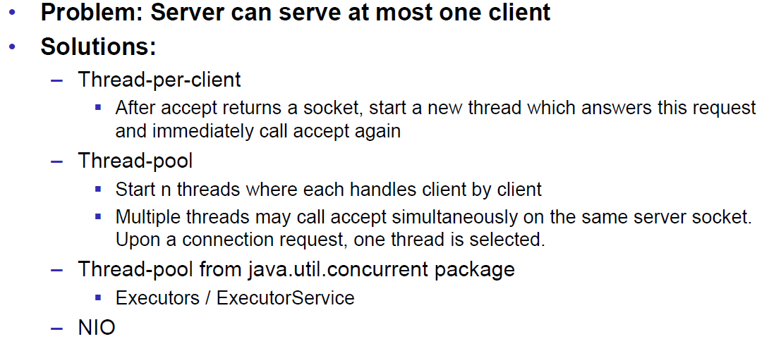

### Concurrent Echo Server (Threaded)

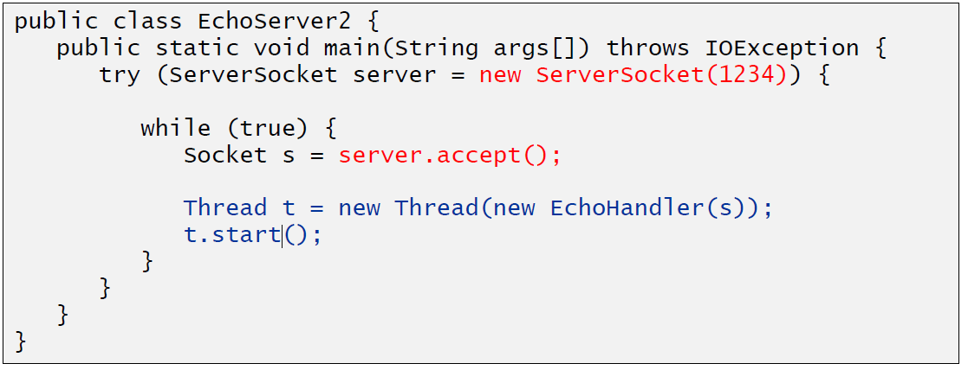

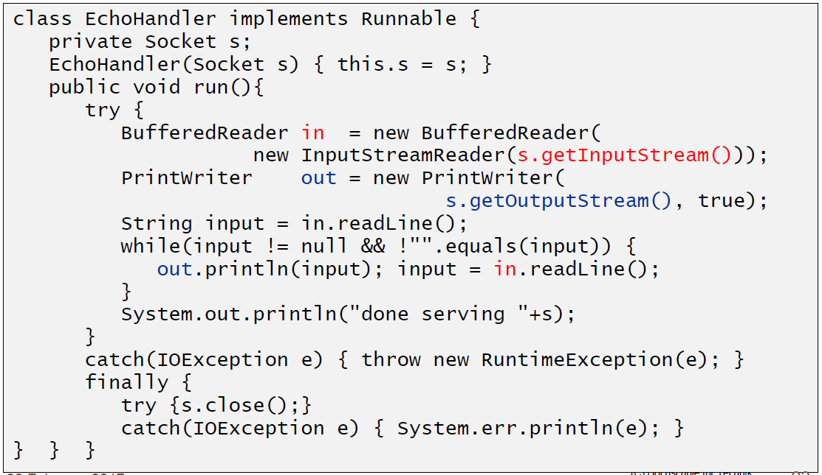

### Concurrent Echo Server (Limitierter Threadpool)

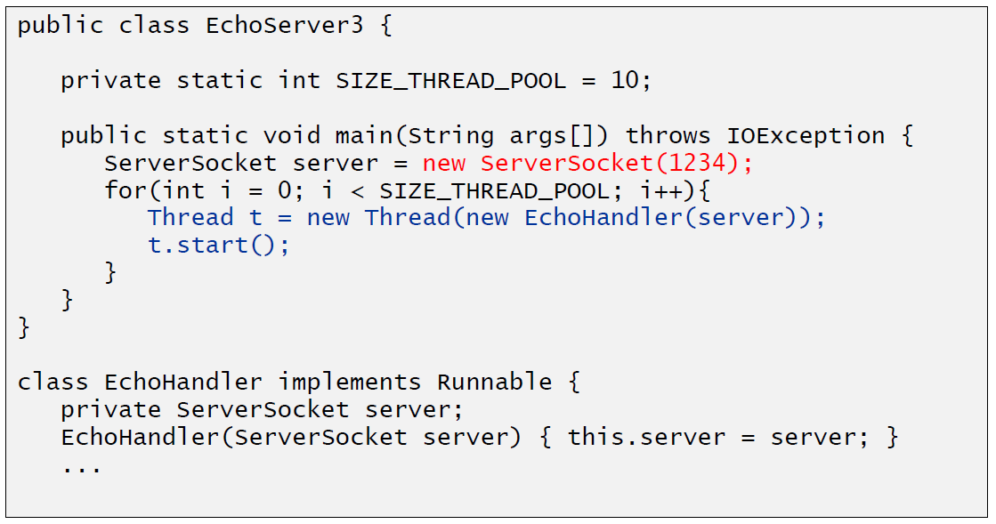

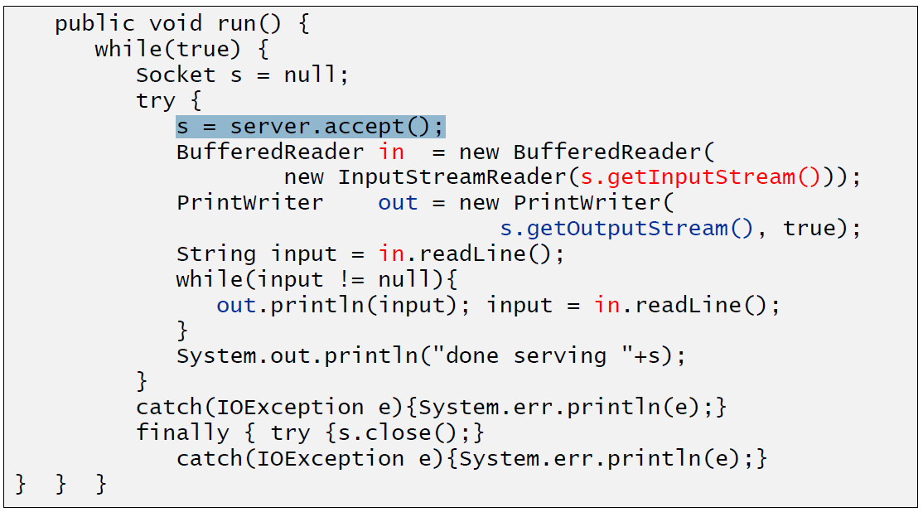

### Concurrent Echo Server (Dynamischer Threadpool)

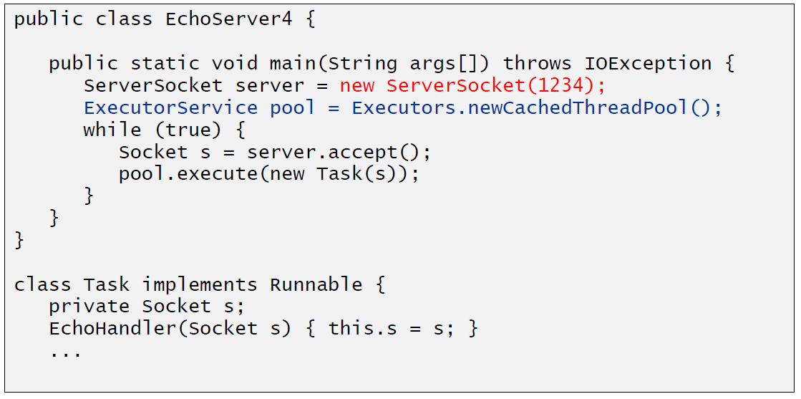

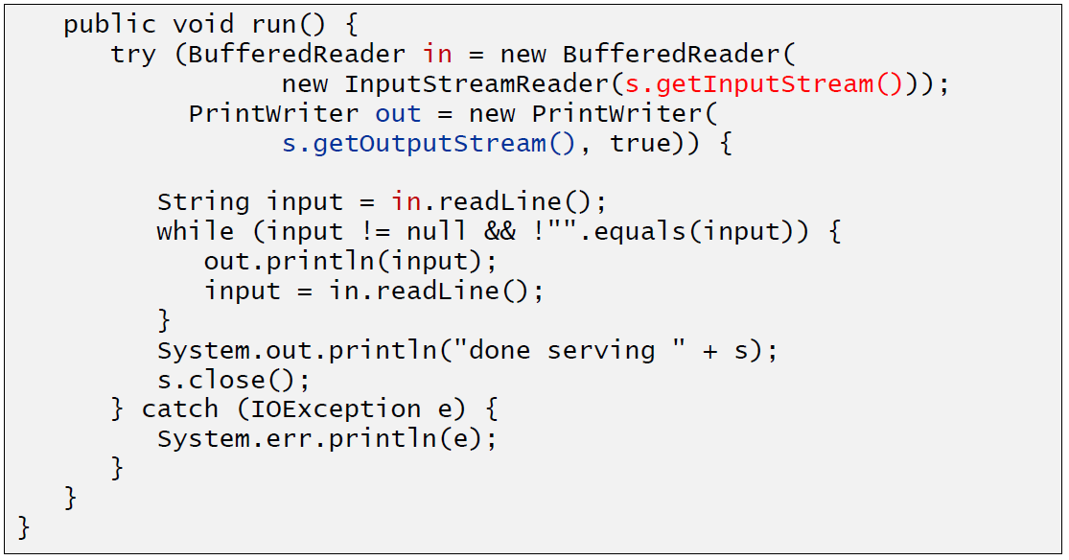

# Woche 2

## Input and Output Streams

### OutputStream

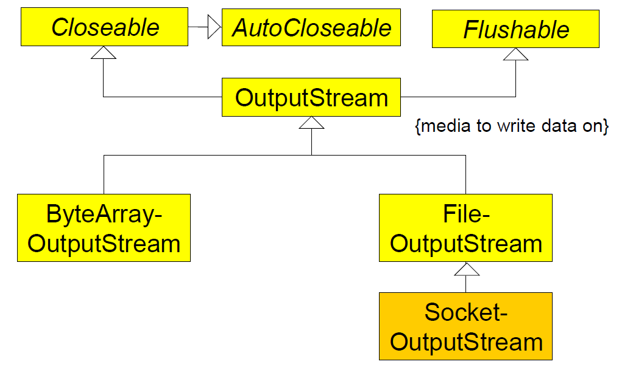

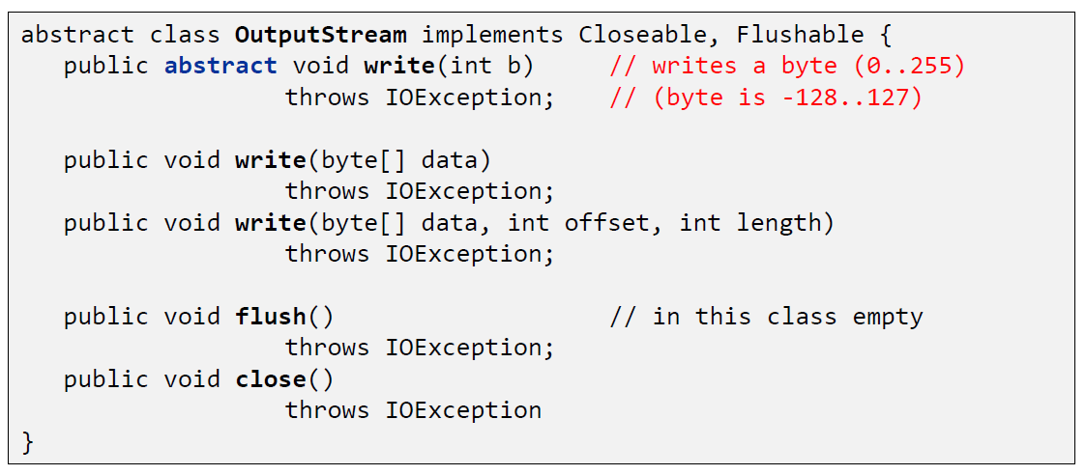

### InputStream

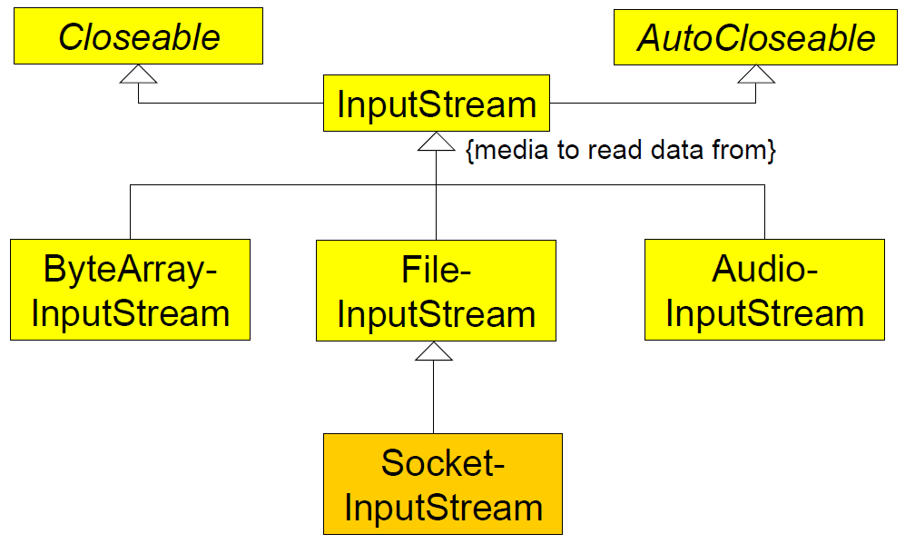

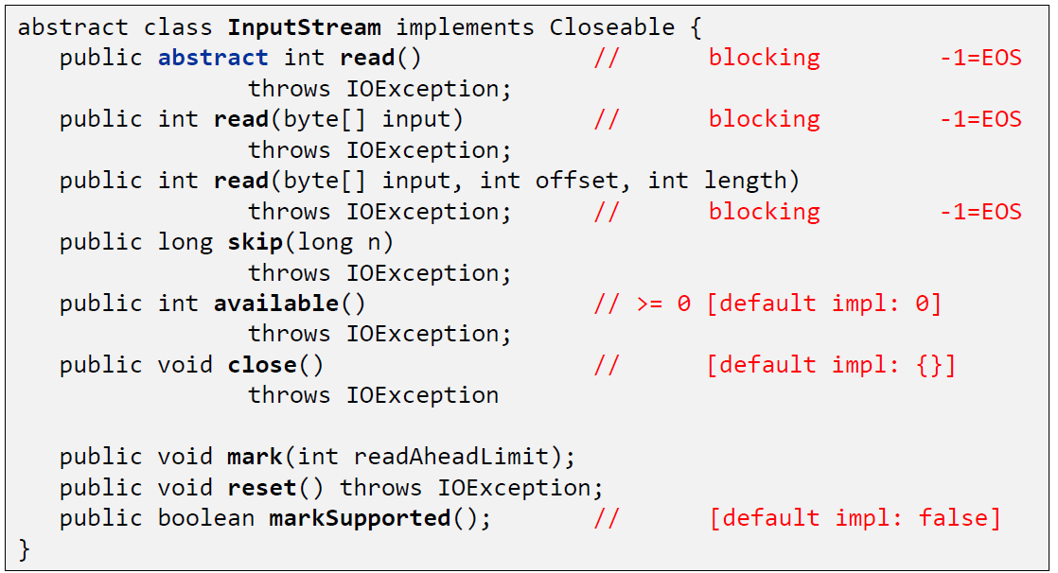

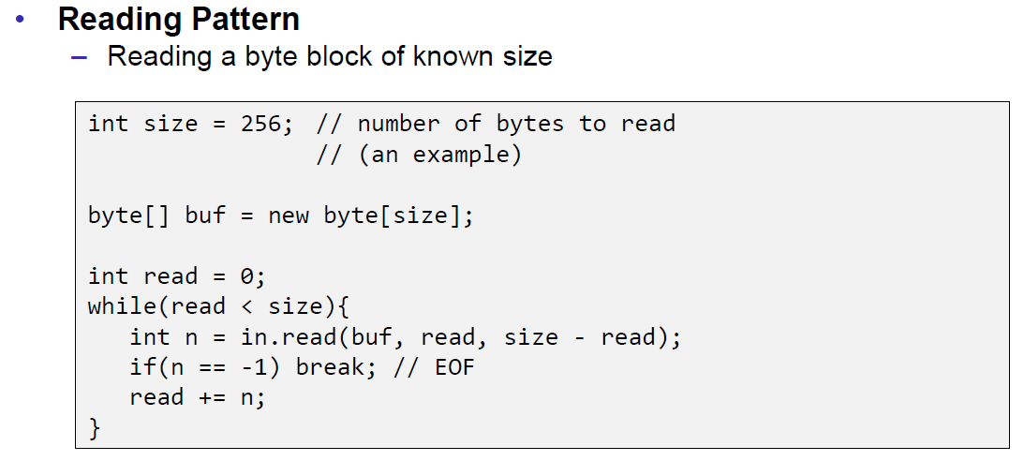

## Filter Streams

### FilterOutputStream

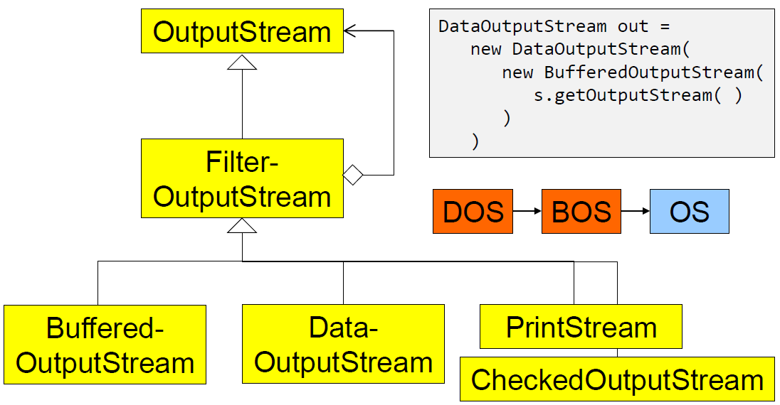

### DataOutputStream

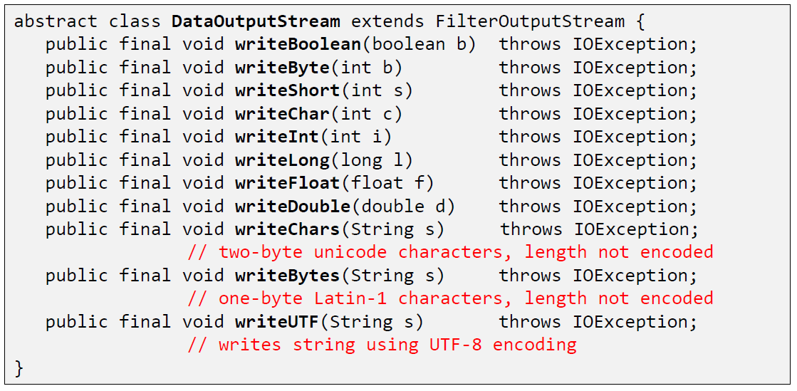

### DataOutputStream with writeInt

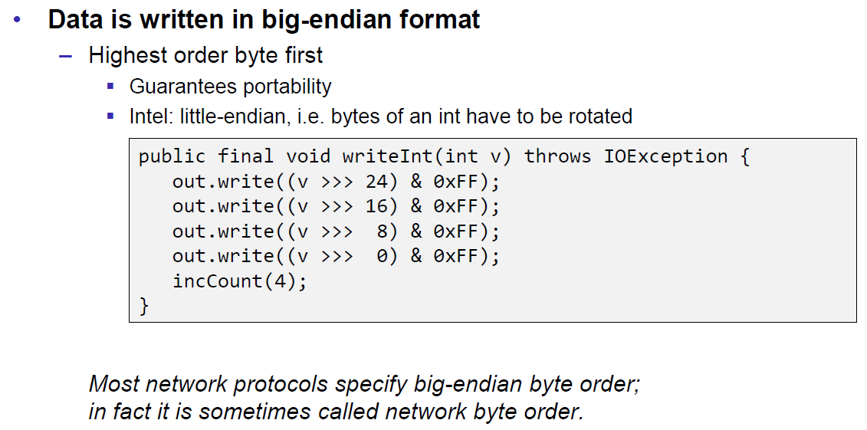

### DataOutputStream with writeUTF

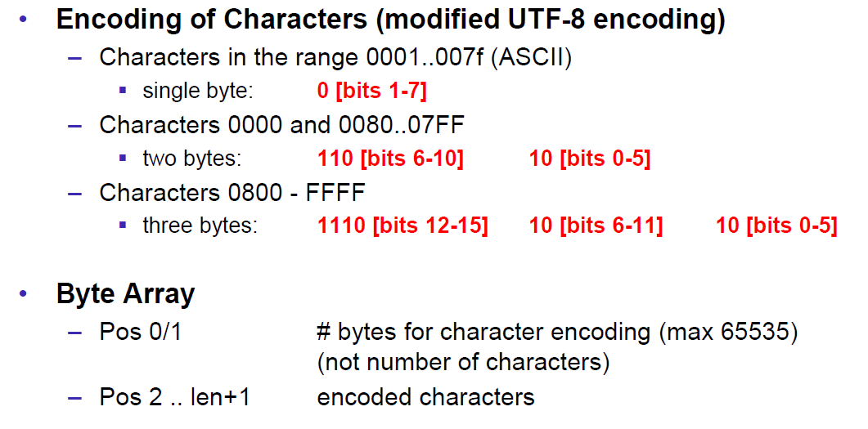

### PrintStream

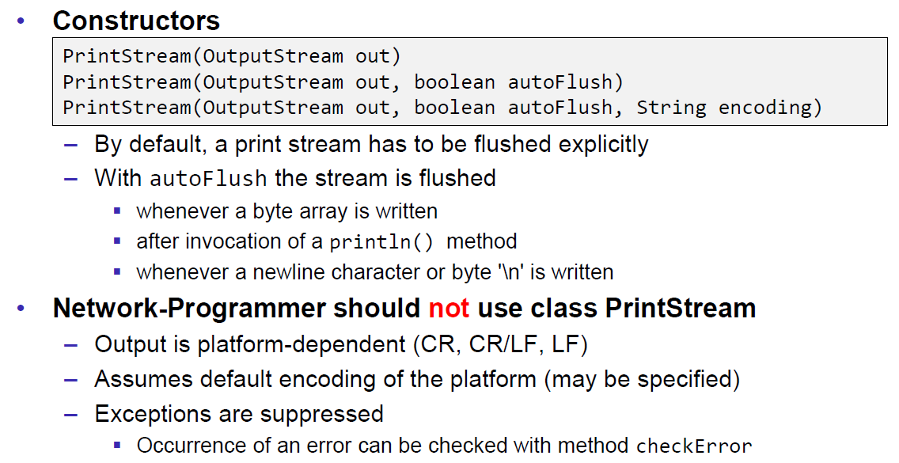

### FilterInputStream

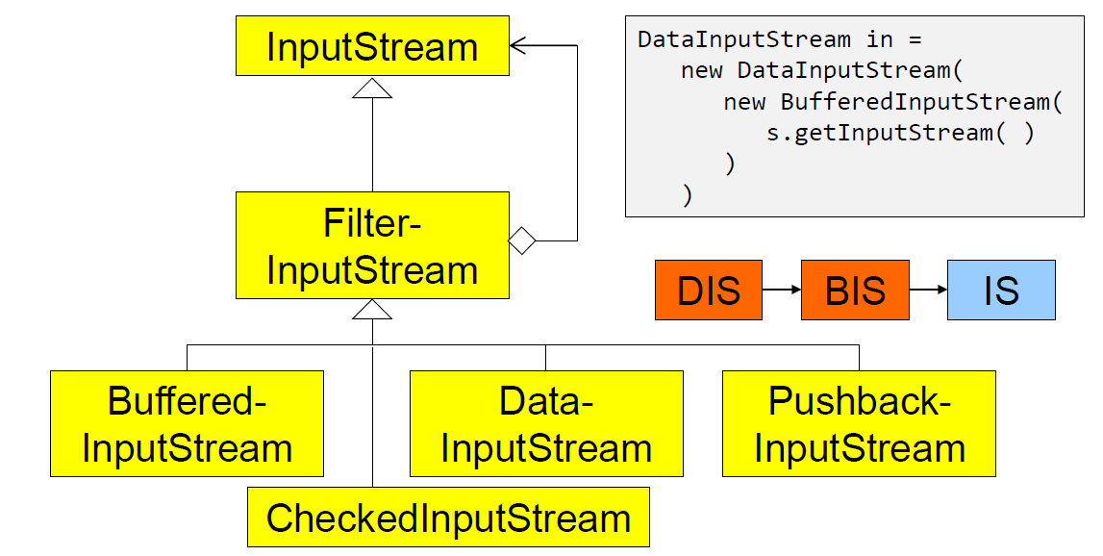

### DataInputStream

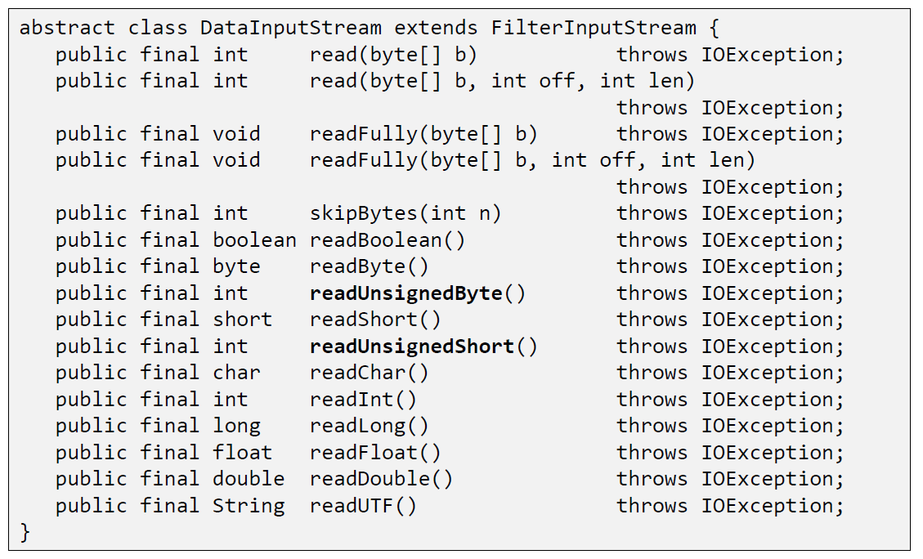

### DataInputStream with readFully

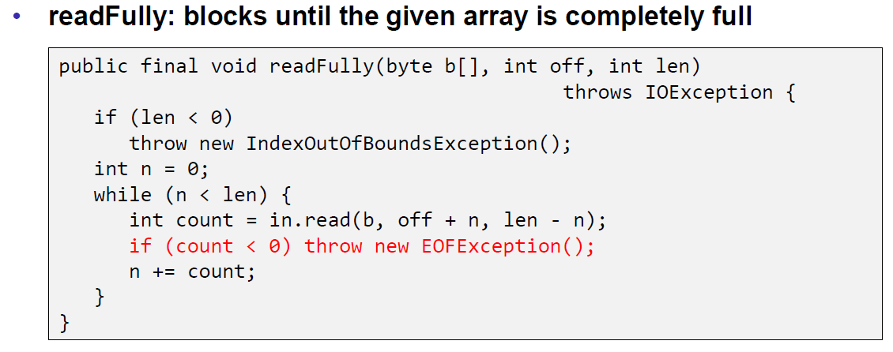

### Filter Streams

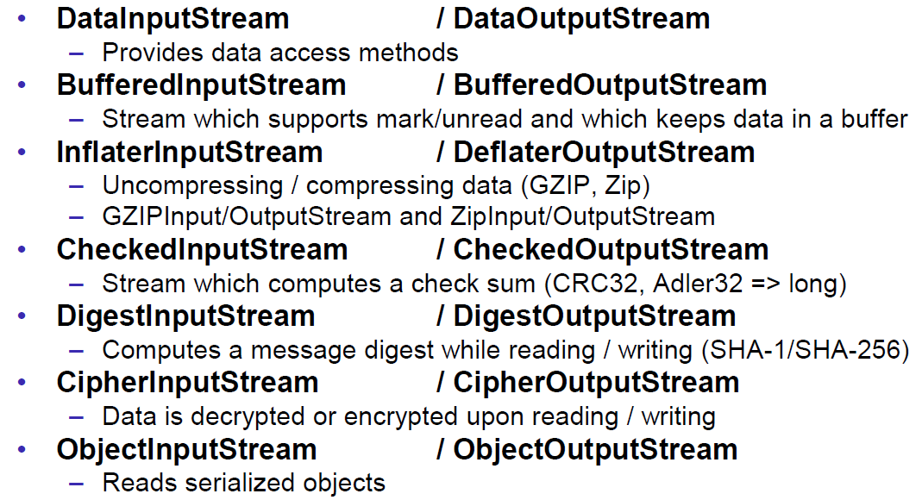

## Object Streams & Serialization

### ObjectStream

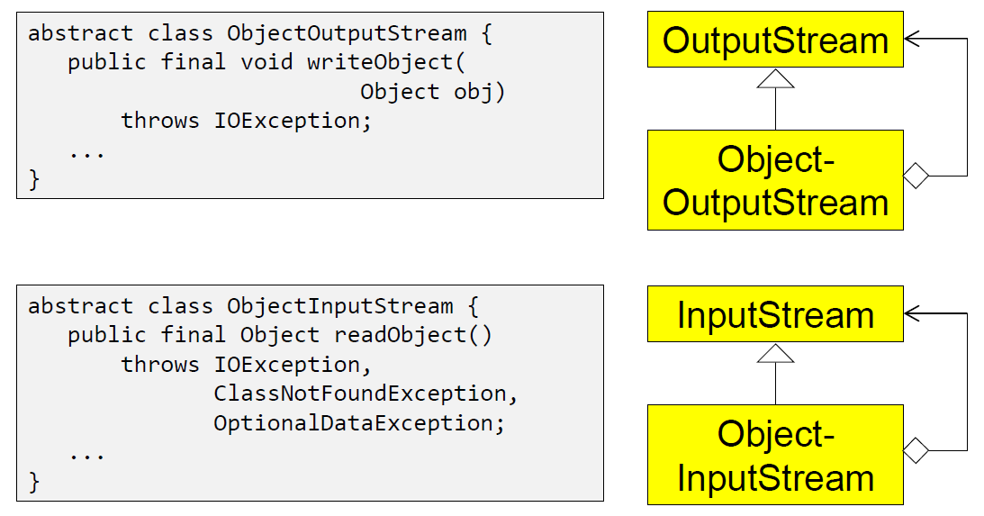

### Serialization with ObjectStream

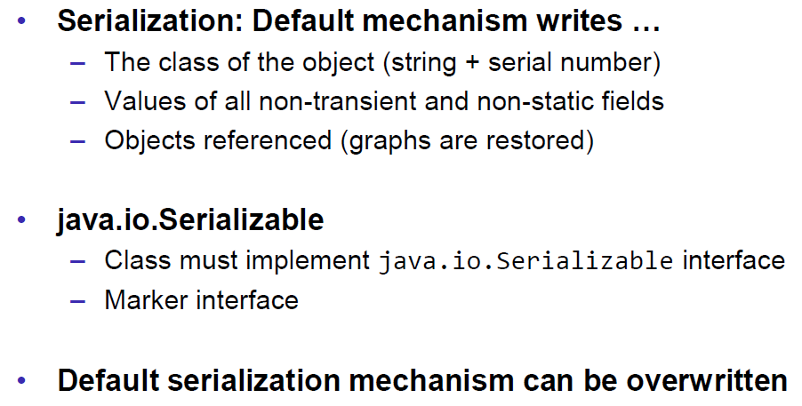

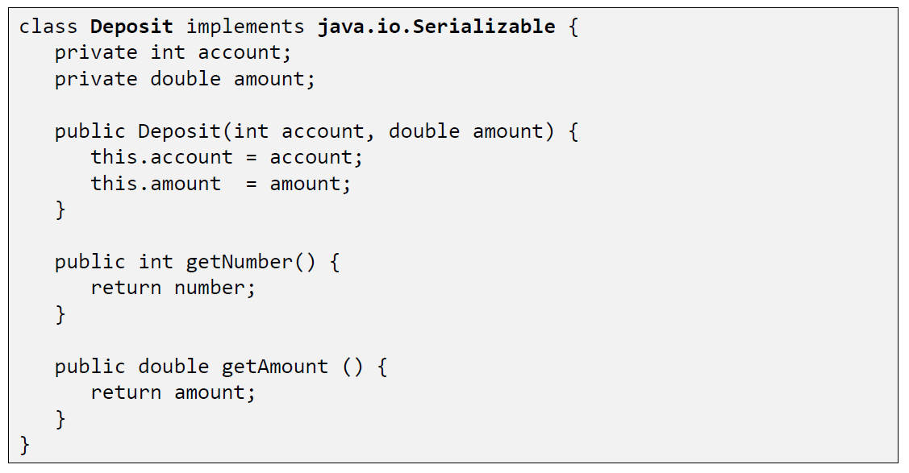

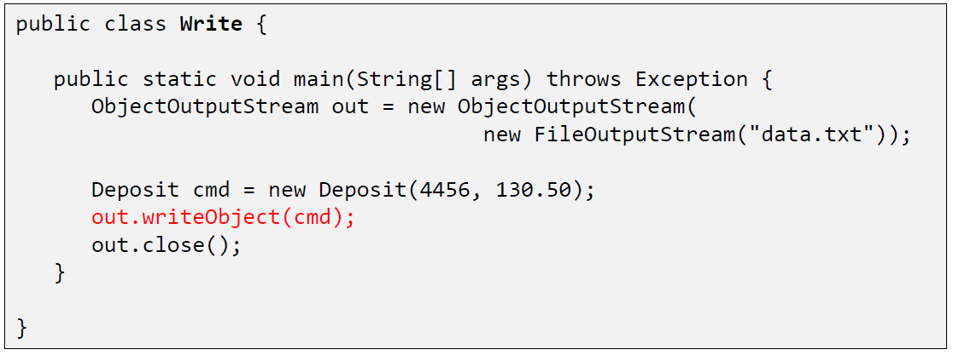

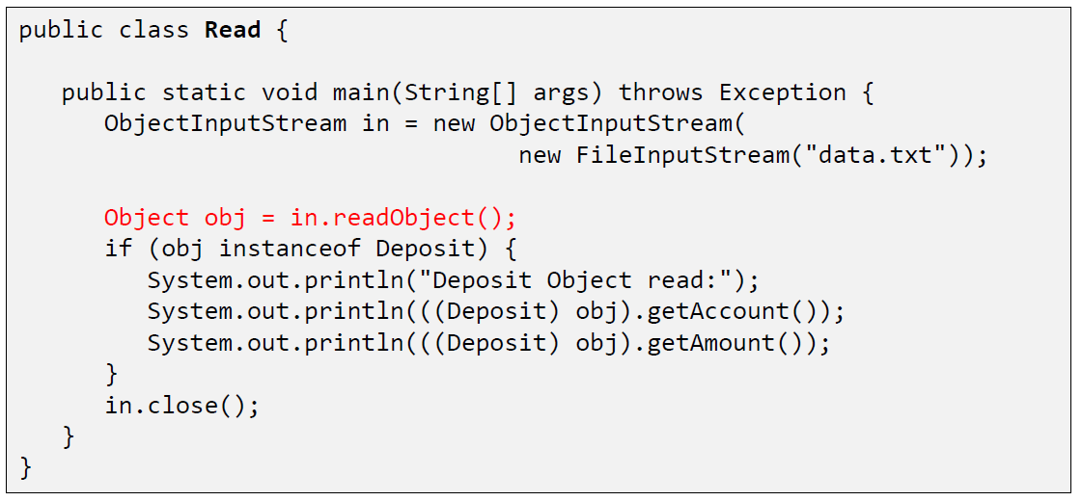

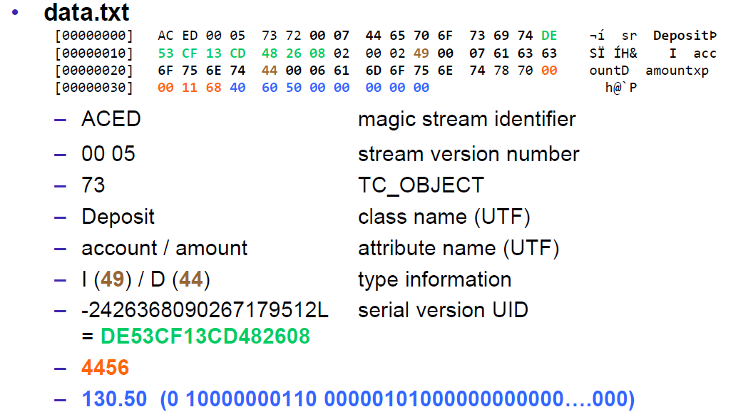

### Serial Version Number

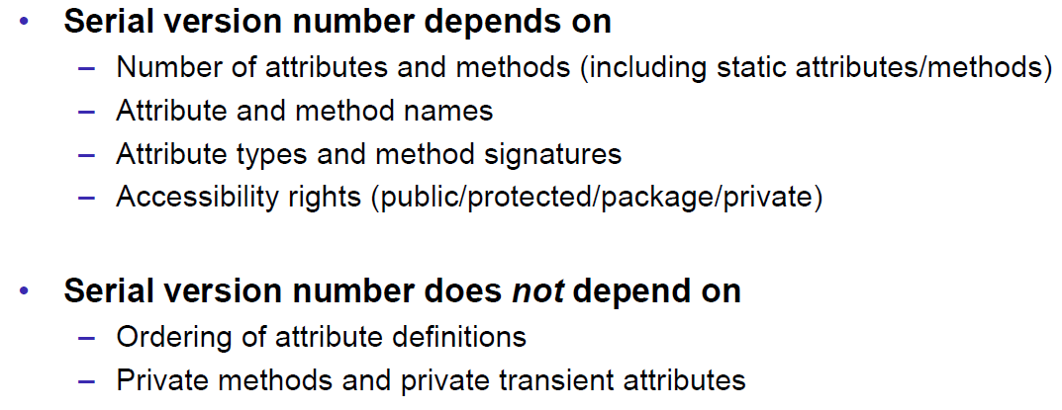

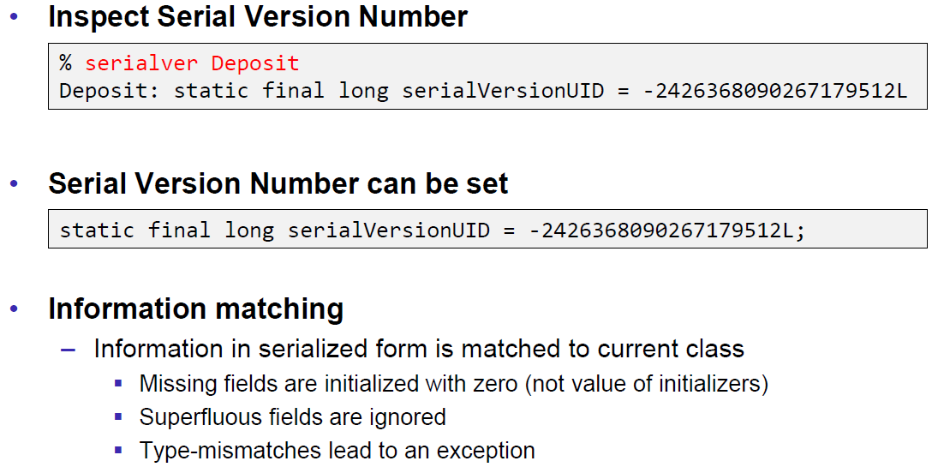

### Serialization Customization

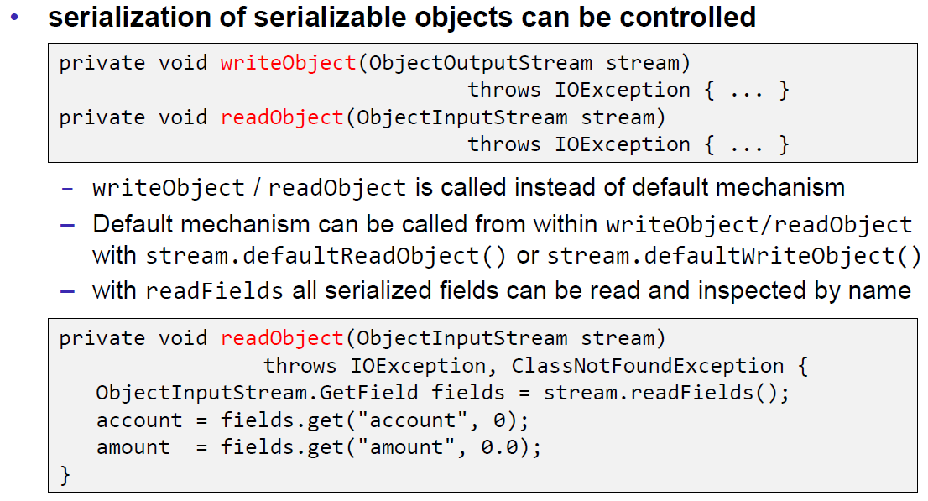

### Serialization Hints

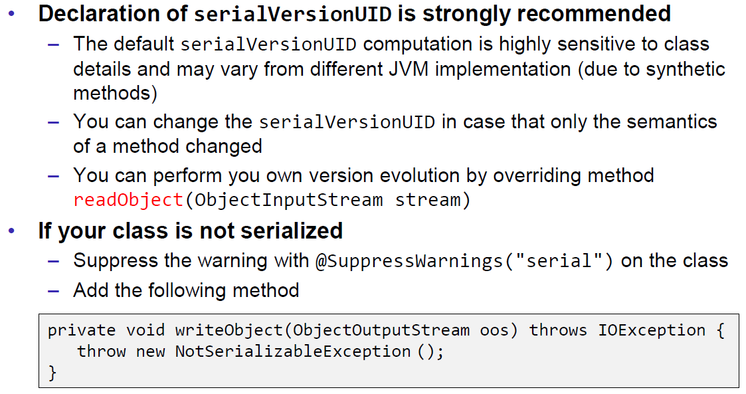

## Sending and Receiving Data

### Framing

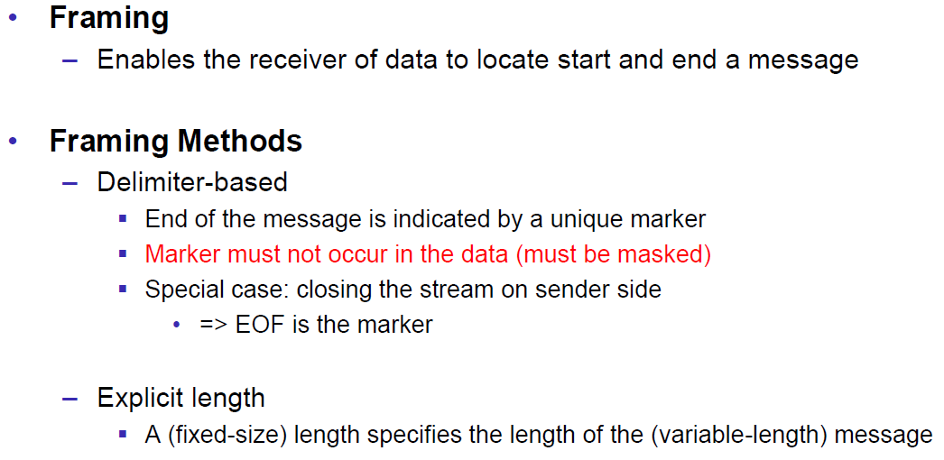

### Example of Framing

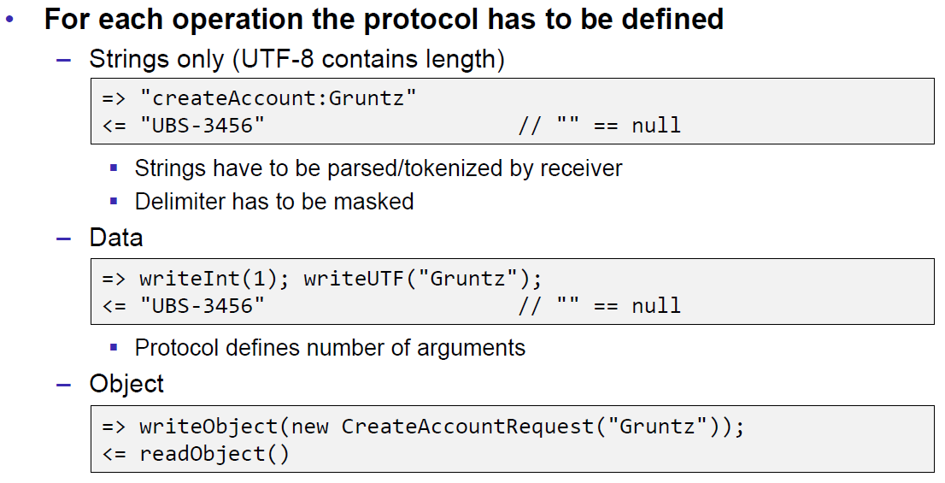

## Summary

### Whole Picture of Input Streams

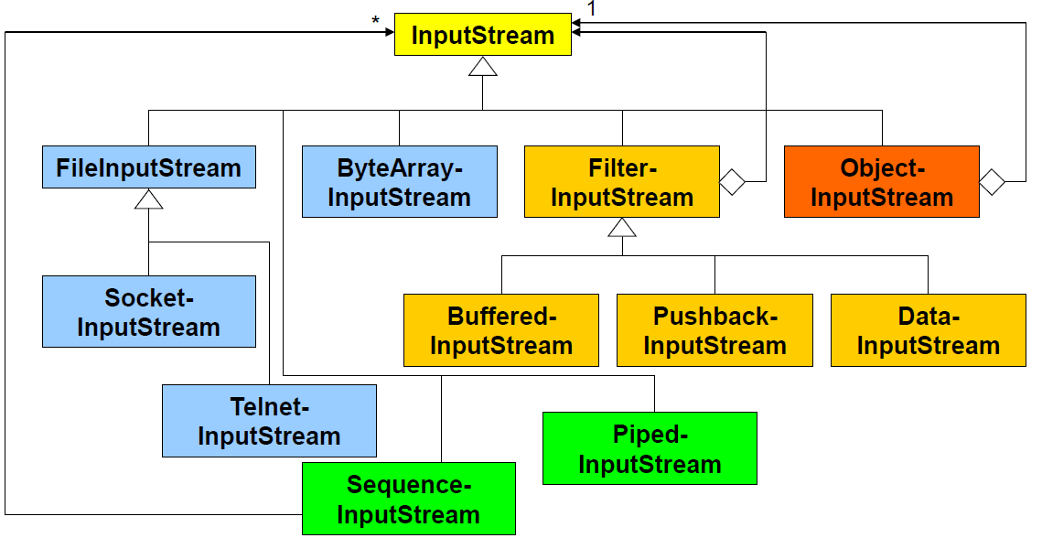

### Whole Picture of Output Streams

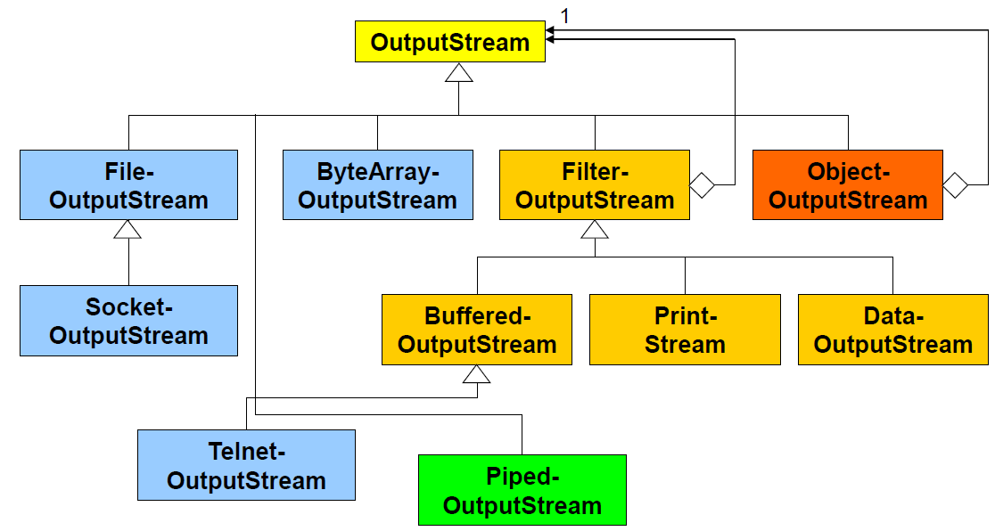

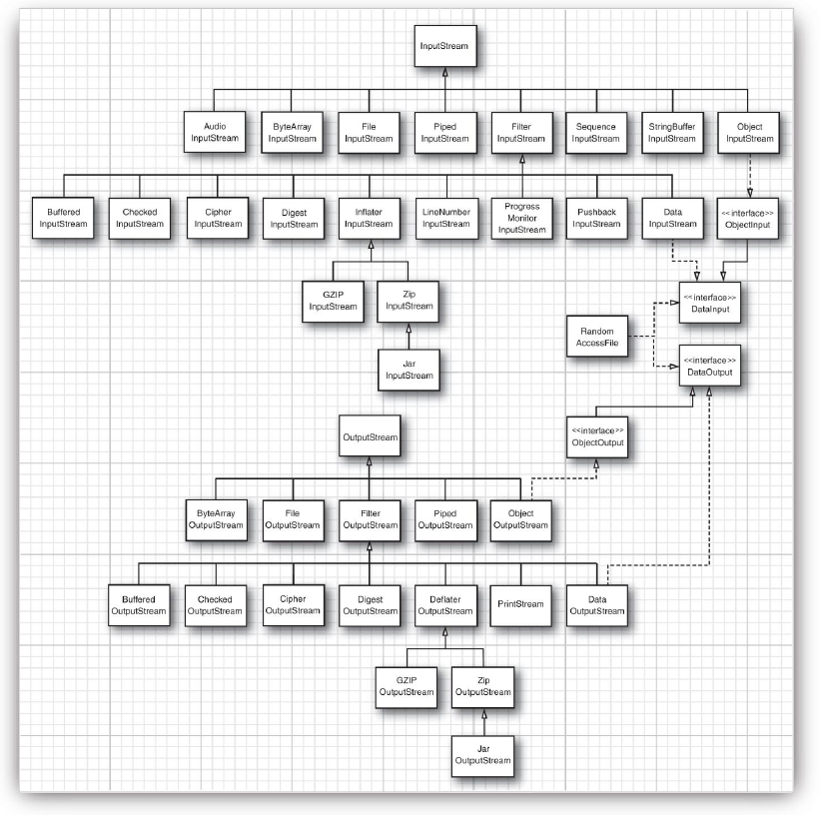

### Reading and Writing Text (Unicode Strings)

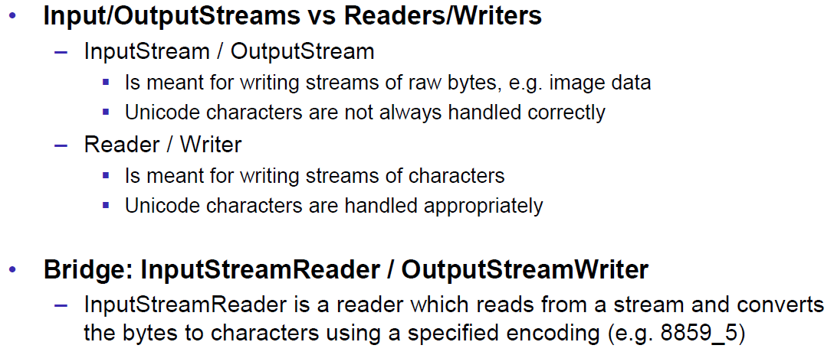

### Whole Picture of Reader

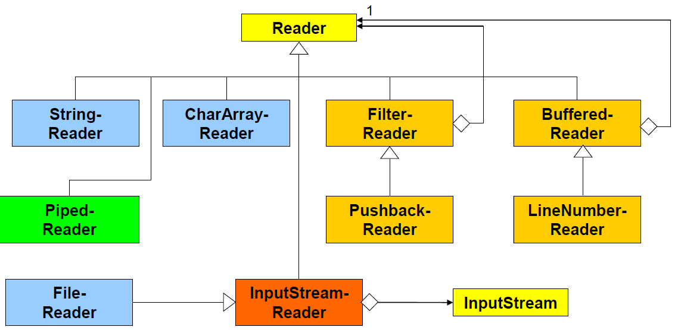

### Whole Picture of Writer

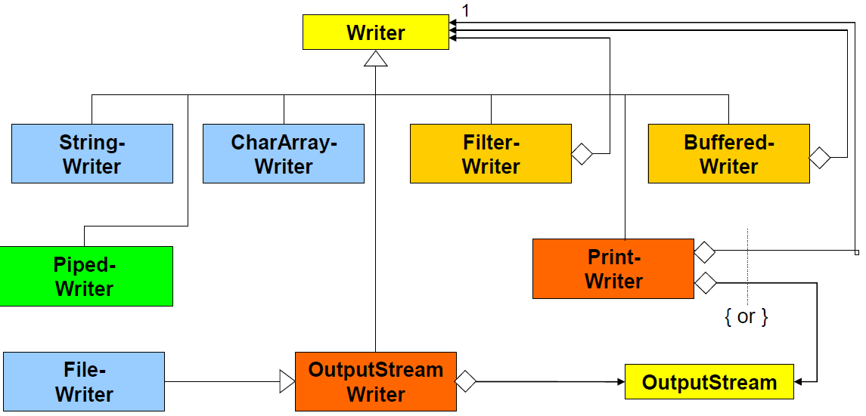

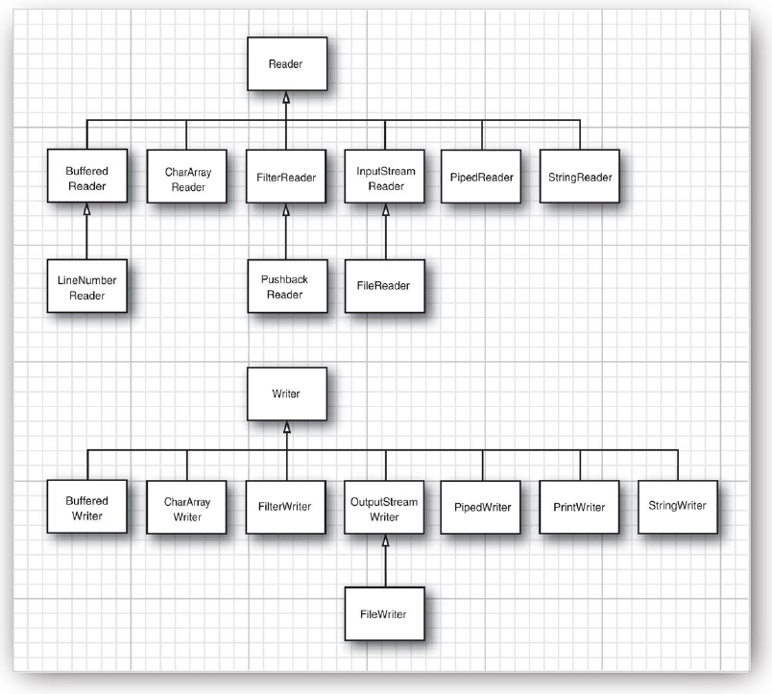

## Controlling Socket Behaviors

### Blocking and Timeouts

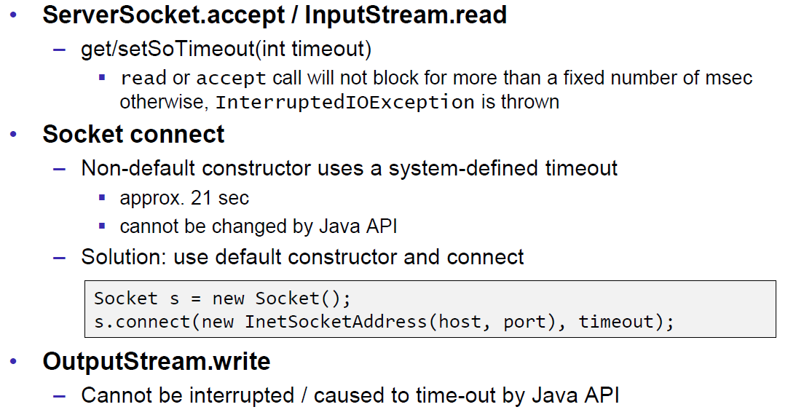

### Send and Receive Buffer Size

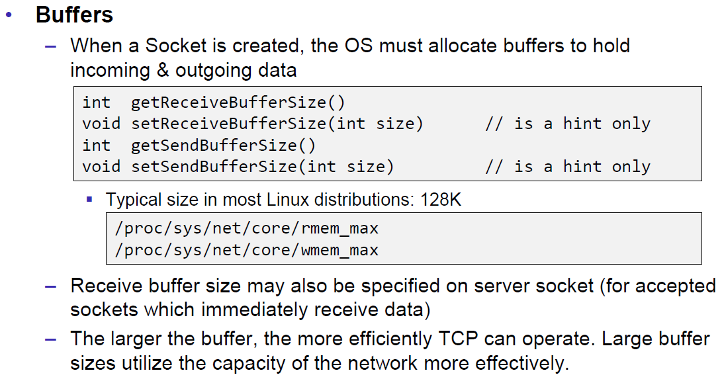

### Package Delay

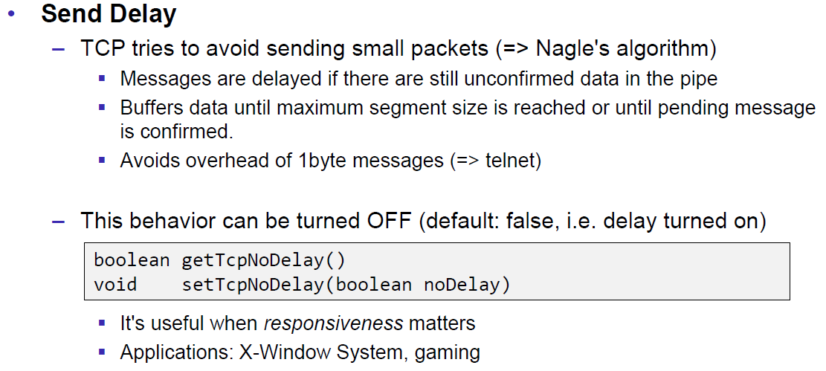

## Closing Connections

### Closing Connections

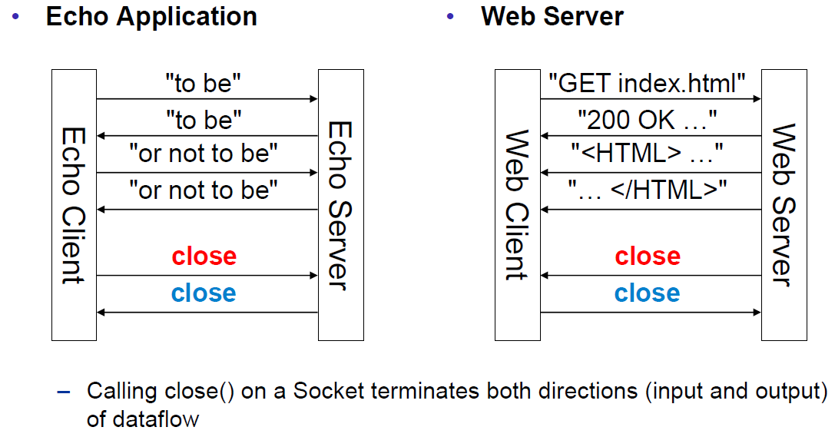

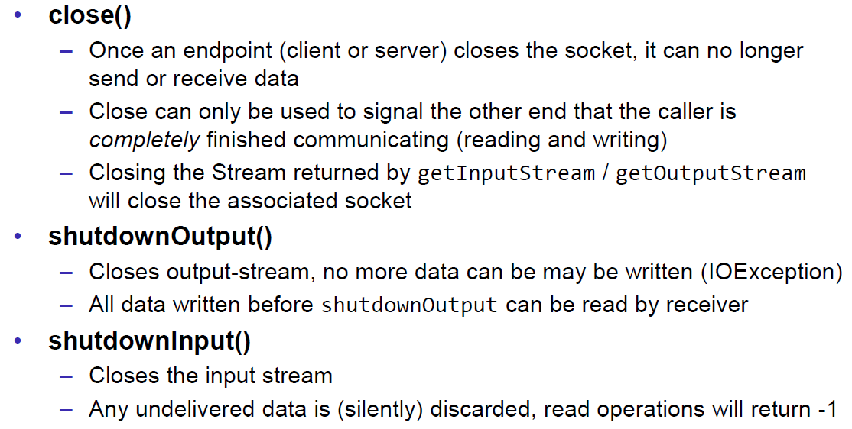

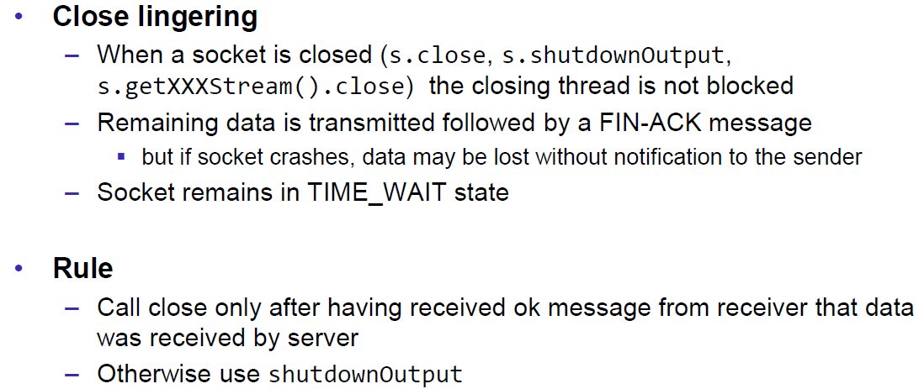

### Example of a Close Test

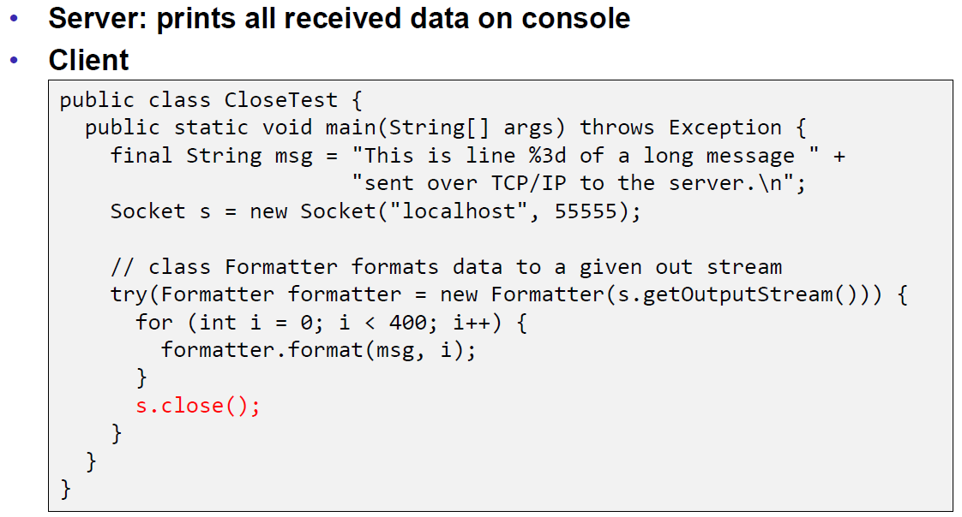

Problem: Some content of the formatter is not received by the server.

Solution: Flush the formatter before you close the socket, otherwise the buffer of the formatter won’t be sent.

### Example of a Compression Server

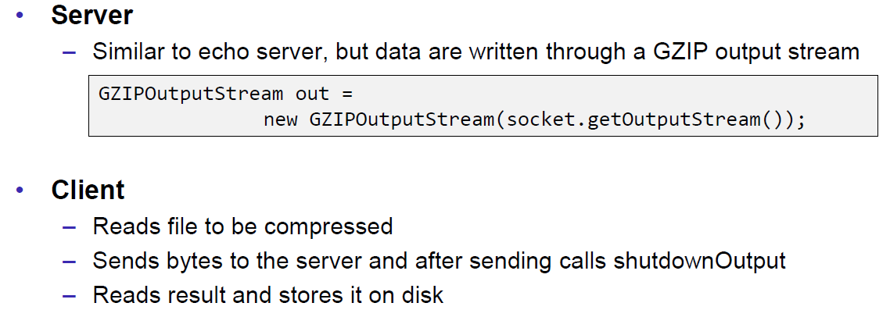

Problem: At some point, the server hangs up and doesn’t reply anymore.

Solution: Don’t send all content before you start reading. Otherwise you will fill up the outgoing (sending) cache of the server (because no one is reading it) and the write process of the server becomes blocking (this prevents a data loss because the outgoing buffer is full). A solution to this problem is to write and read block by block or to start the send process in a separate thread (Both happens in the client), so the client is able to immediately read the result and prevents a full sender buffer of the server.

## UDP Sockets

### UDP (User Datagram Protocol)

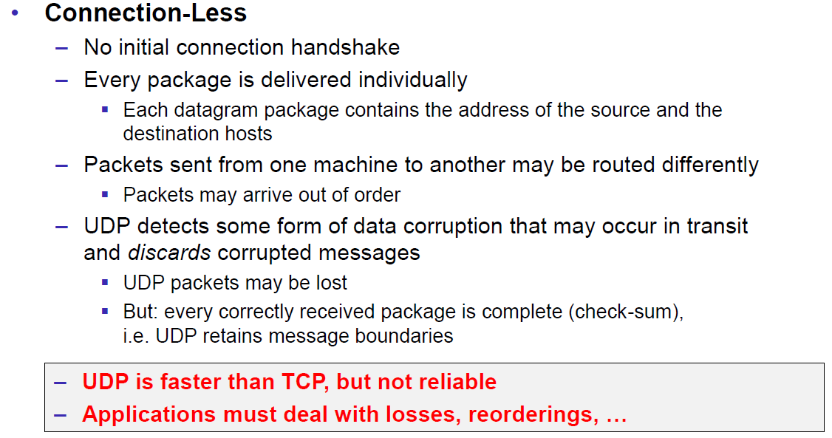

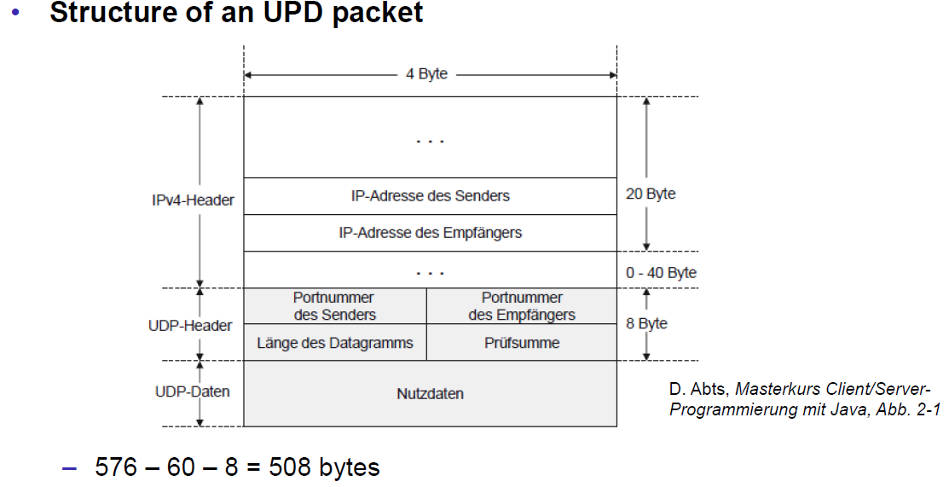

### Java Classes for Datagram

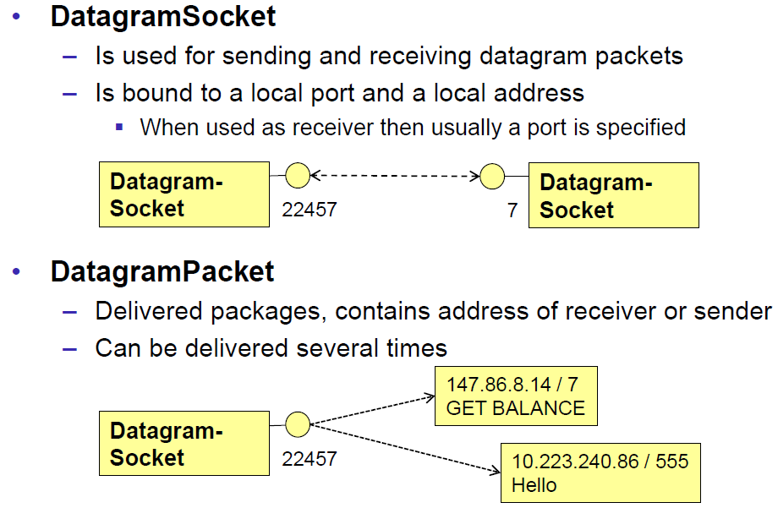

### DatagramSocket

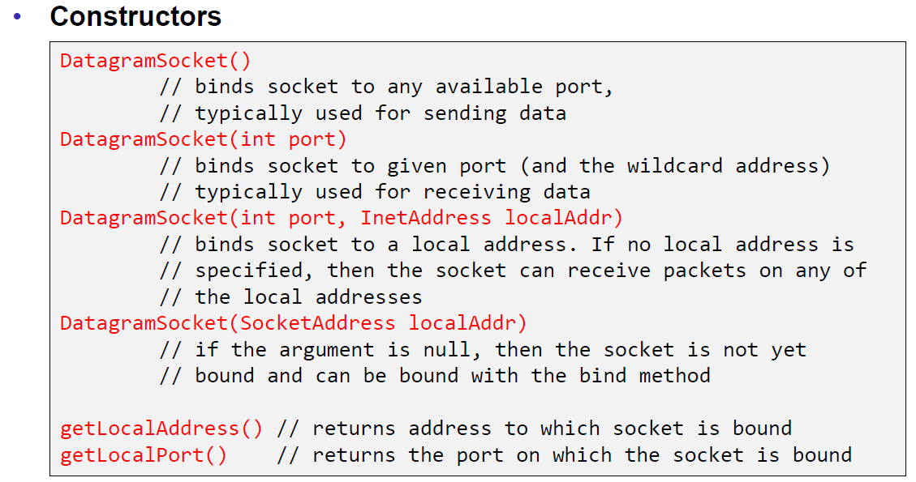

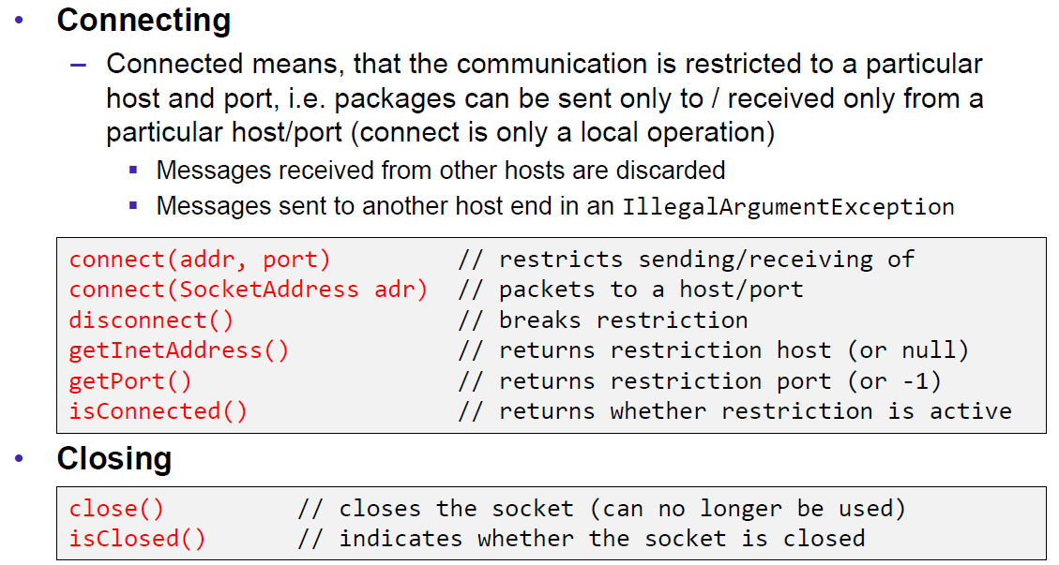

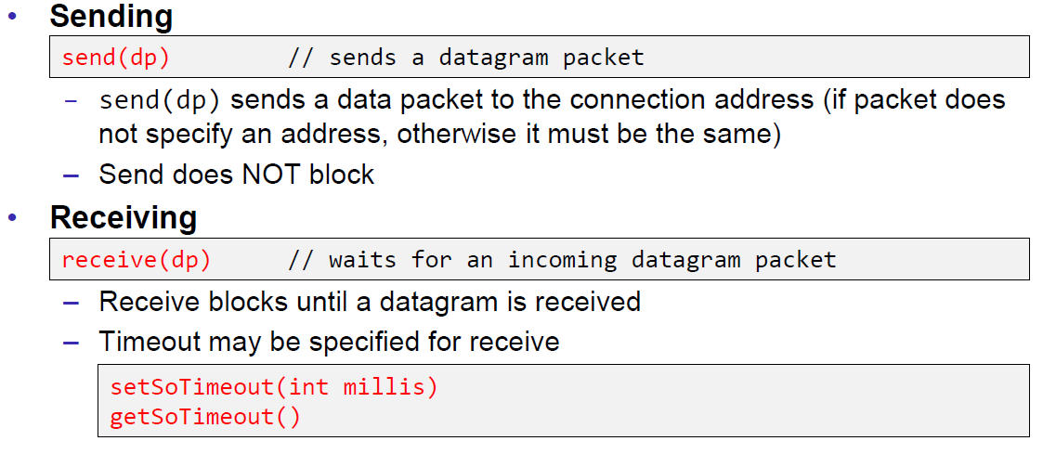

### DatagramPacket

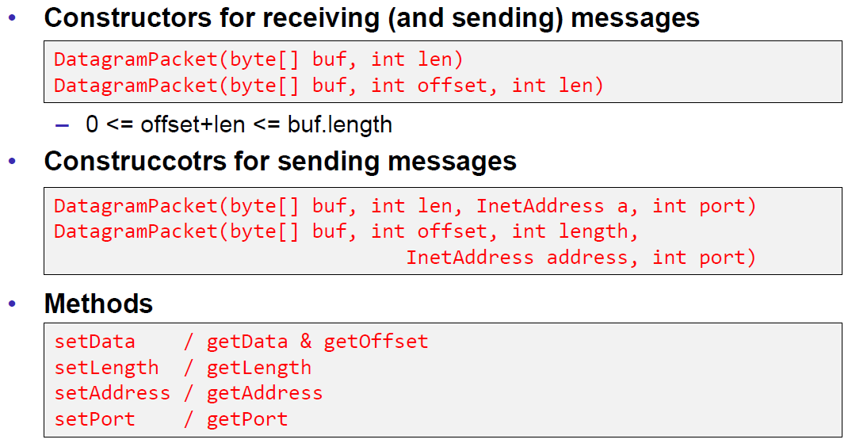

### Example of a UDP Server and Client

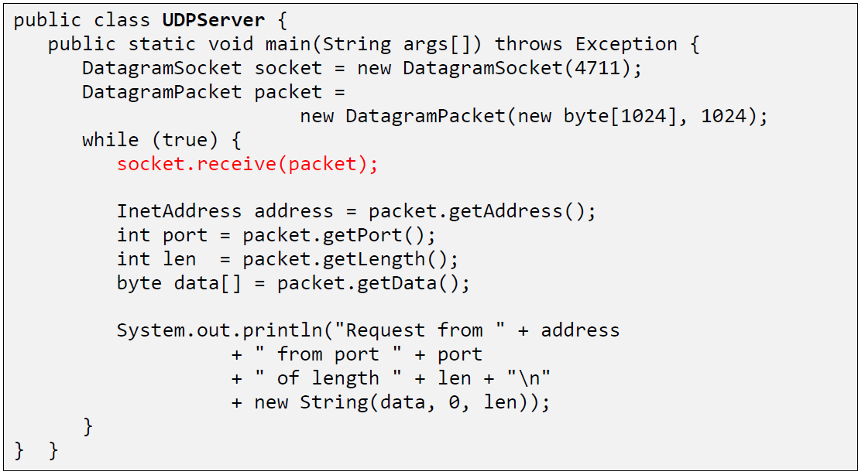

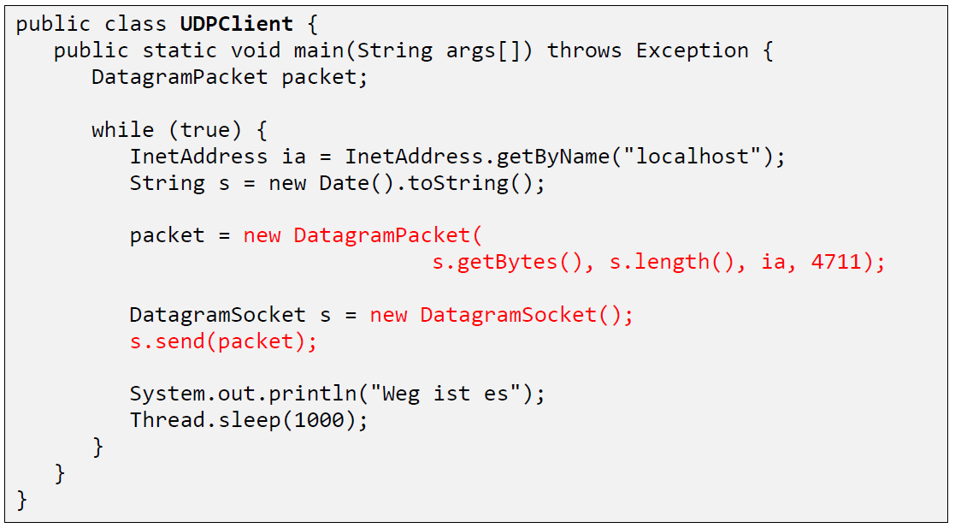

### UDP Implementation

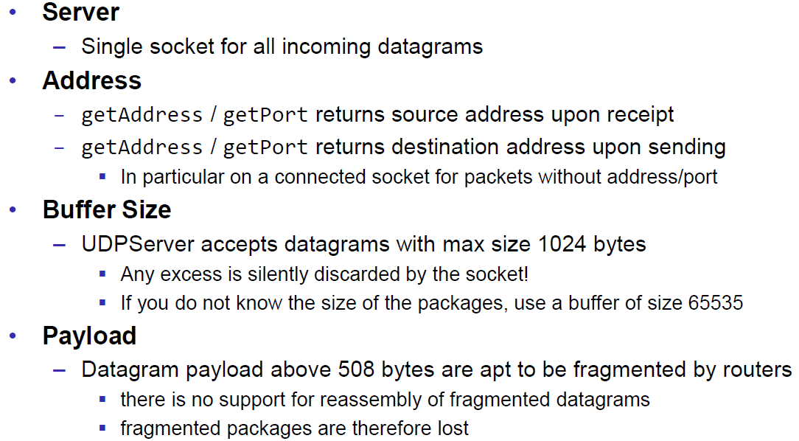

### Reliable UDP

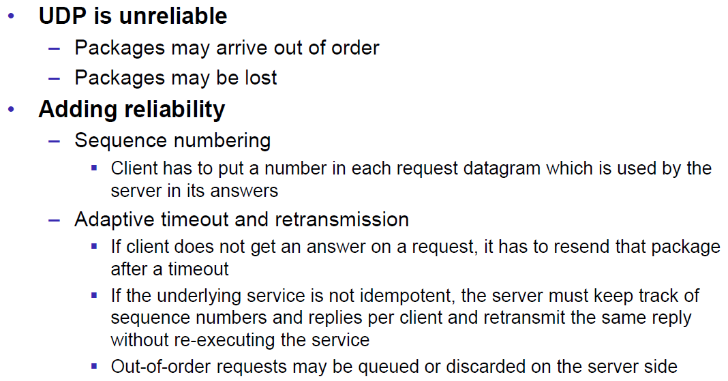

# Woche 3

## HTTP Protocol

### IETF RFC

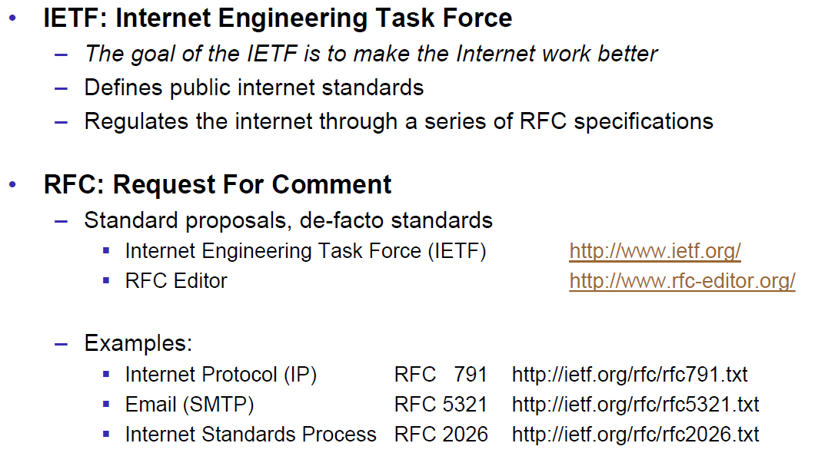

### HTTP Protocol

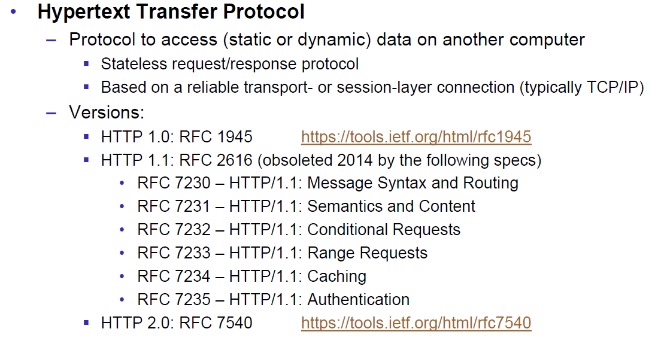

### HTTP Request

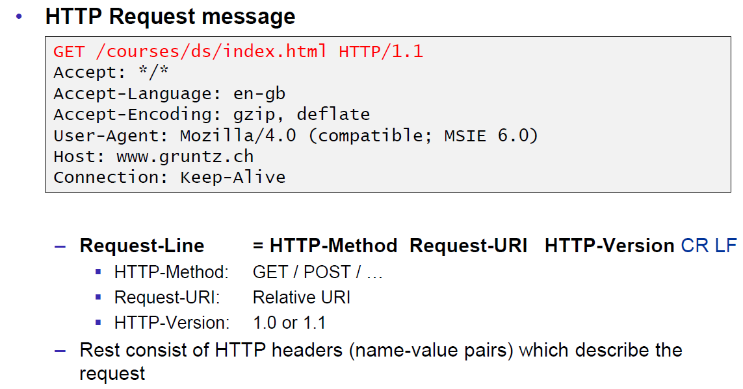

### HTTP Response

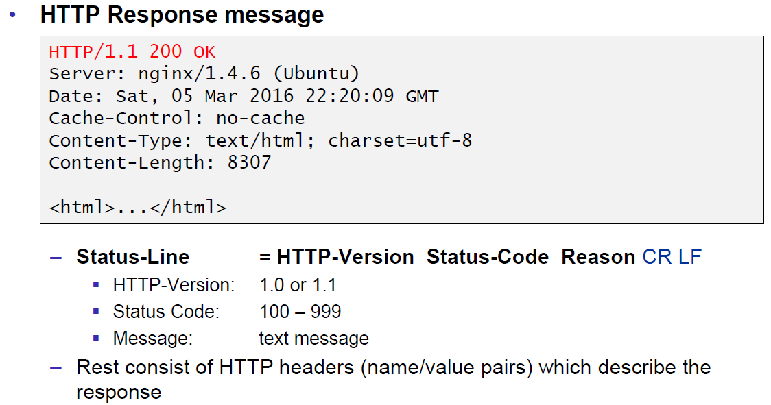

### HTTP Protocol

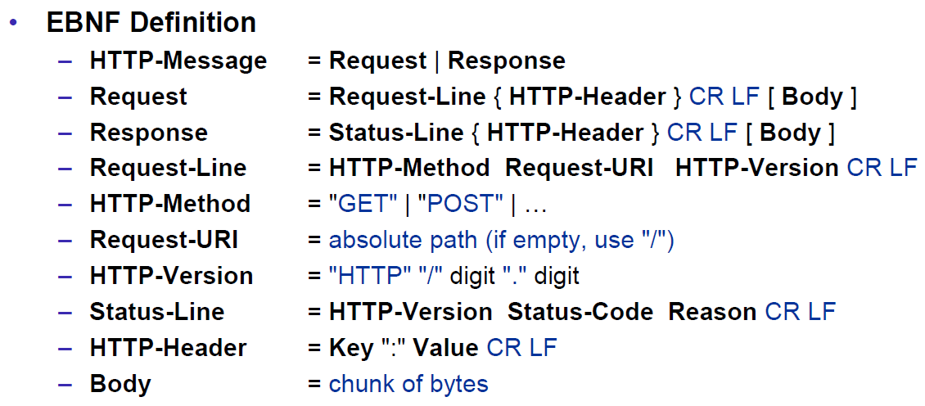

### HTTP Sample

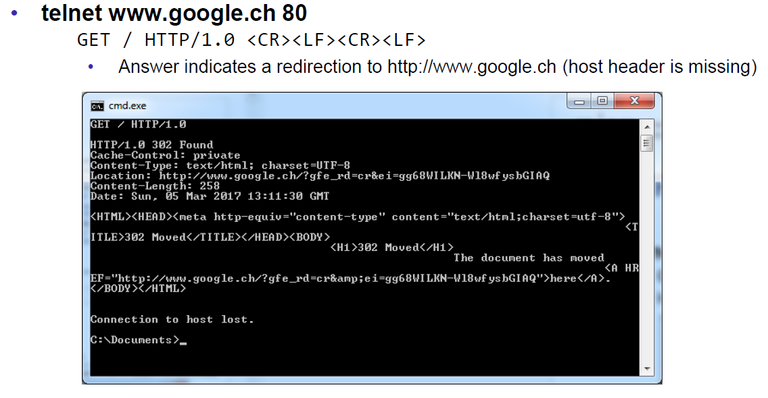

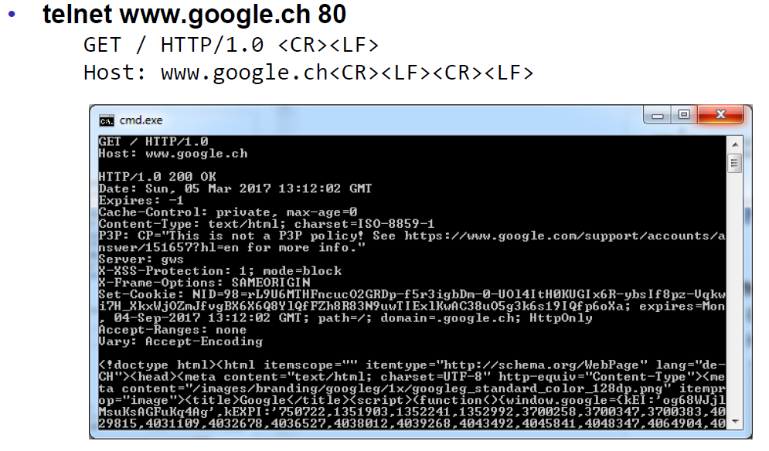

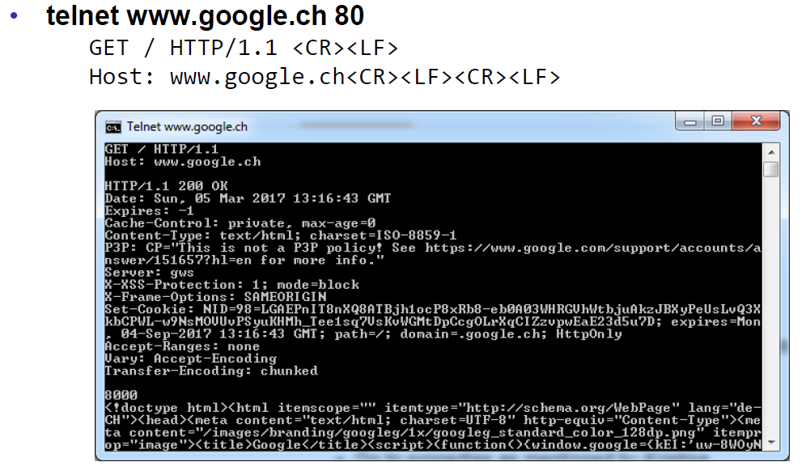

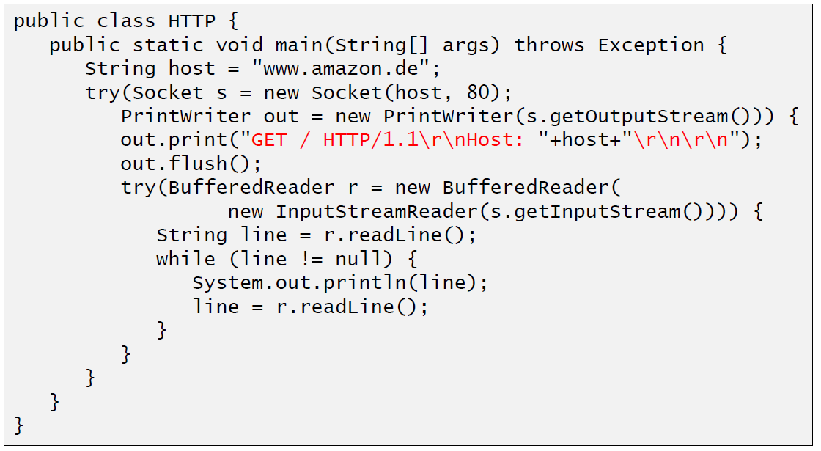

### HTTP 1.0 Request Methods

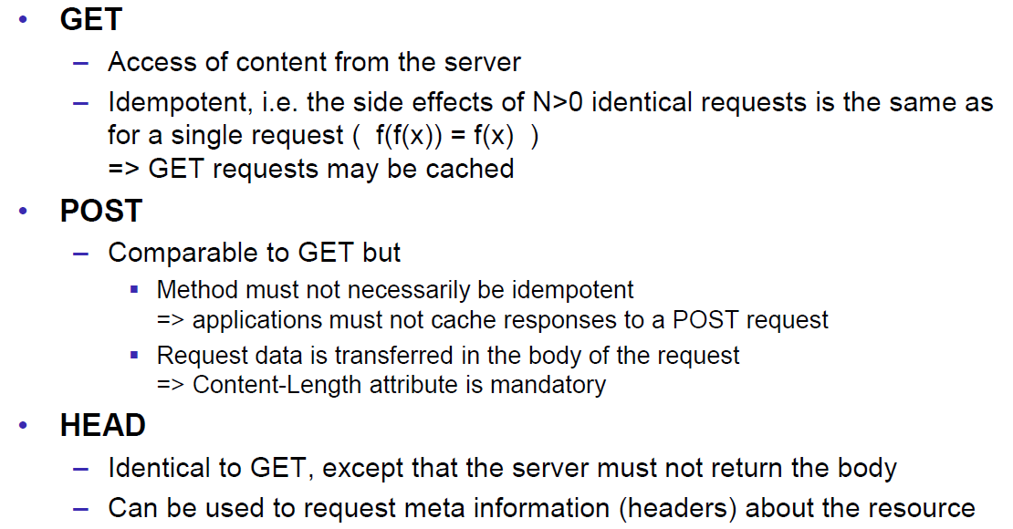

### HTTP Response Codes

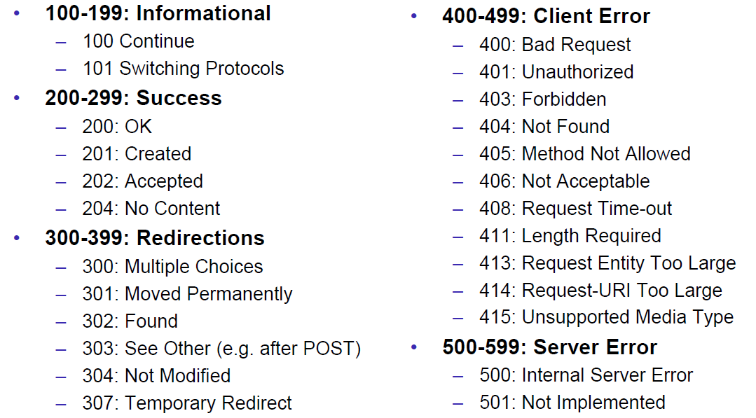

### HTTP Request Headers

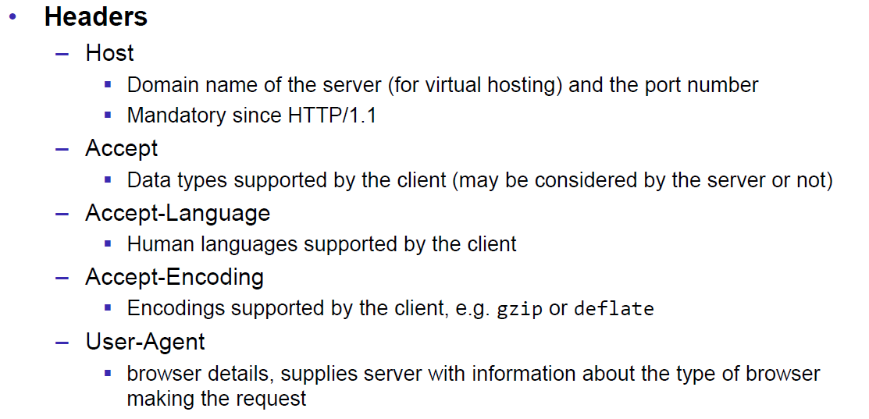

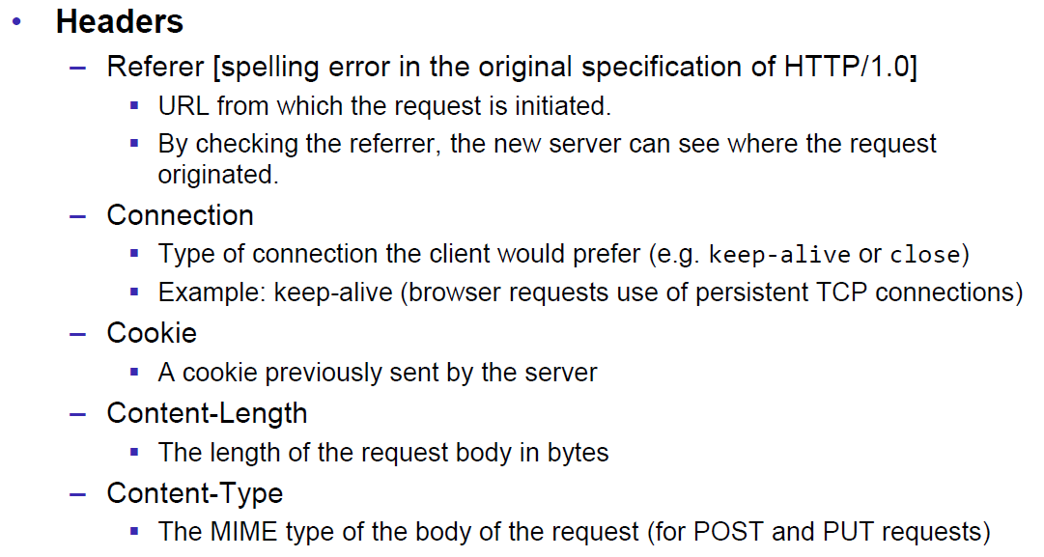

### HTTP Response Headers

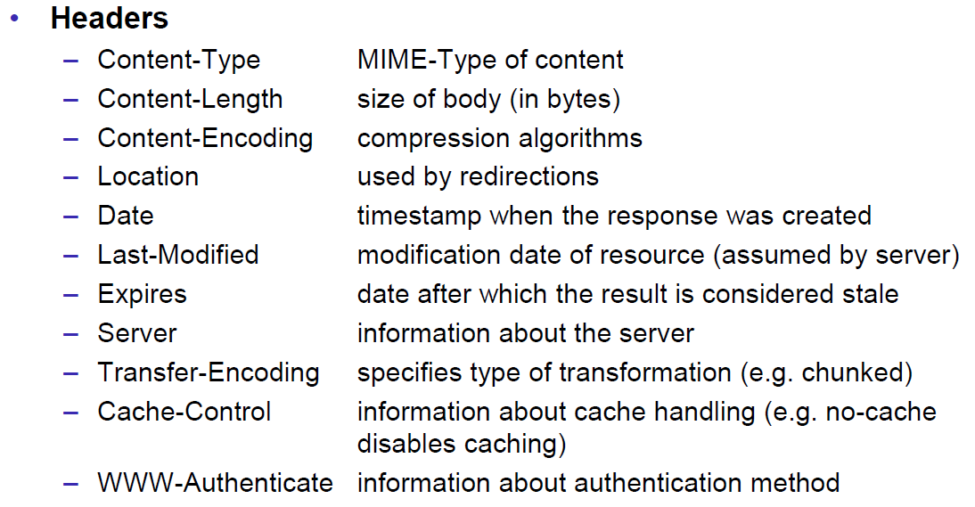

### MIME Types

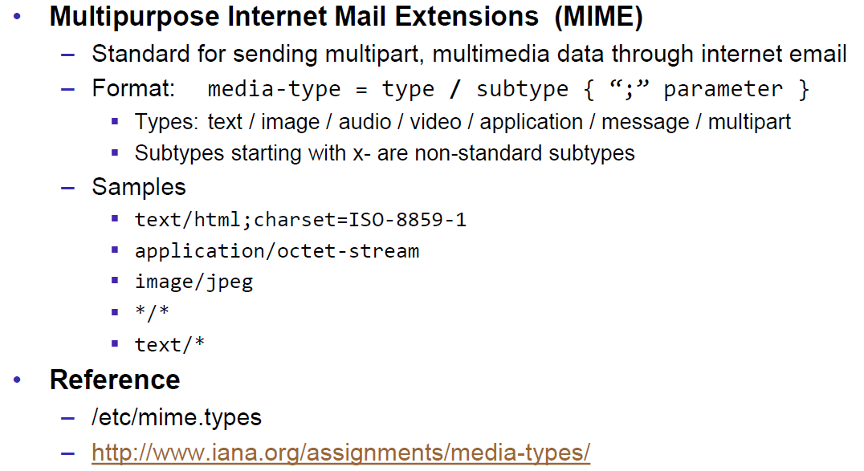

### HTTP Request/Response Sample

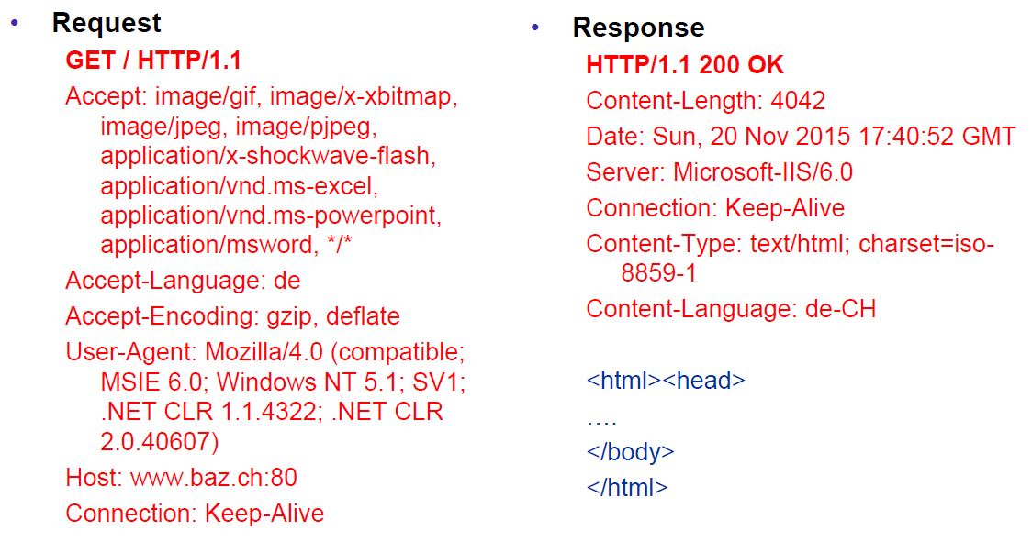

### HTTP 1.1 Enhancements

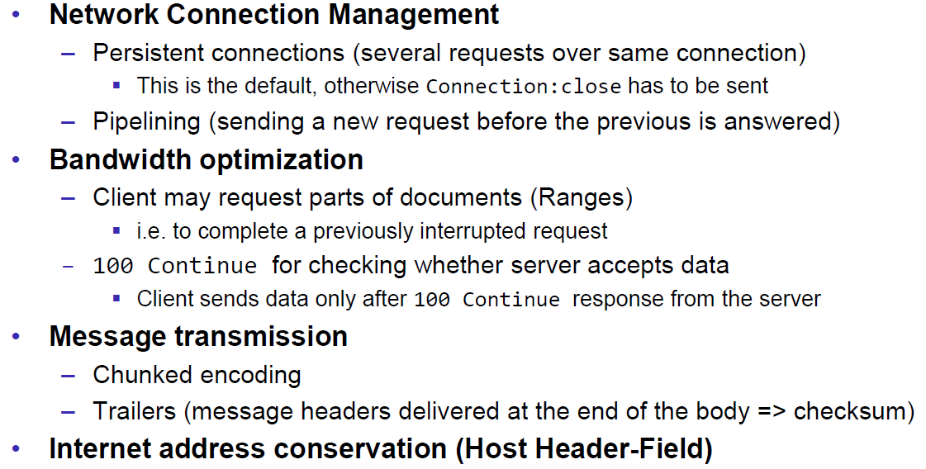

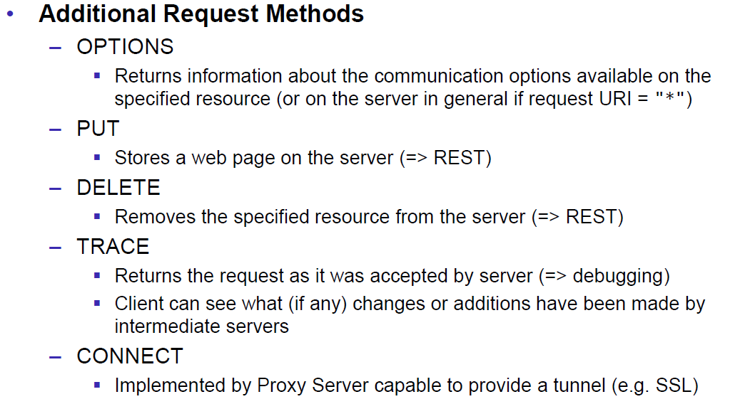

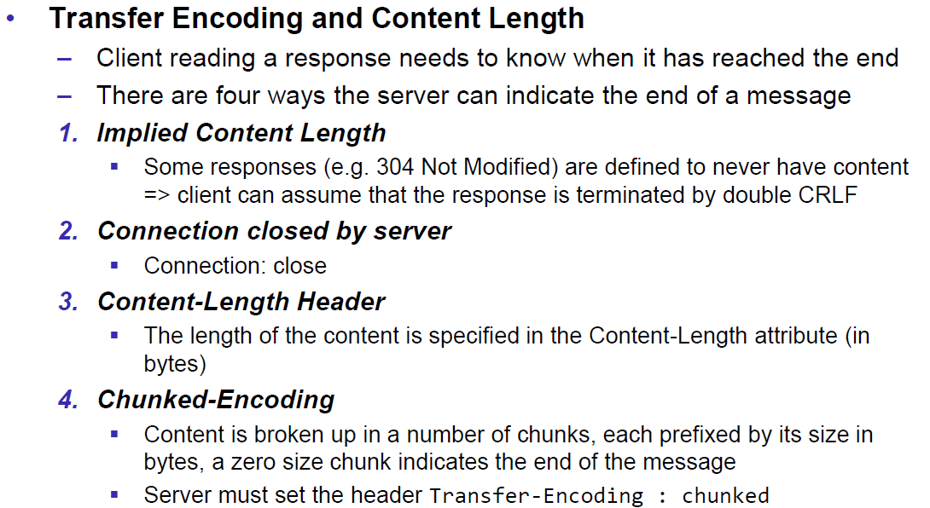

## HTTP Web Server

### A simple Web Server

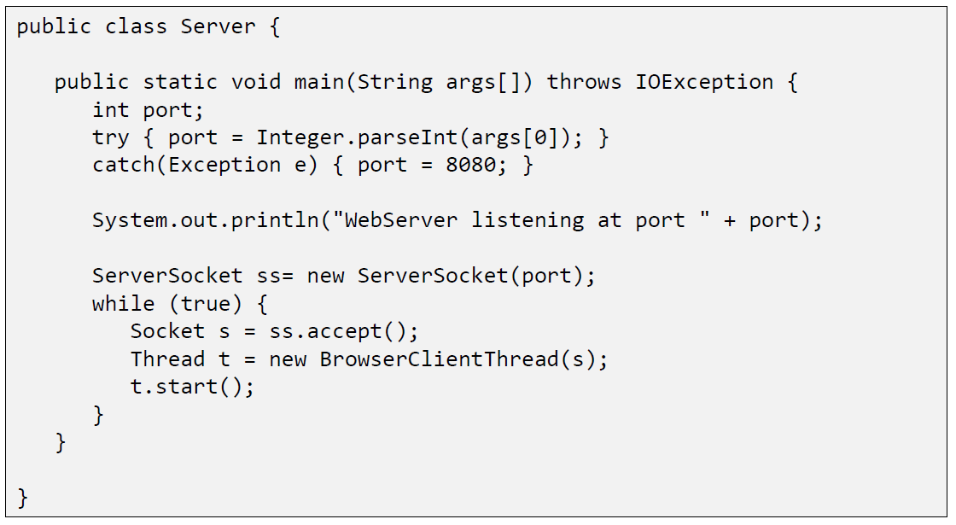

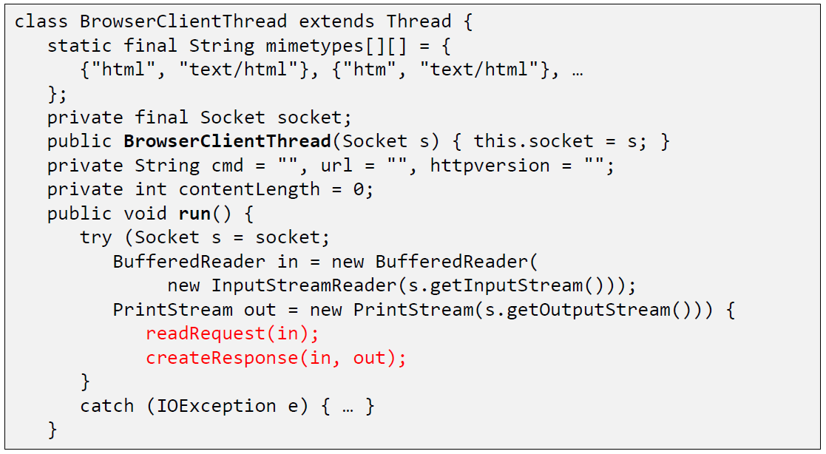

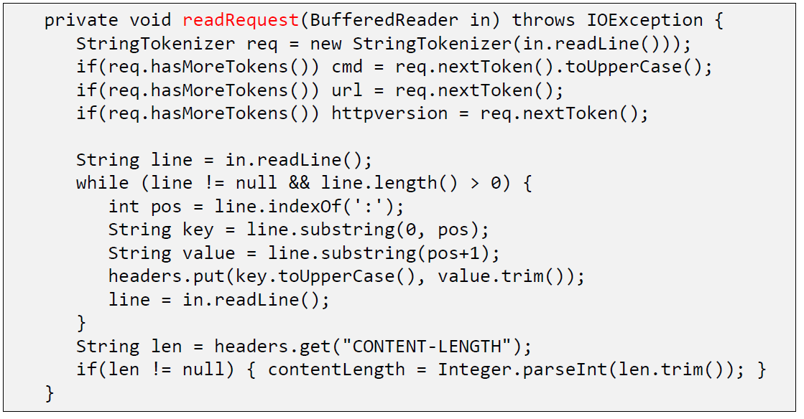

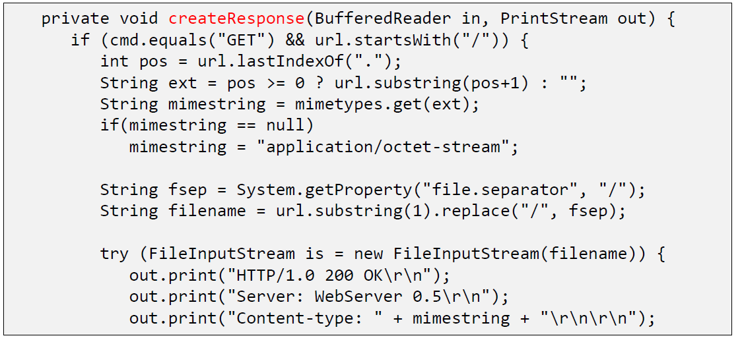

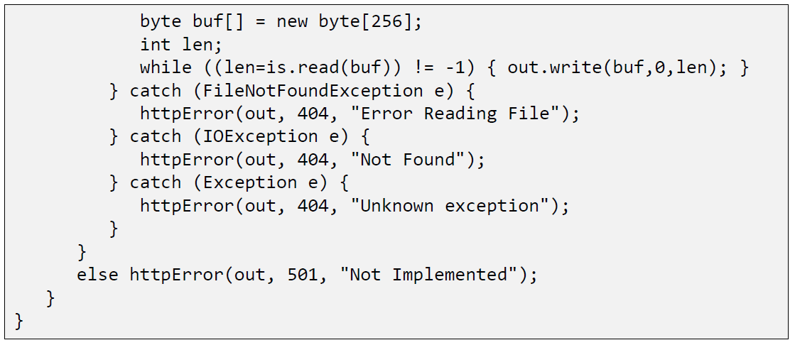

### Java internal Web Server

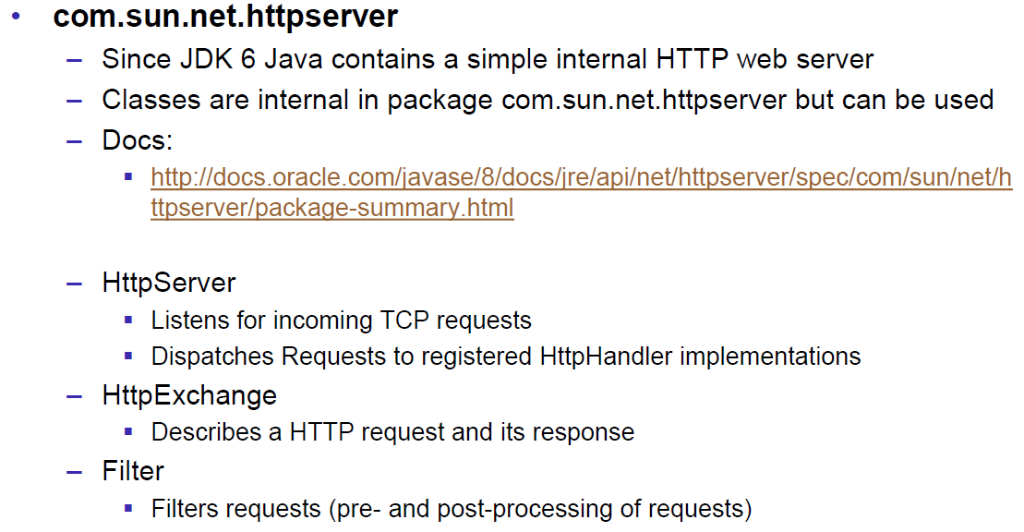

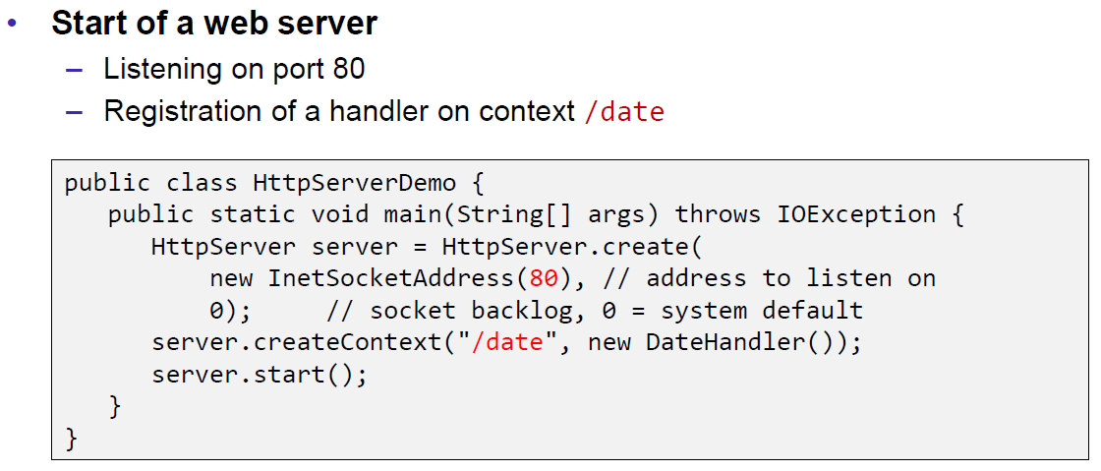

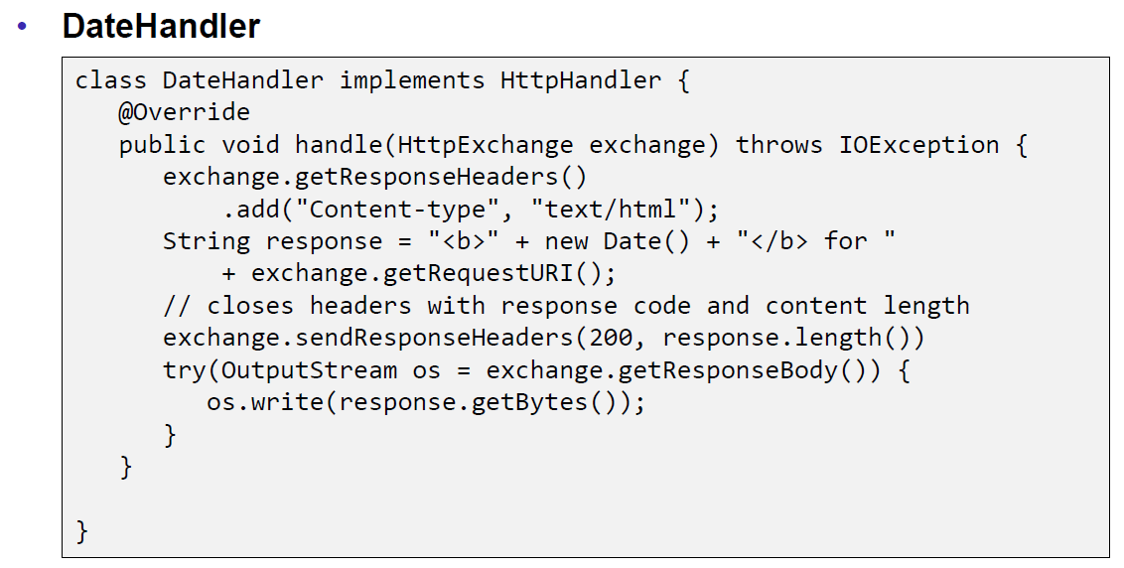

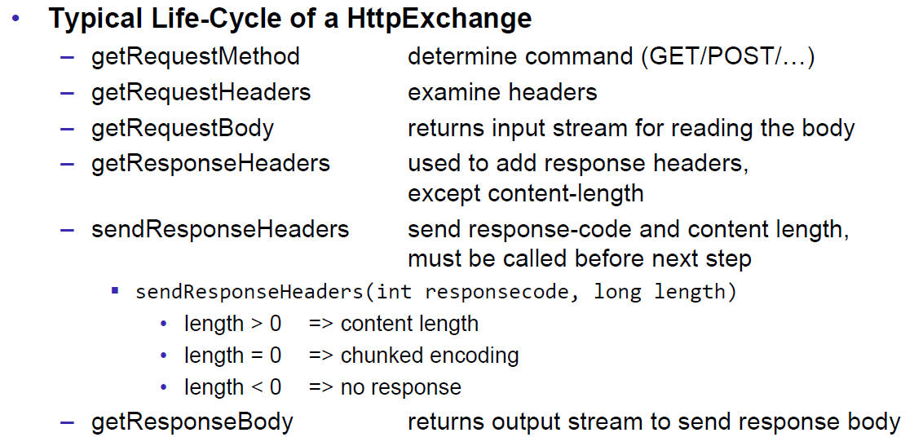

## HTML Forms & URL Encoding

### HTML GET Form

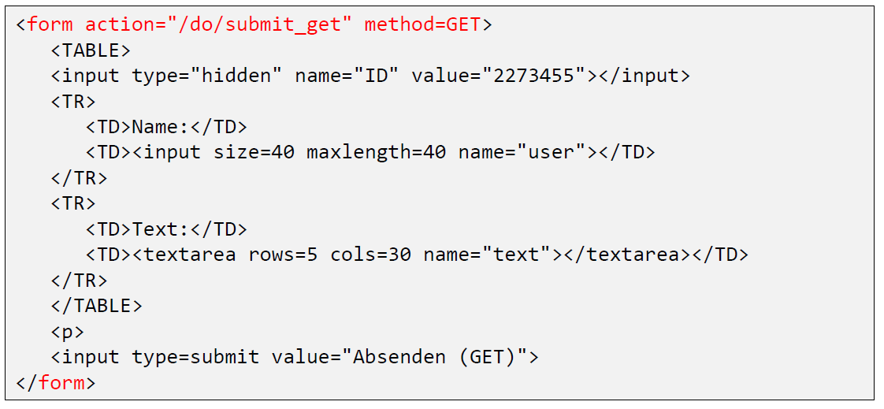

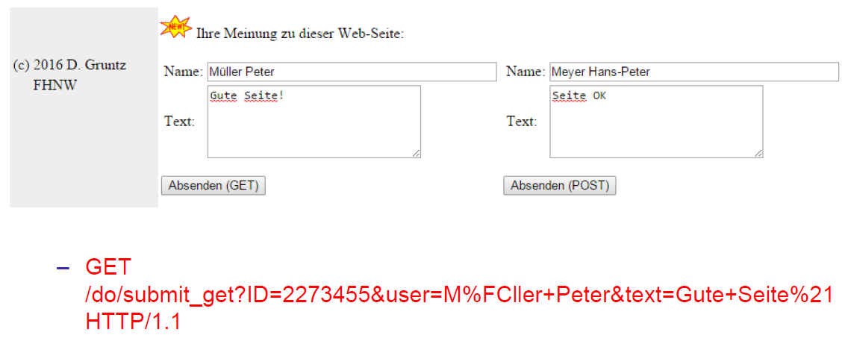

### URL Encoding

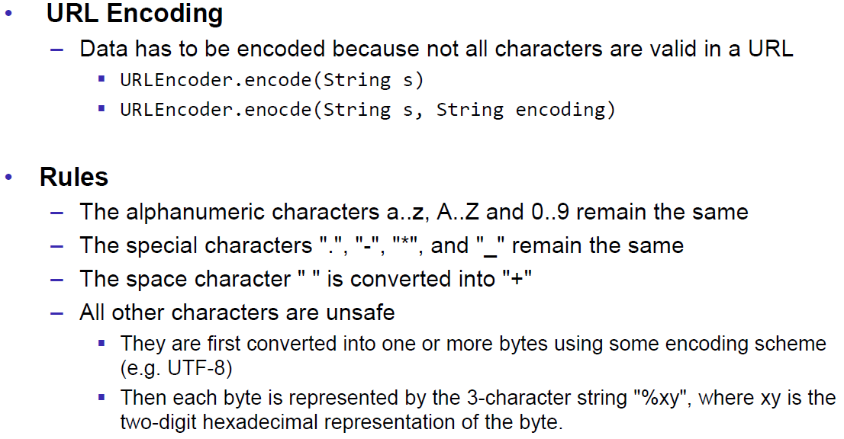

### HTML POST Form

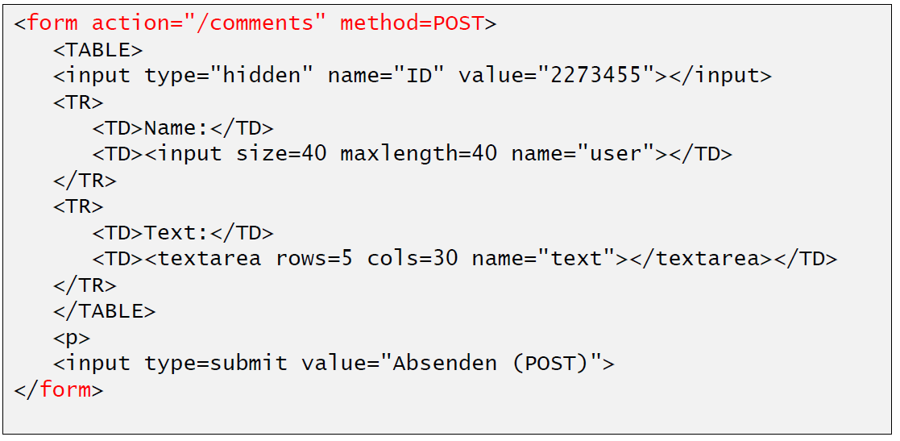

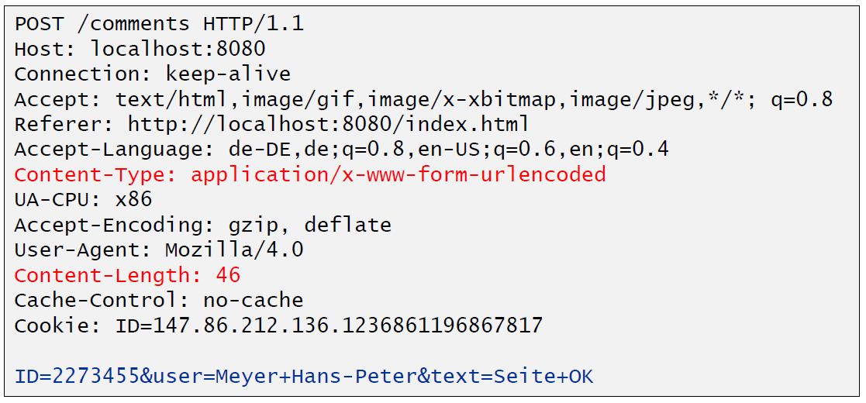

## HTTP Requests from Java

### URL

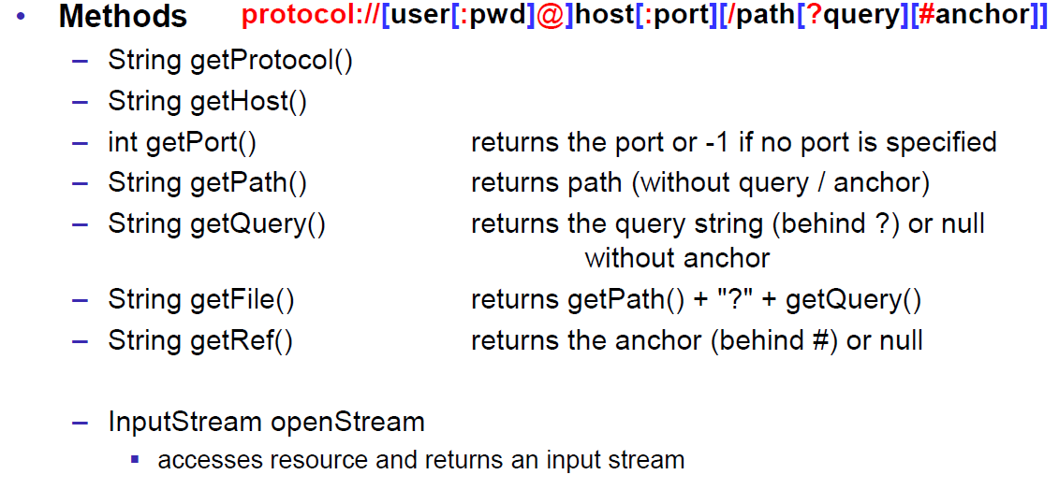

### Sending GET Requests from within Java

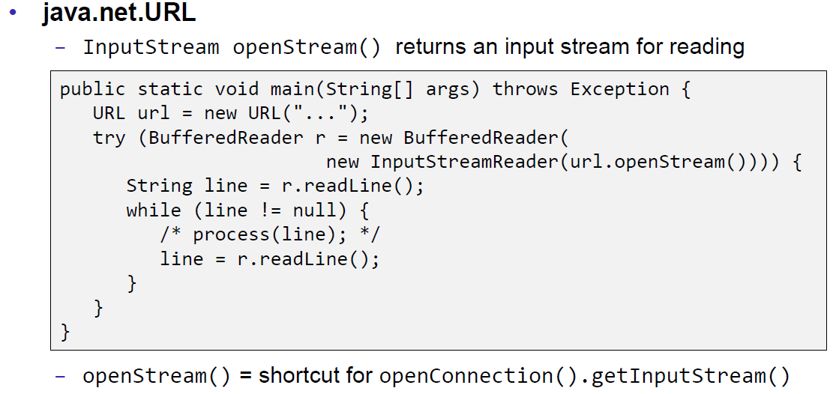

### URLConnection

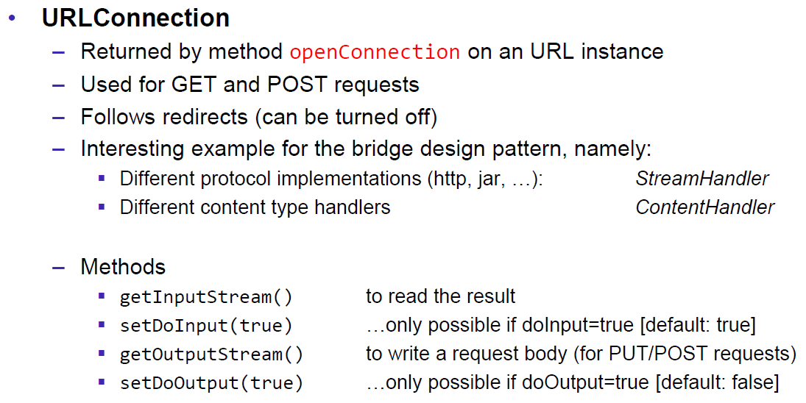

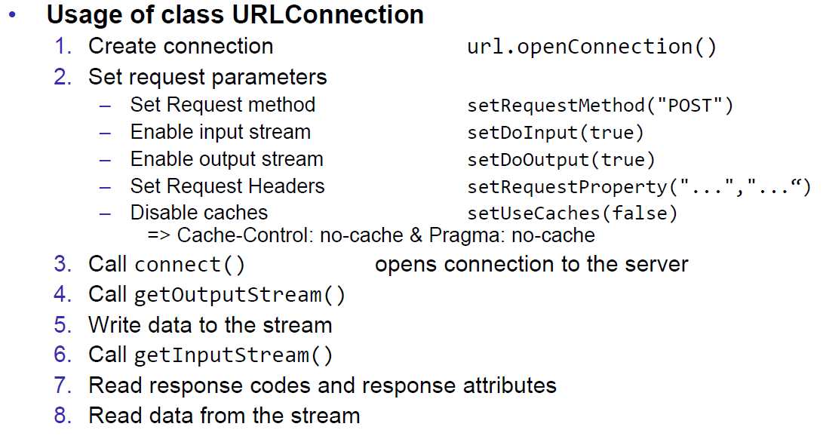

### URLConnection Tips & Tricks

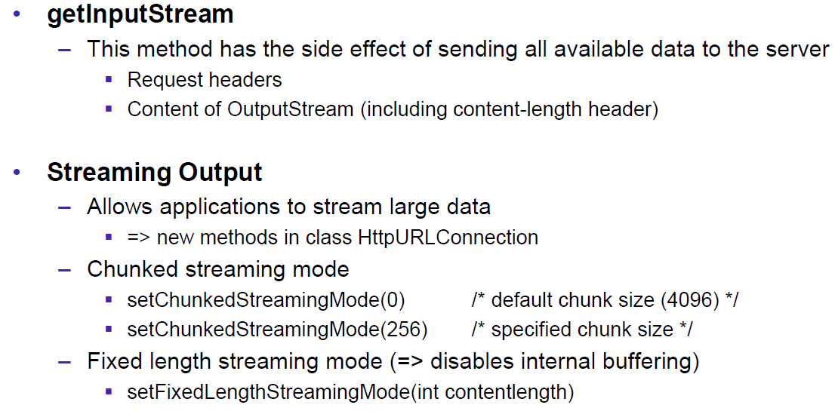

### Sample 1: URLConnection GET

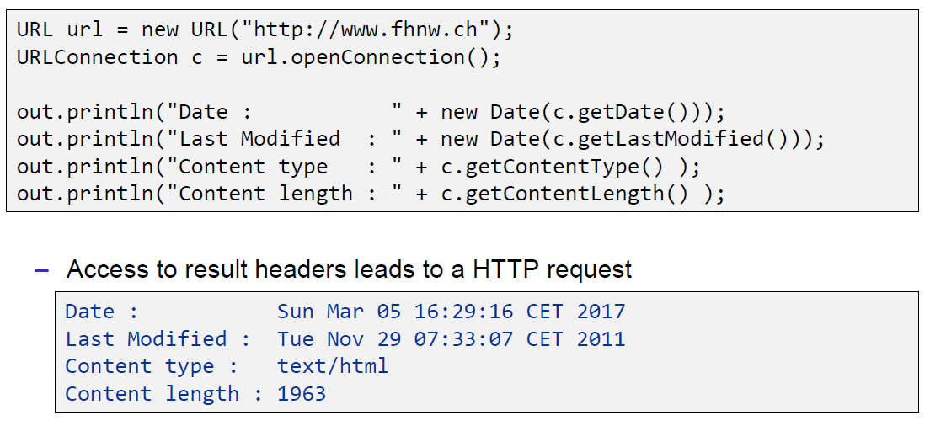

### Sample 2: URLConnection POST

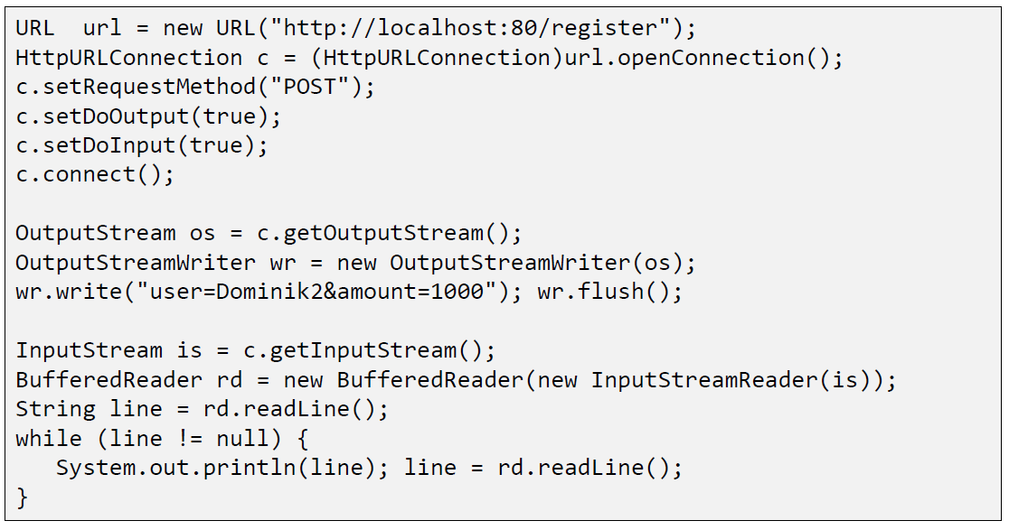

### Sample 3: Currency Converter

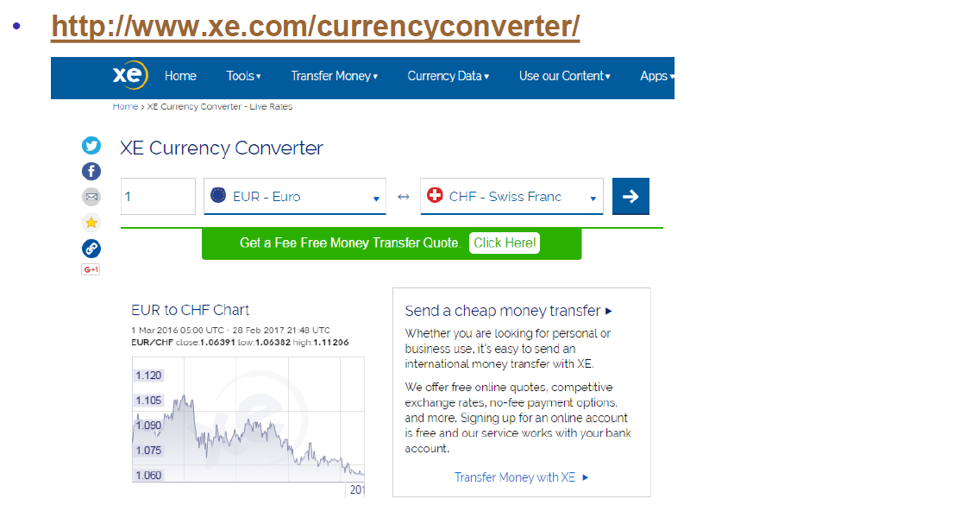

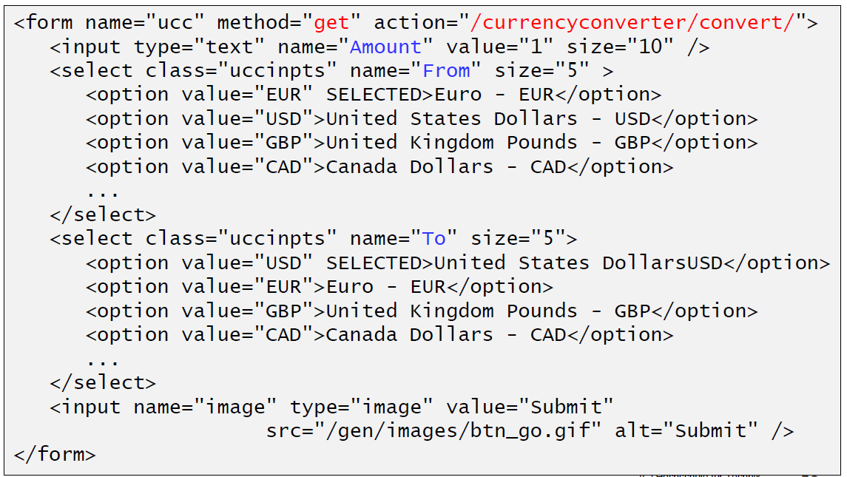

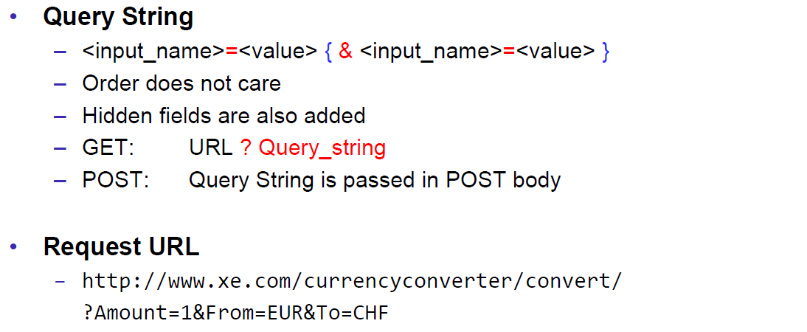

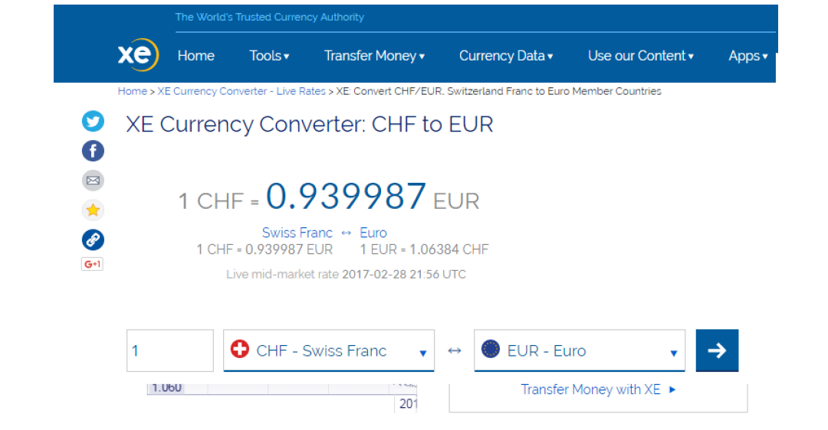

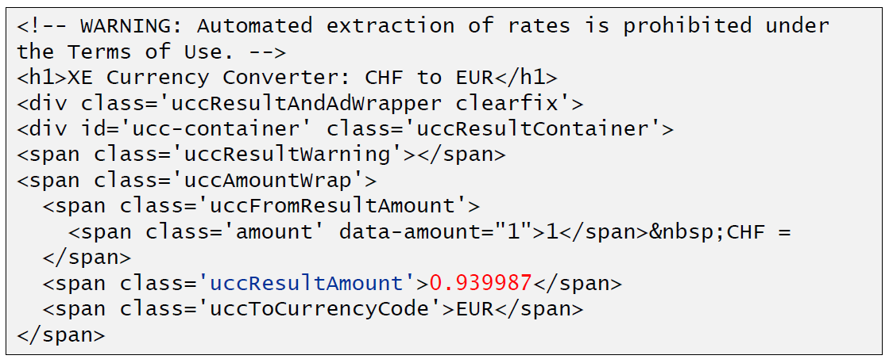

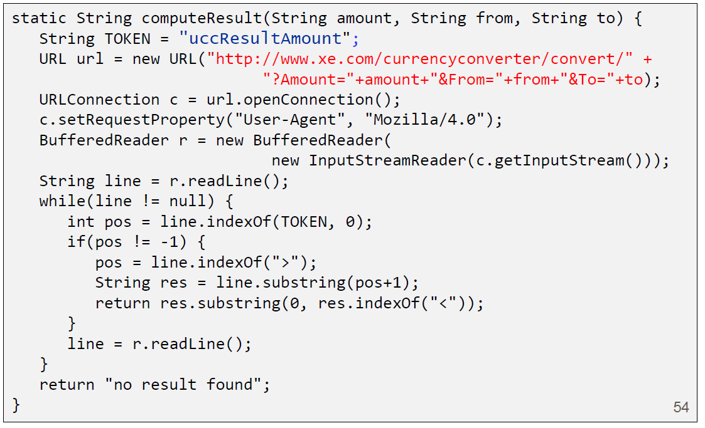

### Other Libraries

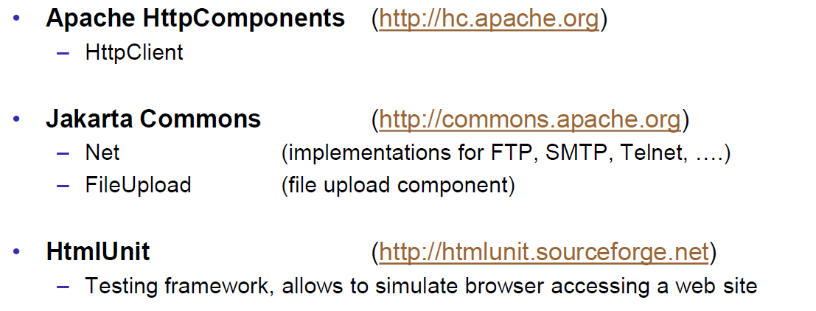

# Woche 4

## Servlets

### Dynamic Content

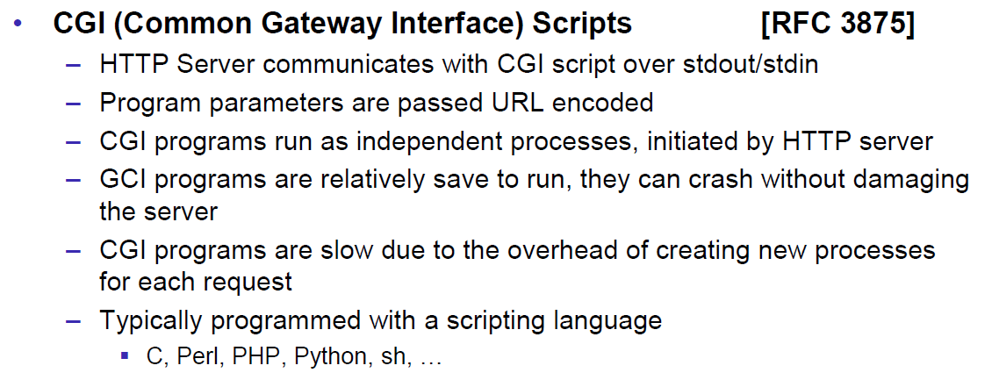

### Servlets

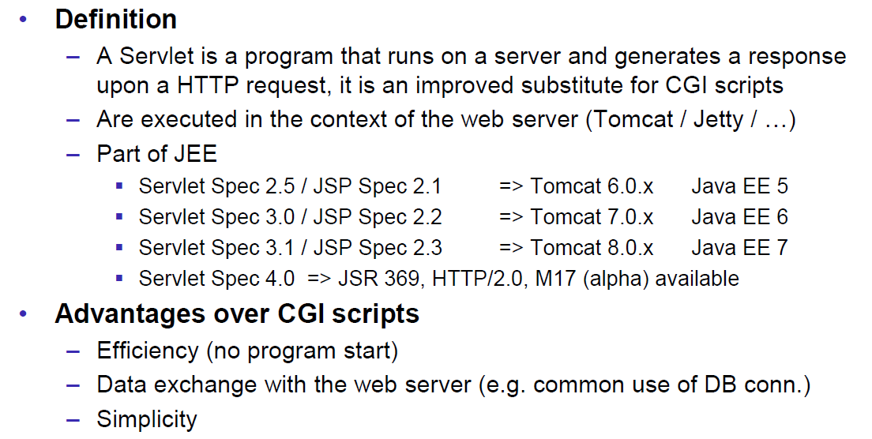

### Servlet Packages

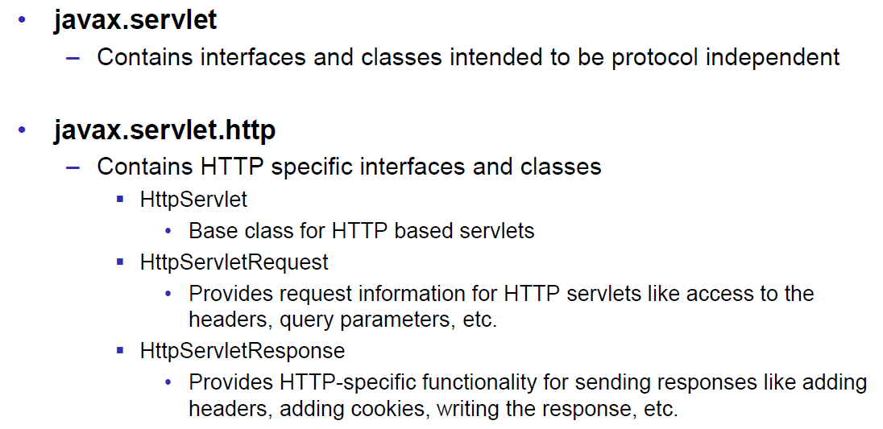

### Servlet Life-Cycle Methods

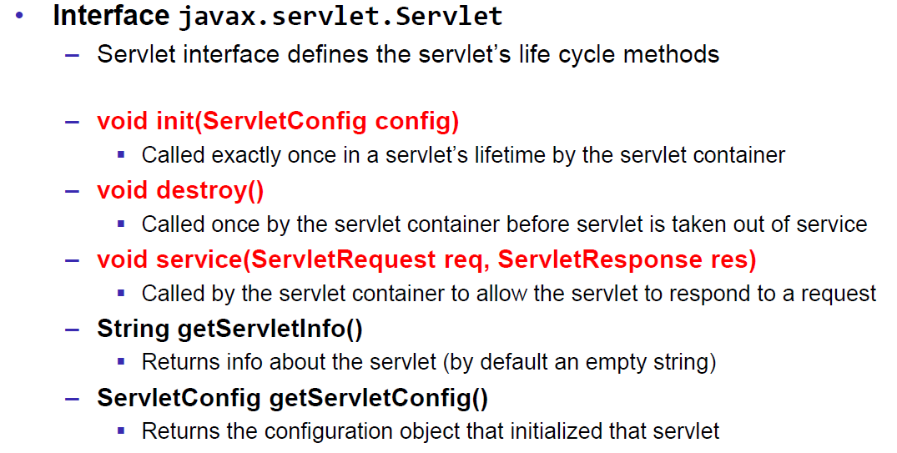

### HttpServlet

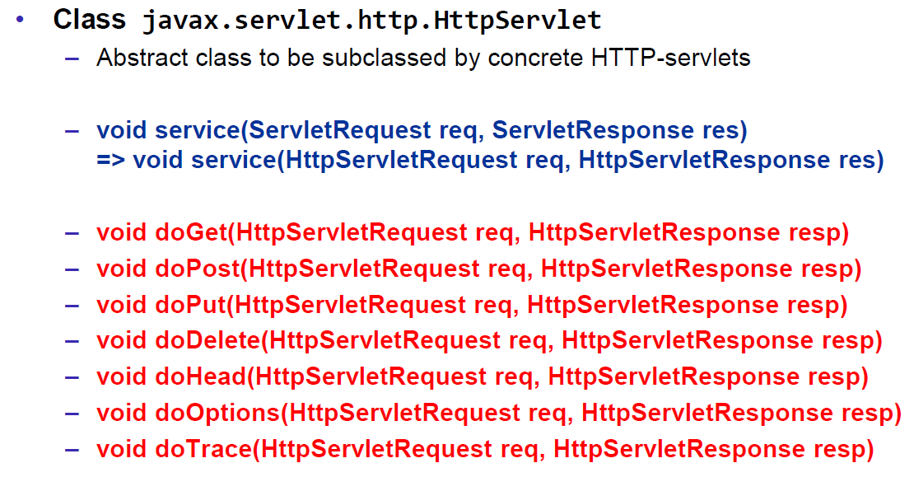

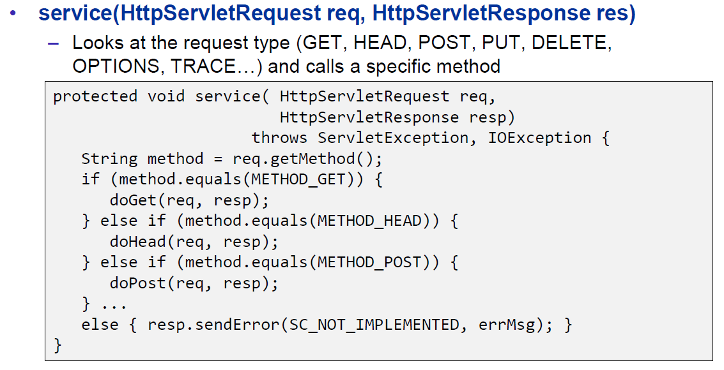

### HttpServletRequest

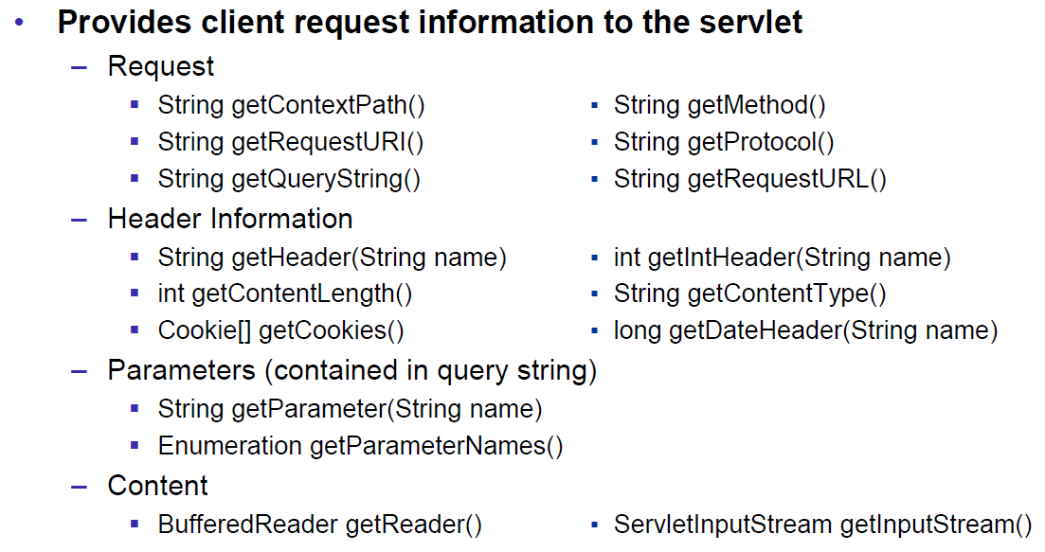

### HttpServletResponse

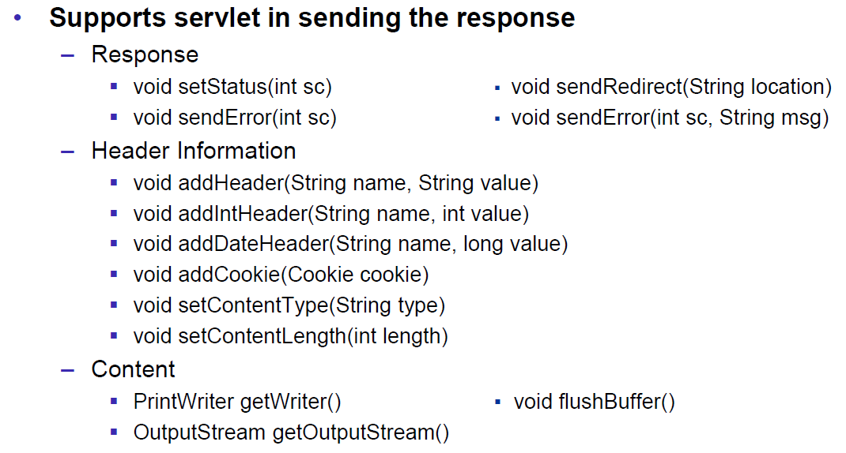

### Servlet Example

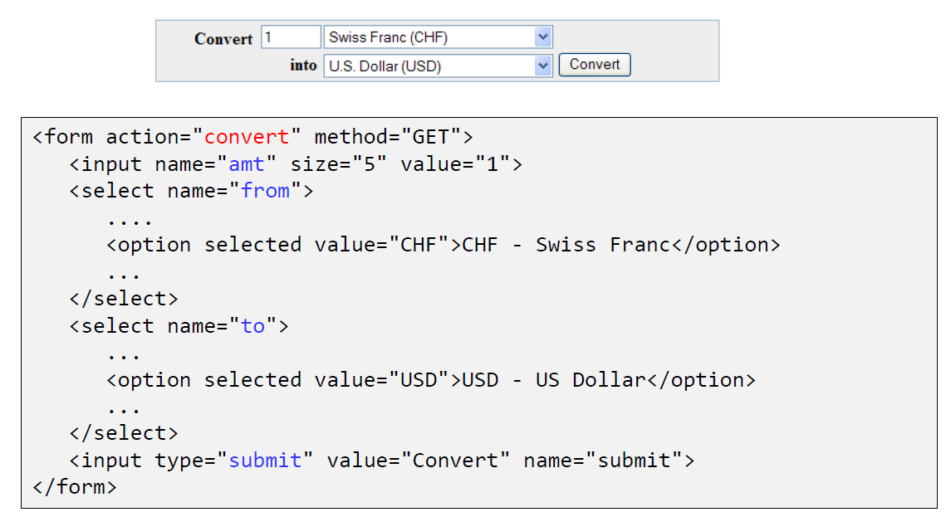

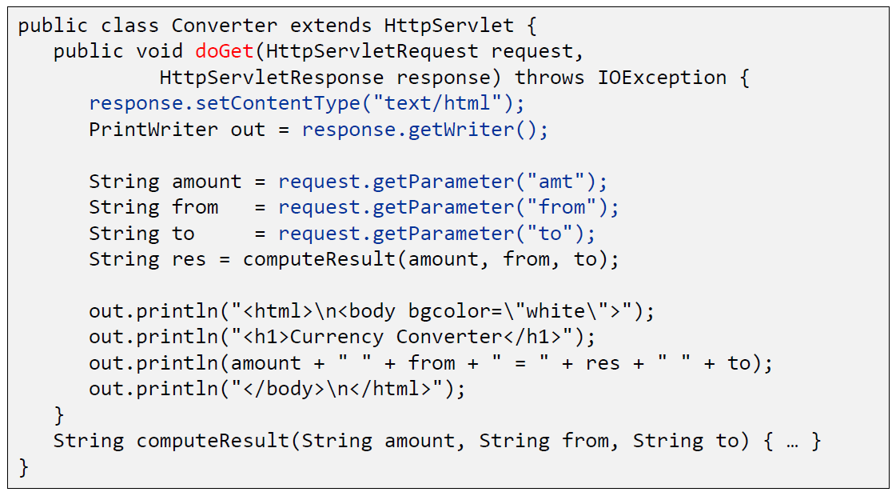

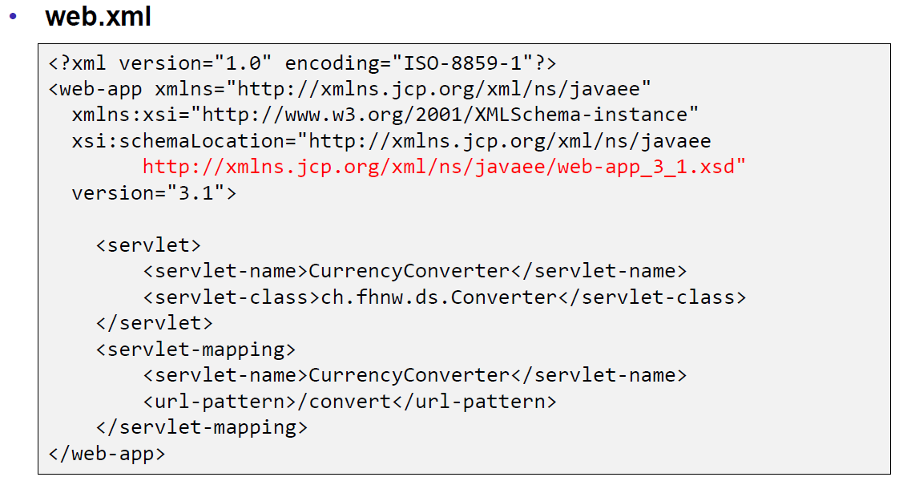

### Webapplication Structure

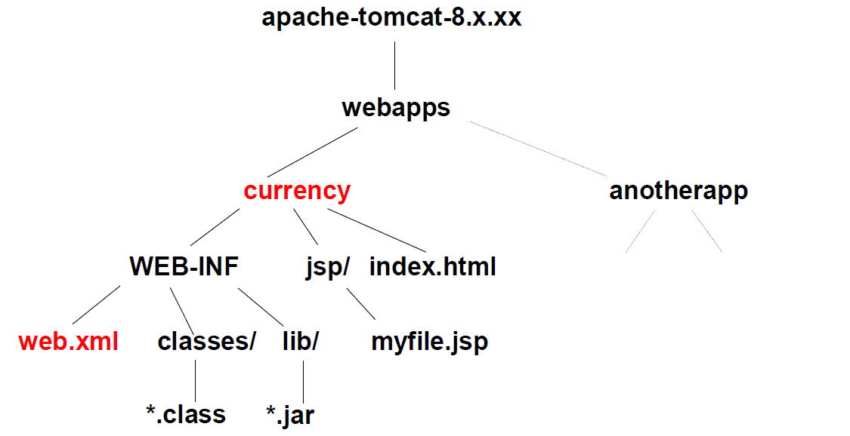

### Annotation WebServlet

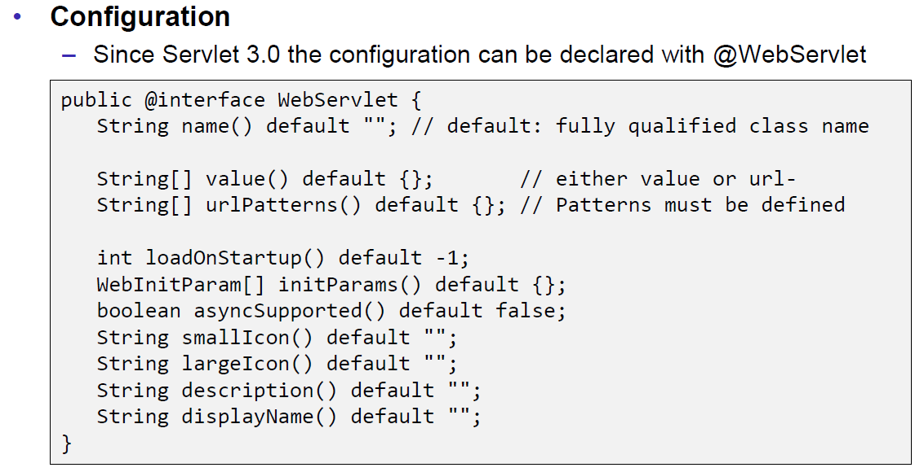

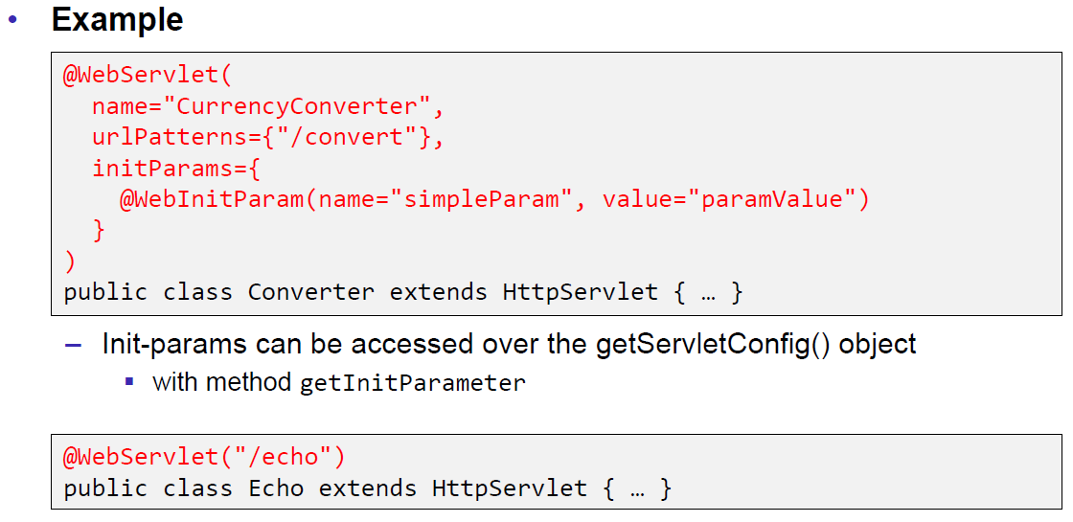

### Webapplication Structure

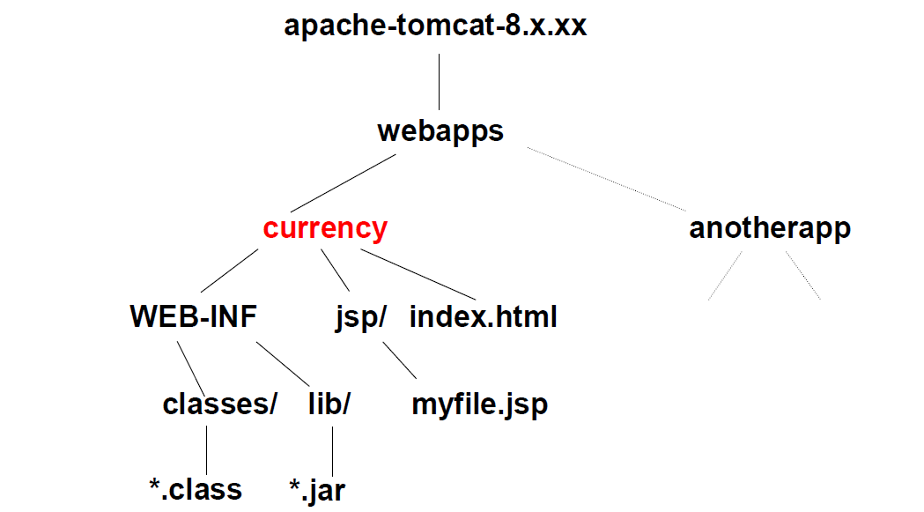

## Tomcat Servlet Server

### Tomcat

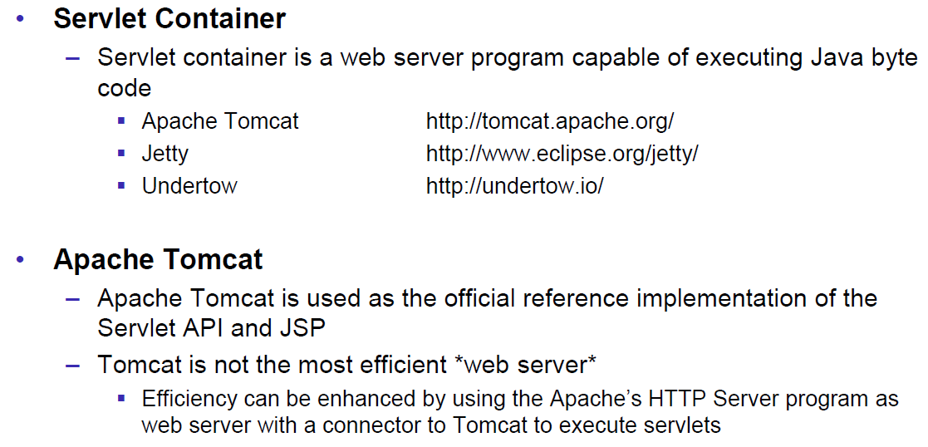

### Tomcat Directory Structure

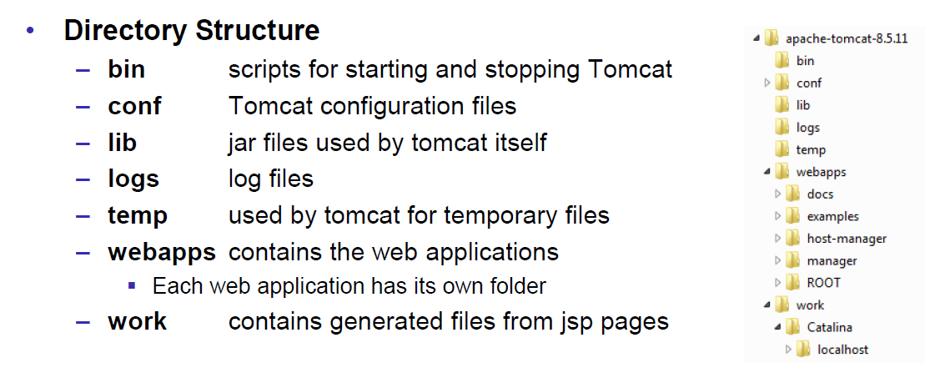

### Tomcat Scripts

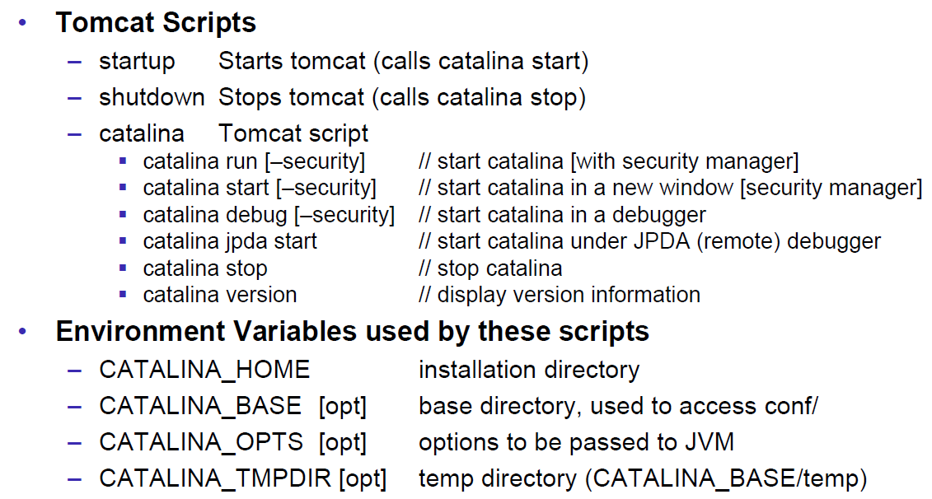

### Tomcat Startup Screen

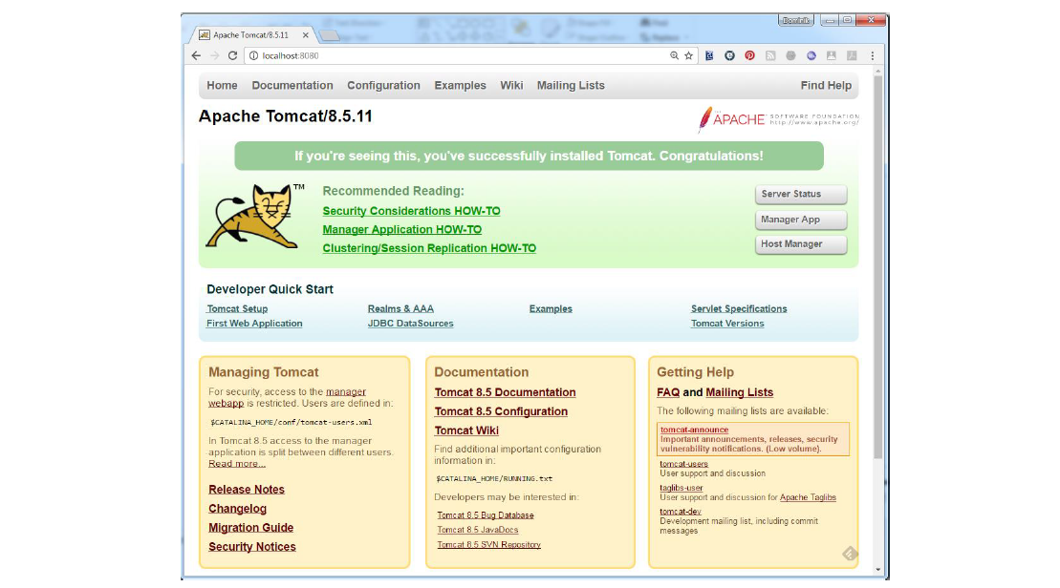

### Tomcat Managers

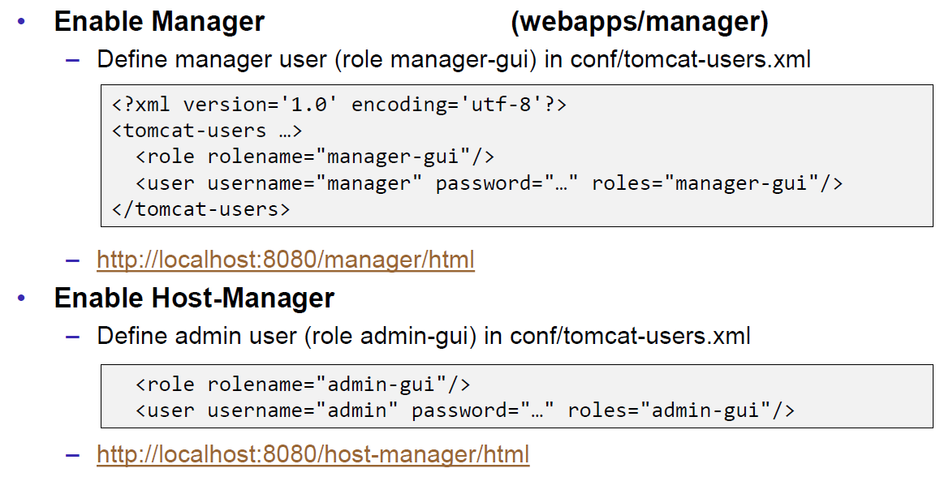

### Debugging

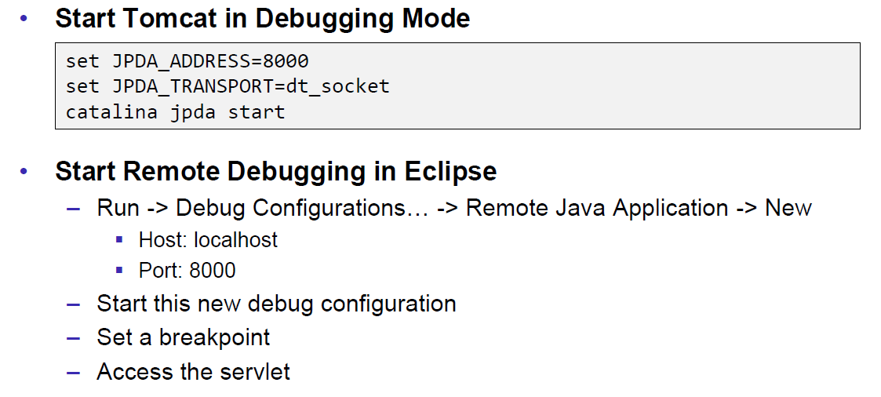

### Tomcat Architecture

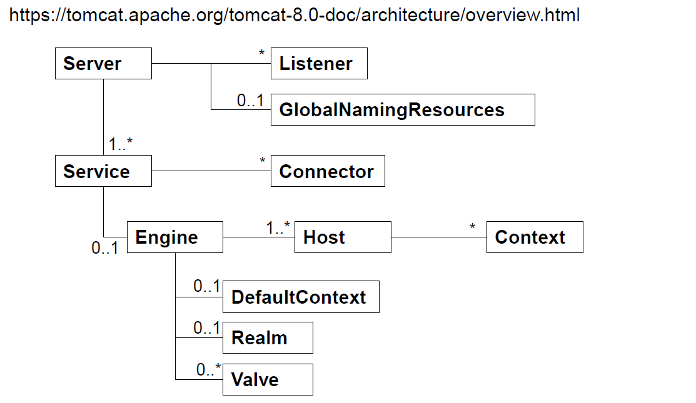

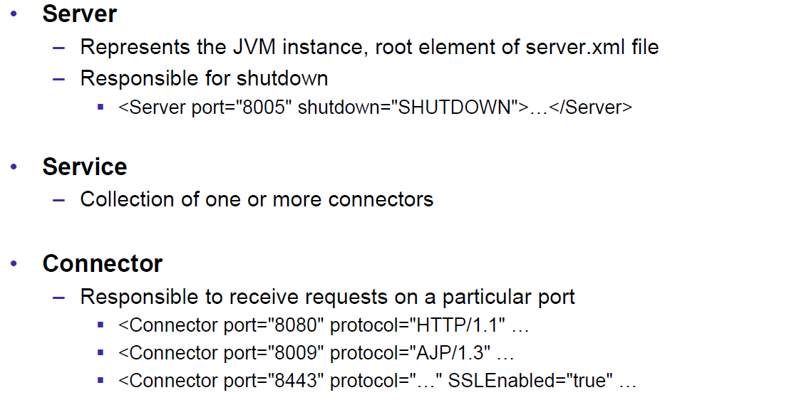

### Configuration of a Host

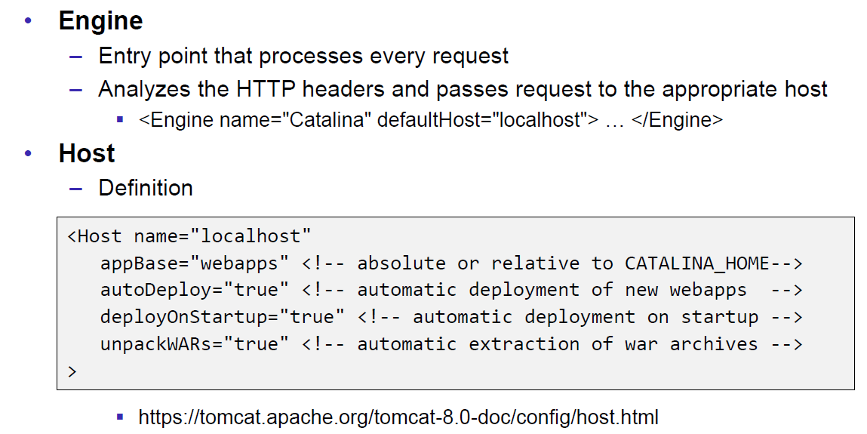

### Configuration of a Context

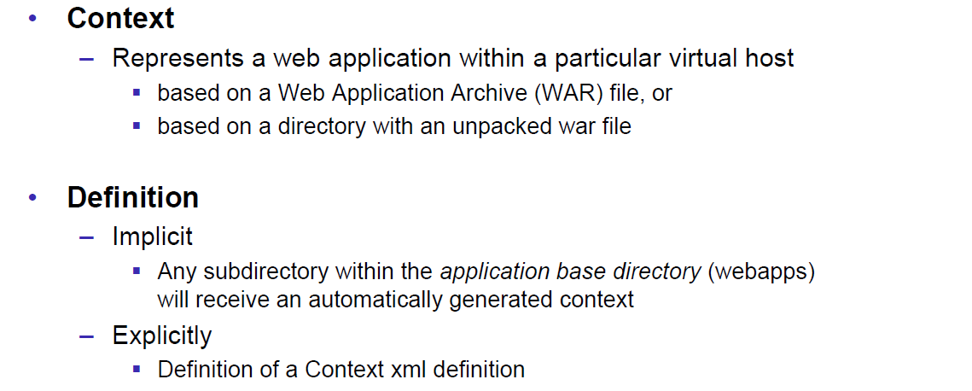

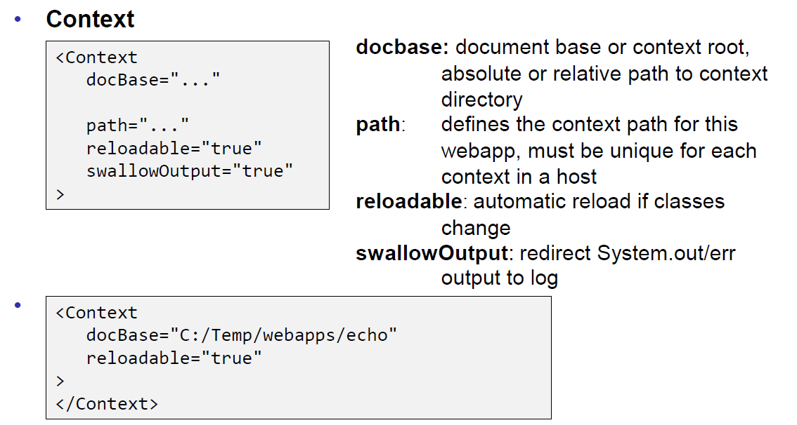

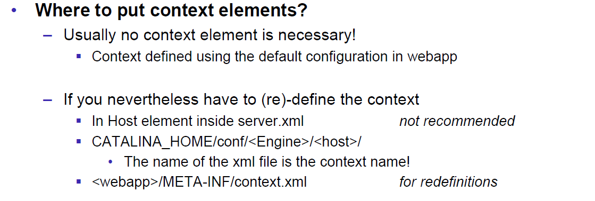

### Deployment while development

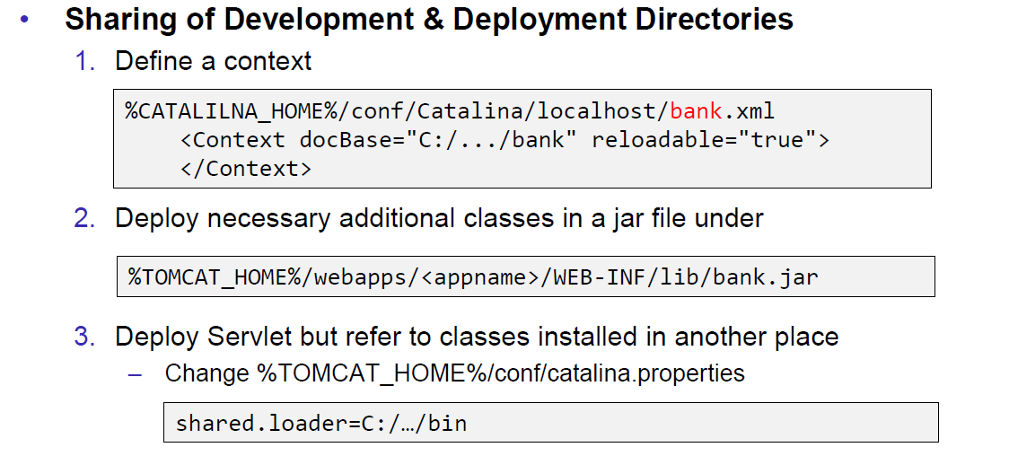

### Eclipse and Servlets (JEE Eclipse Version)

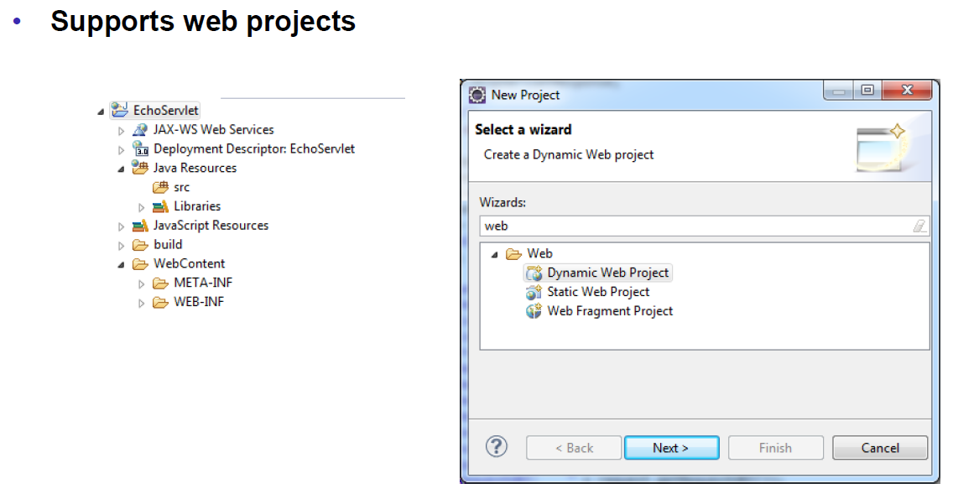

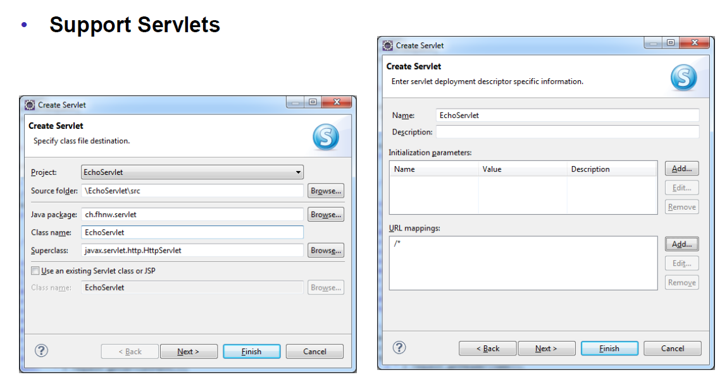

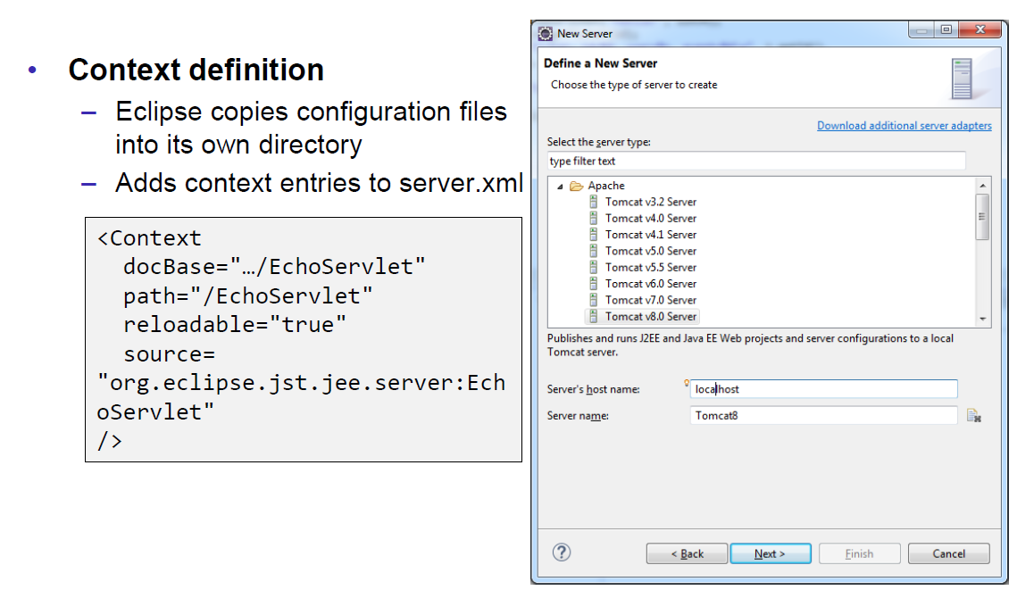

# Woche 5

## Motivation XML-RPX

### Services over HTTP (Currency Converter)

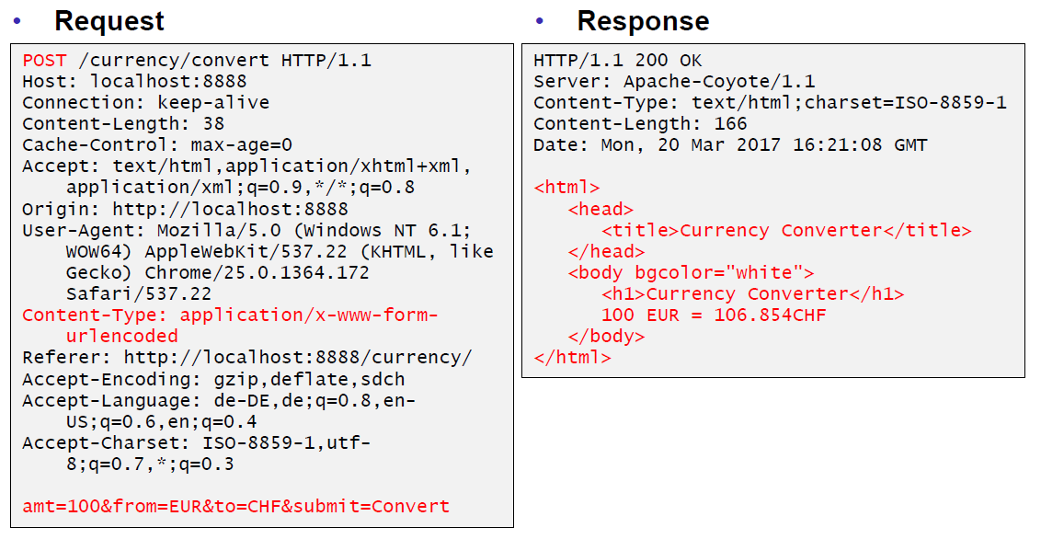

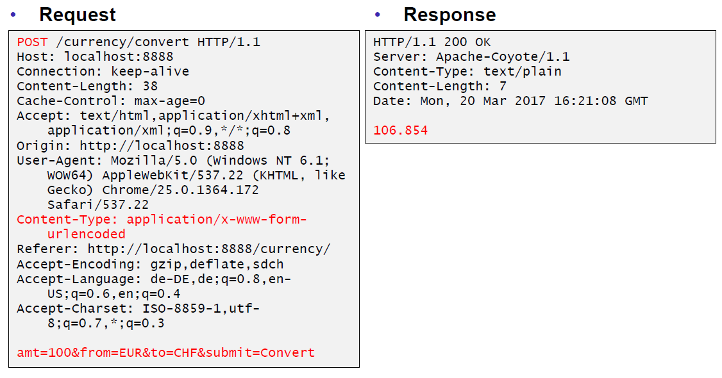

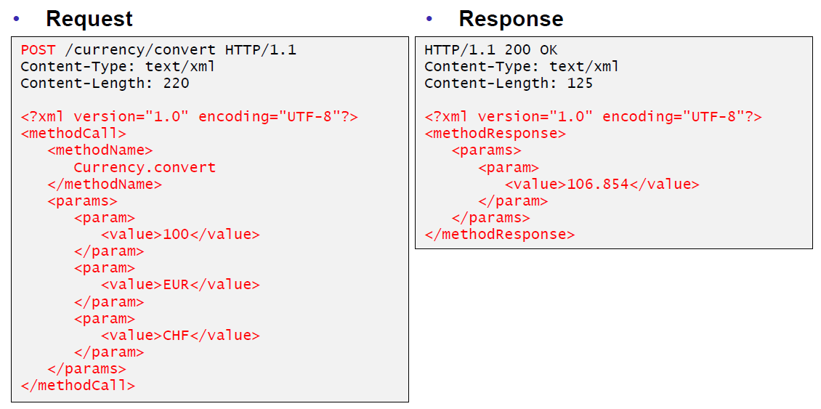

### XML-Remote Procedure Calls

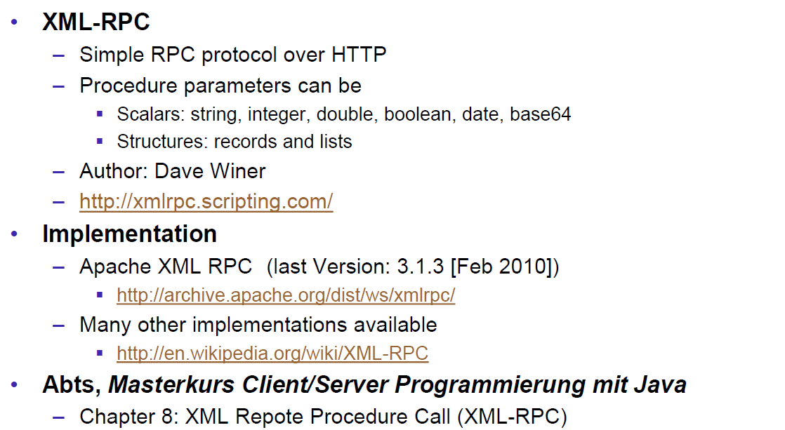

## SOAP und JAX-WS

### SOAP

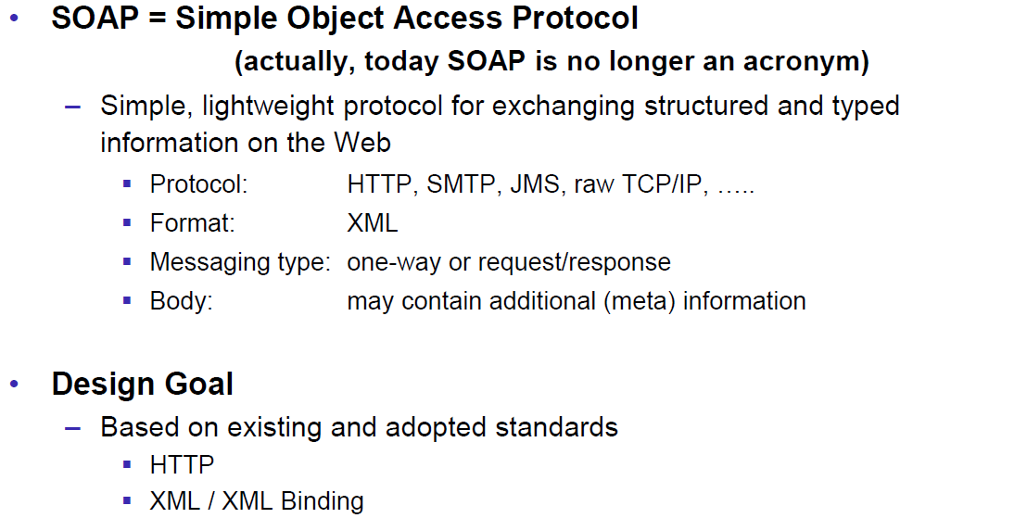

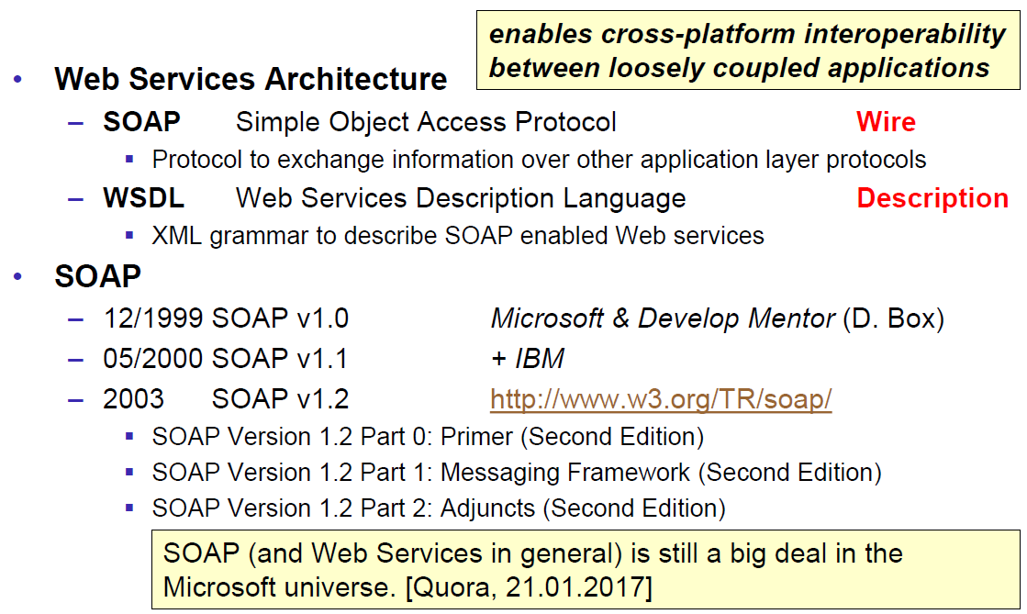

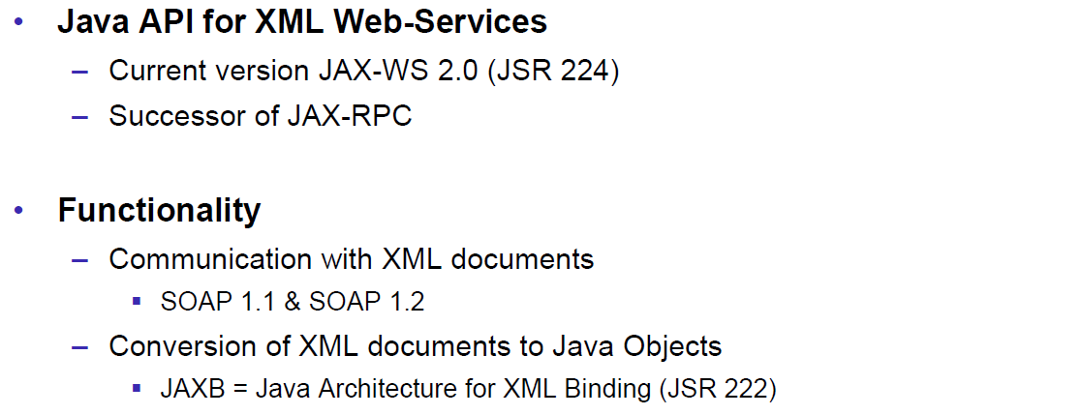

### JAX-WS

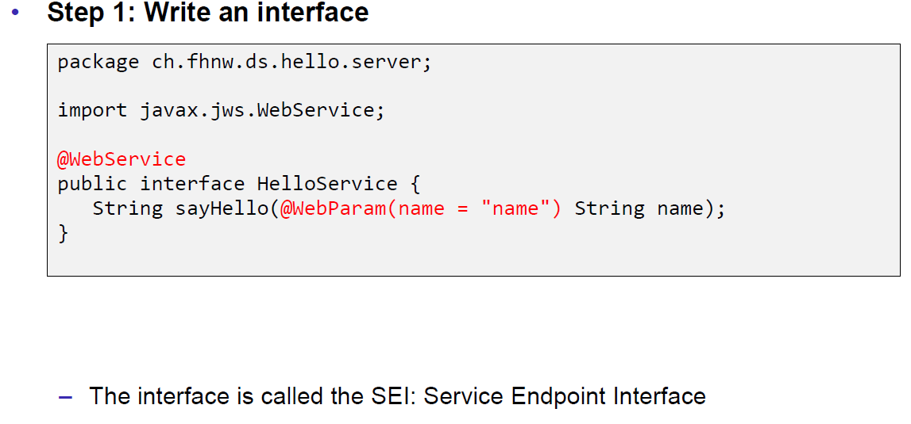

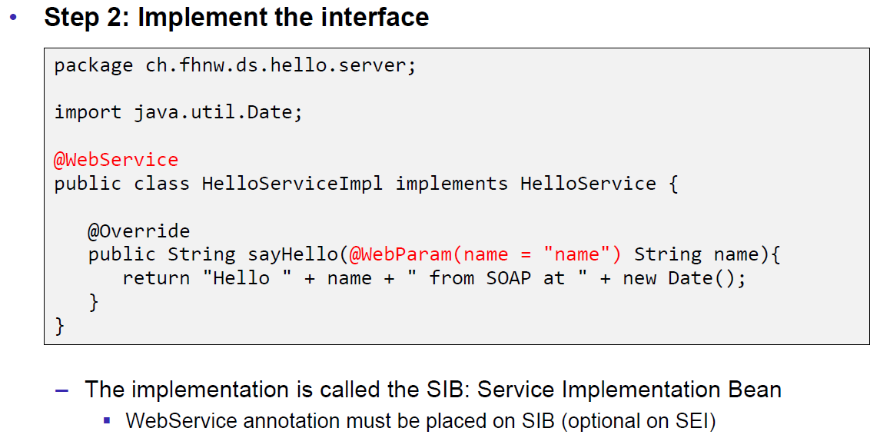

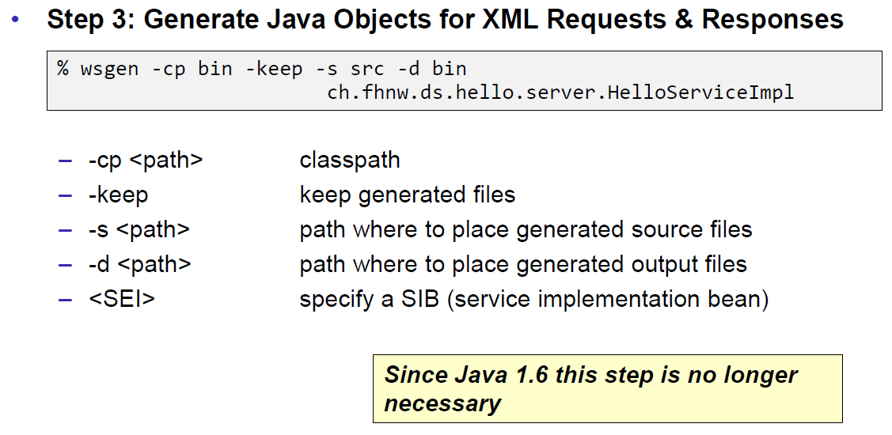

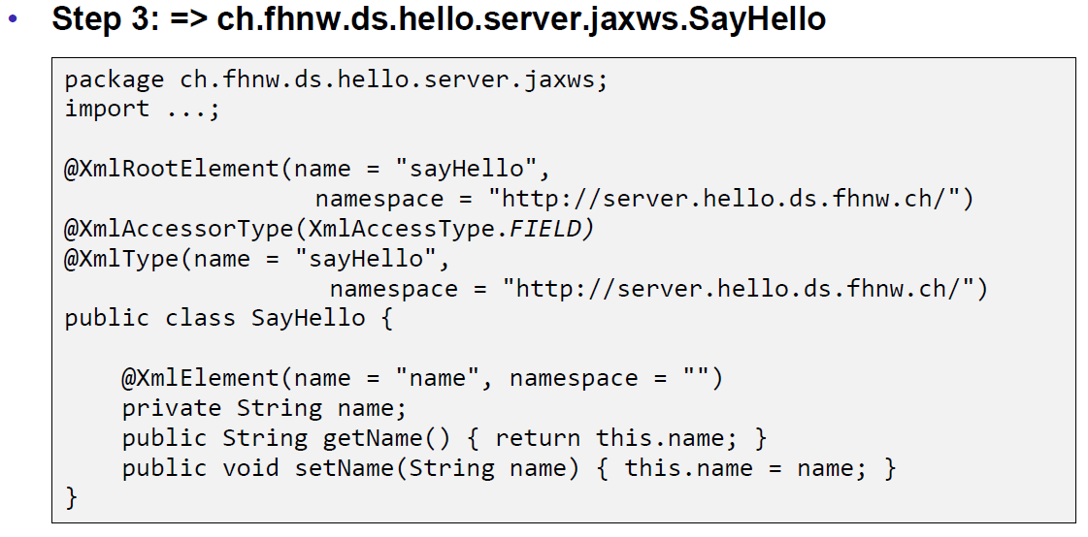

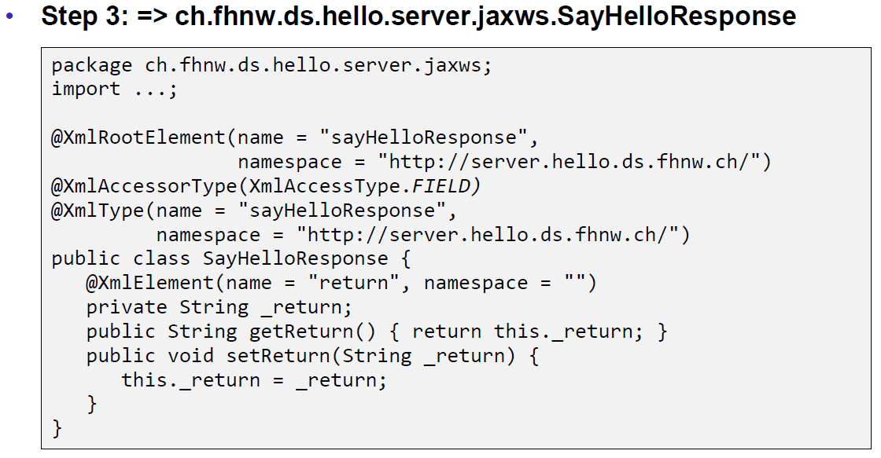

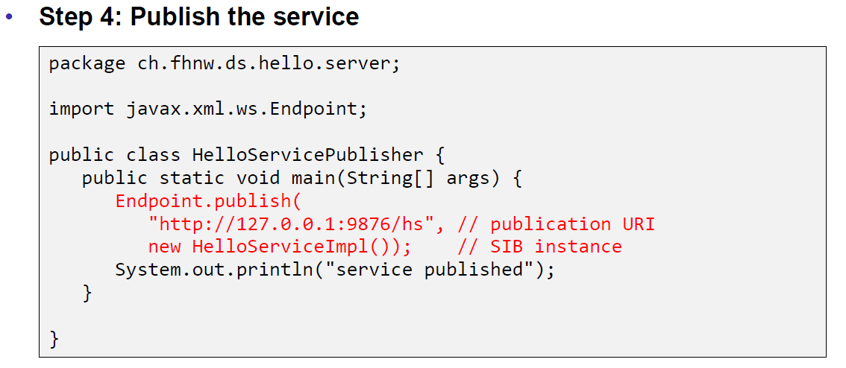

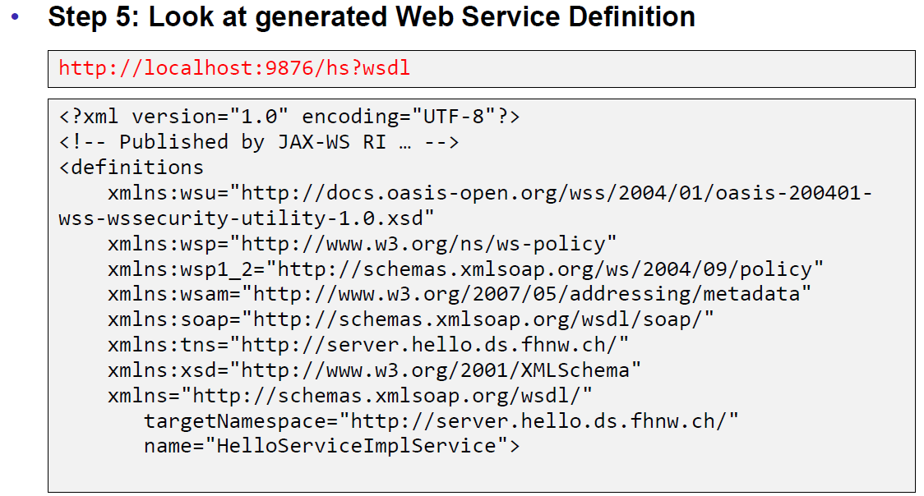

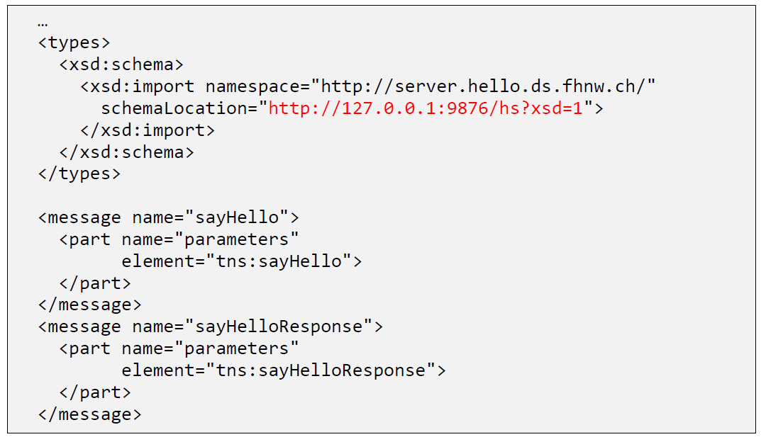

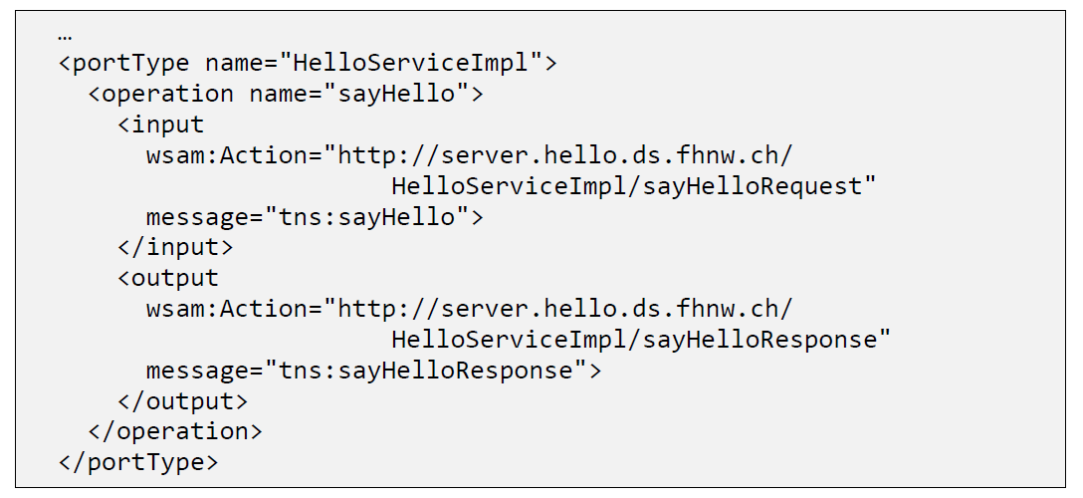

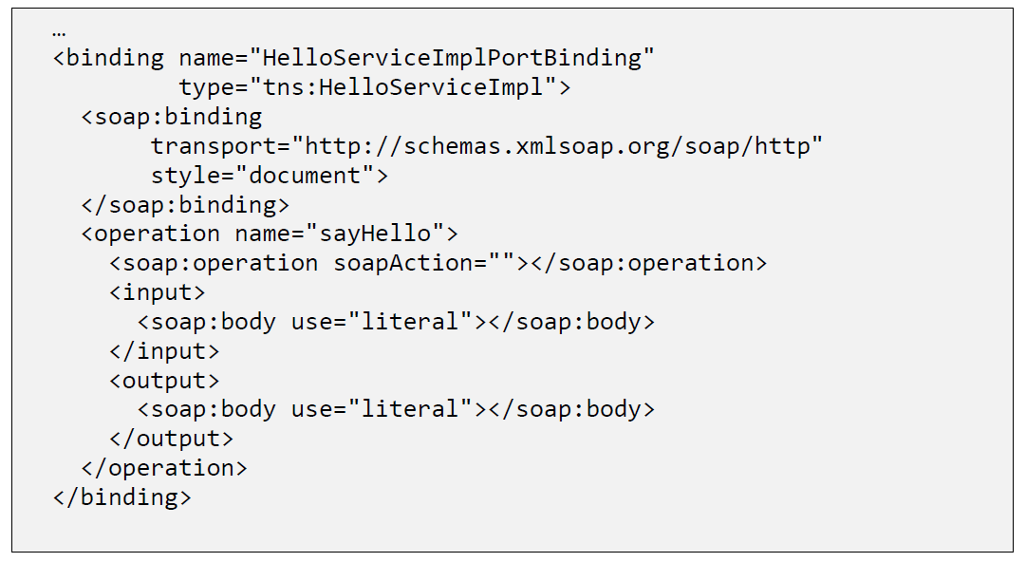

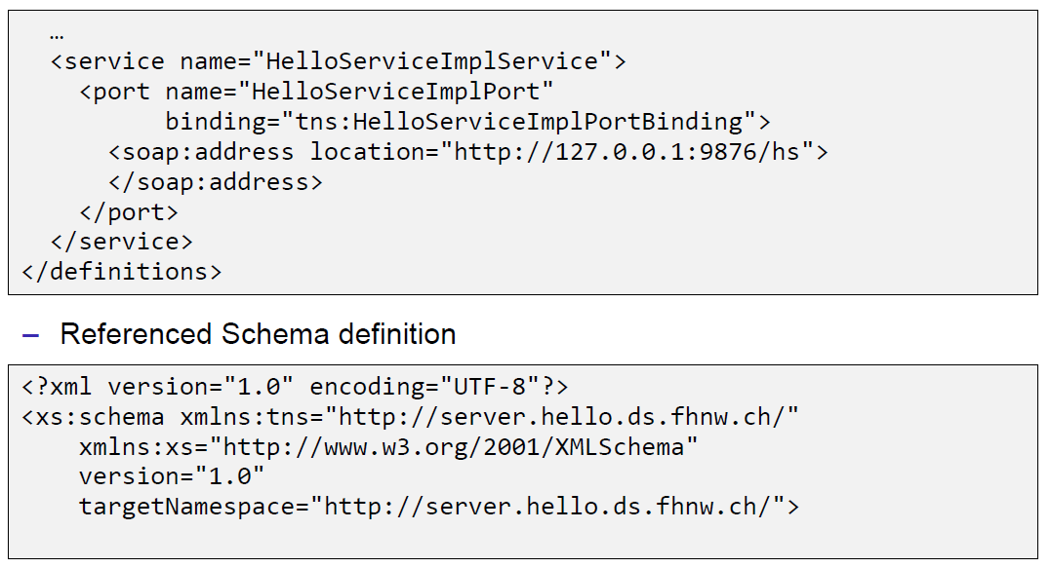

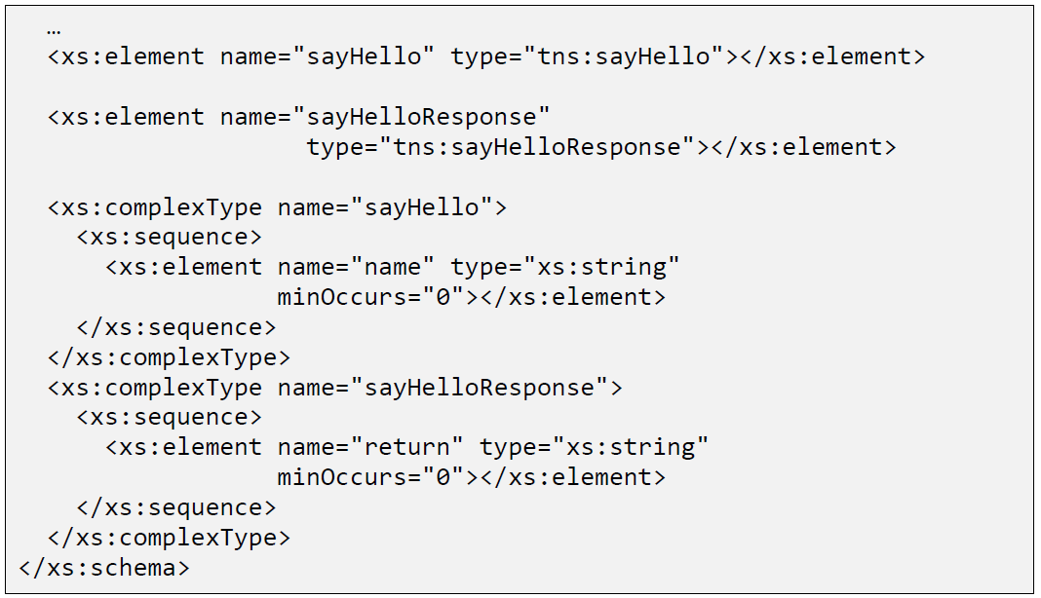

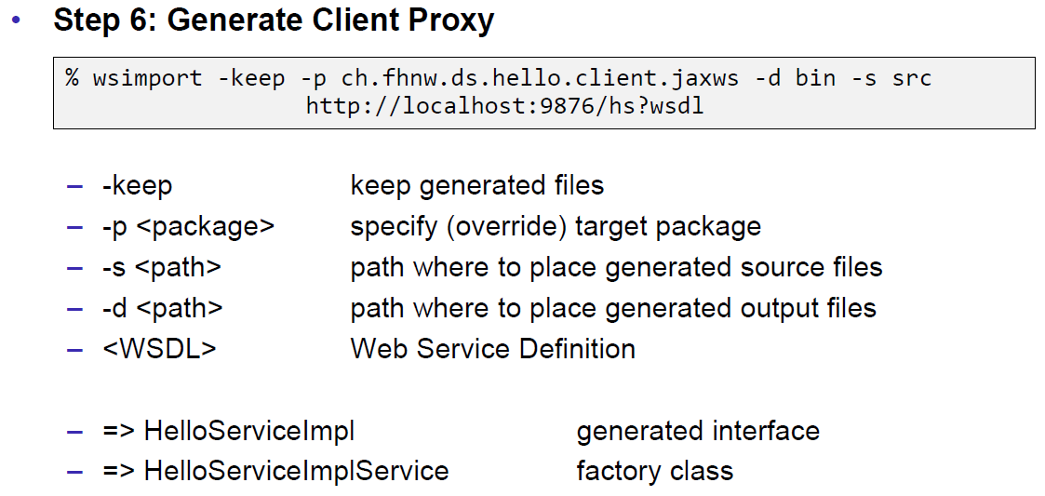

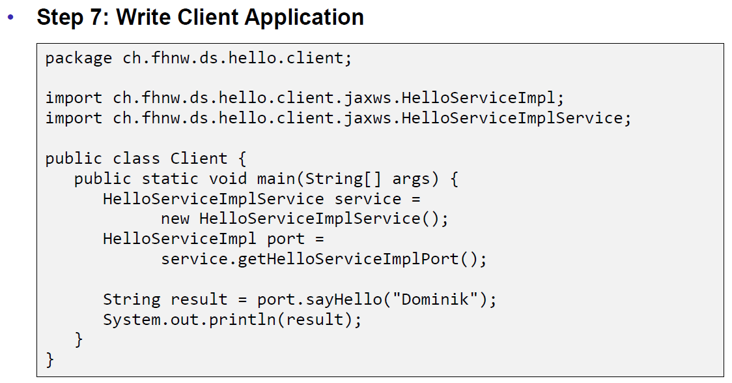

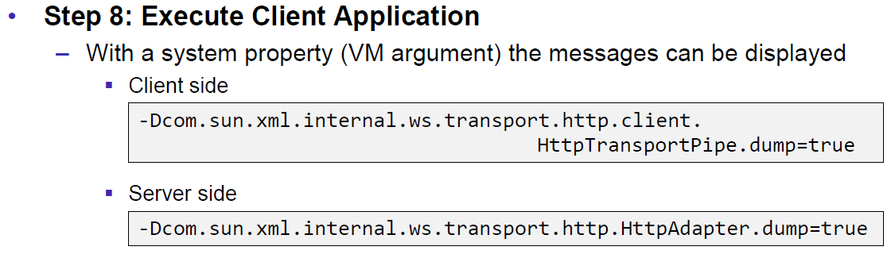

### JAX-WS HTTP Request

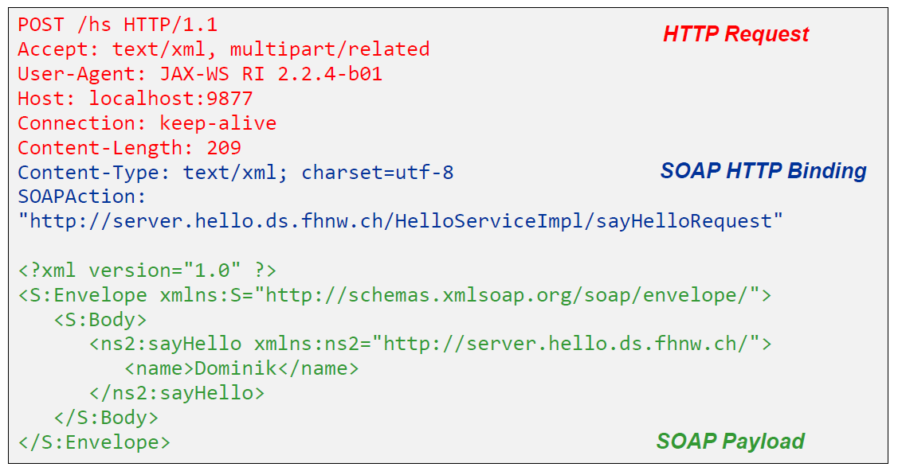

### JAX-WS HTTP Response

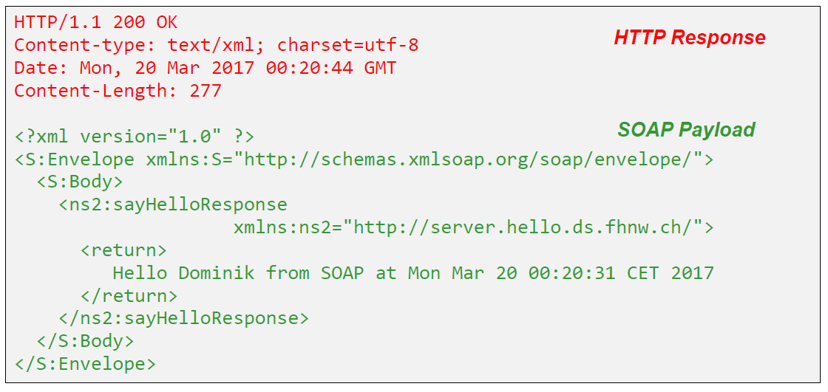

### SOAP Message Structure

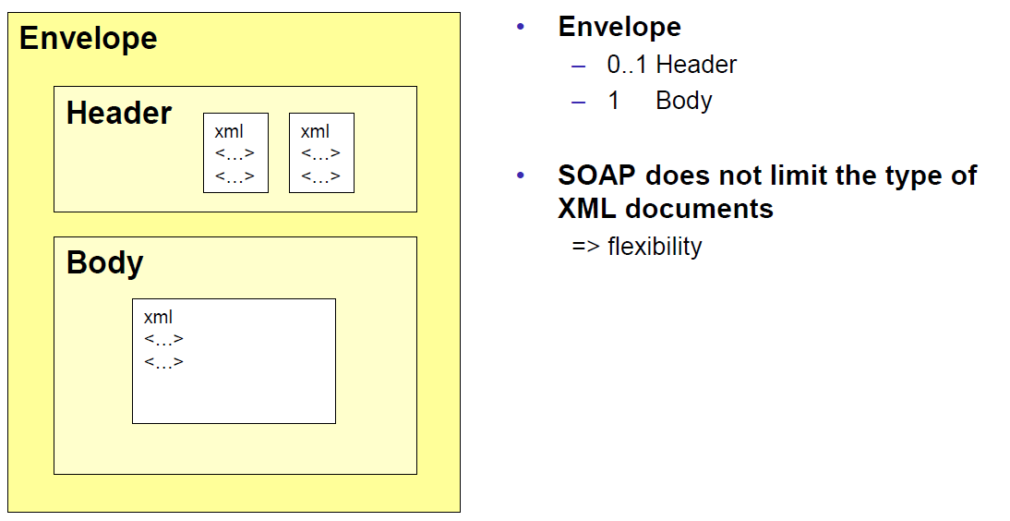

### Tools for SOAP

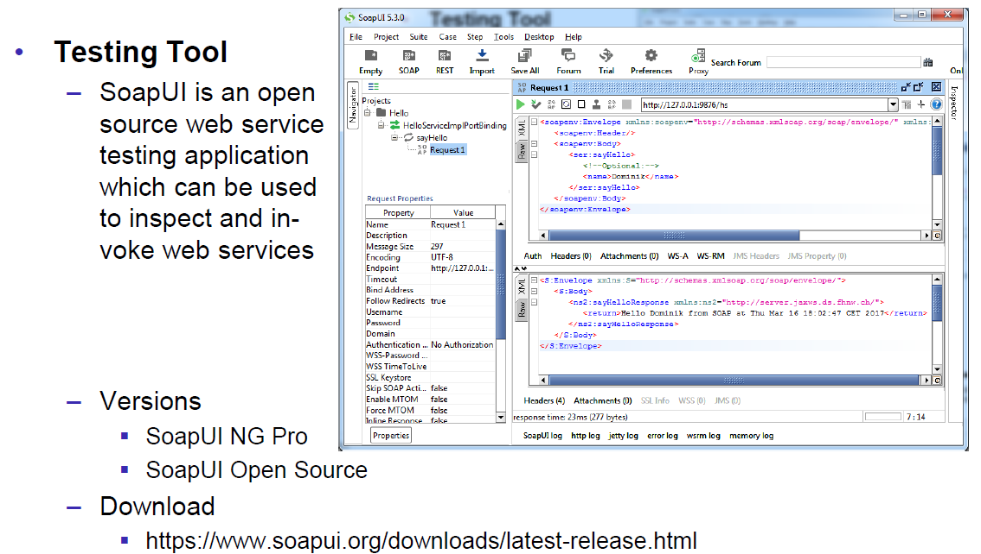

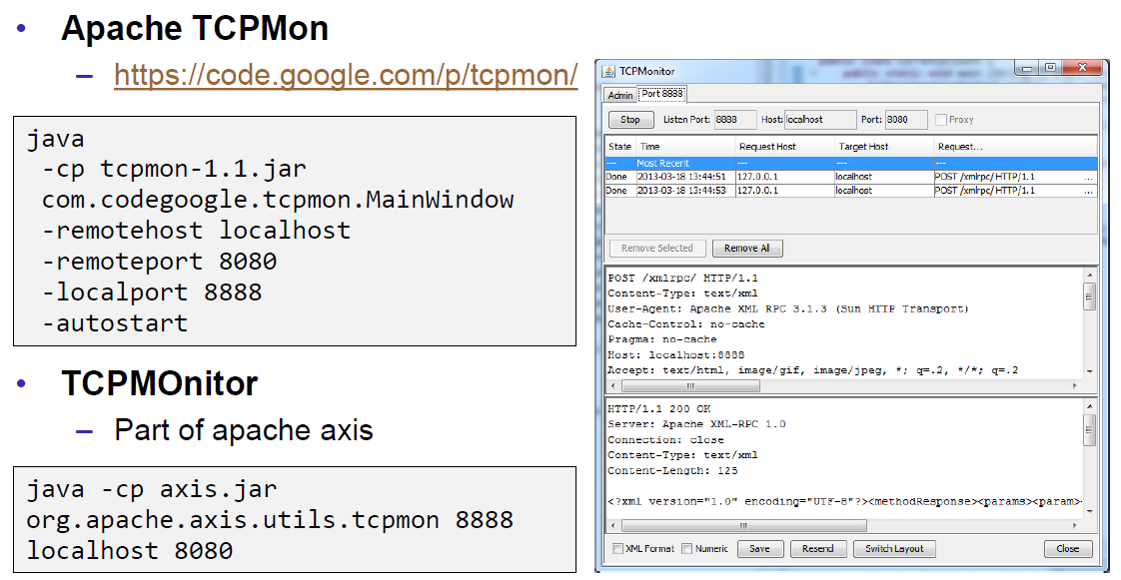

## WSDL

### WSDL

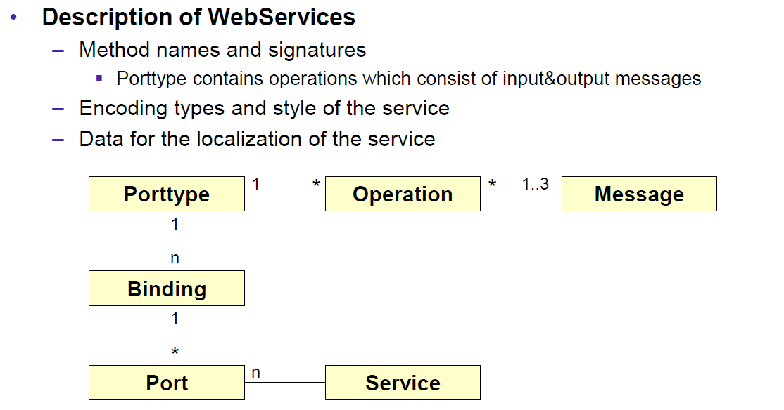

### WSDL Examples

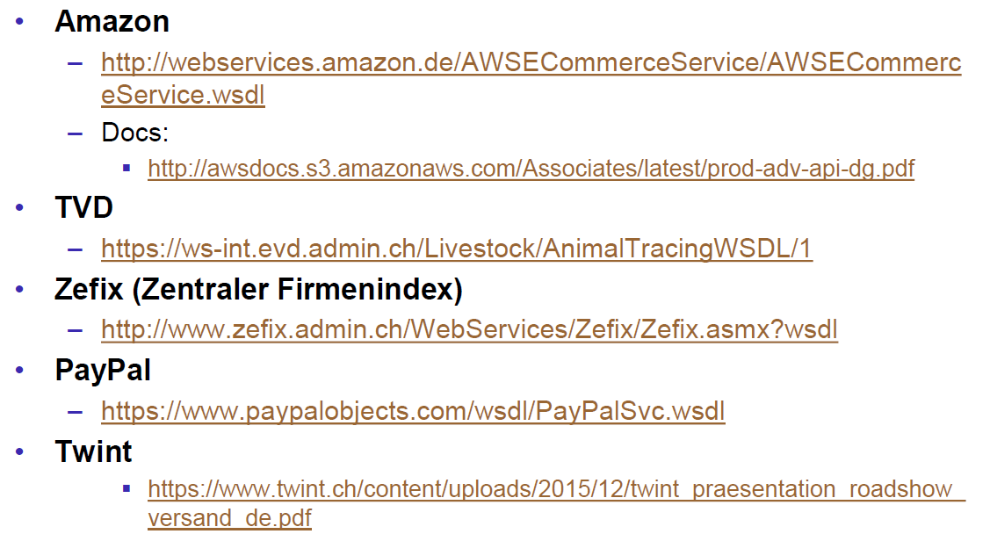

### WSDL Structure

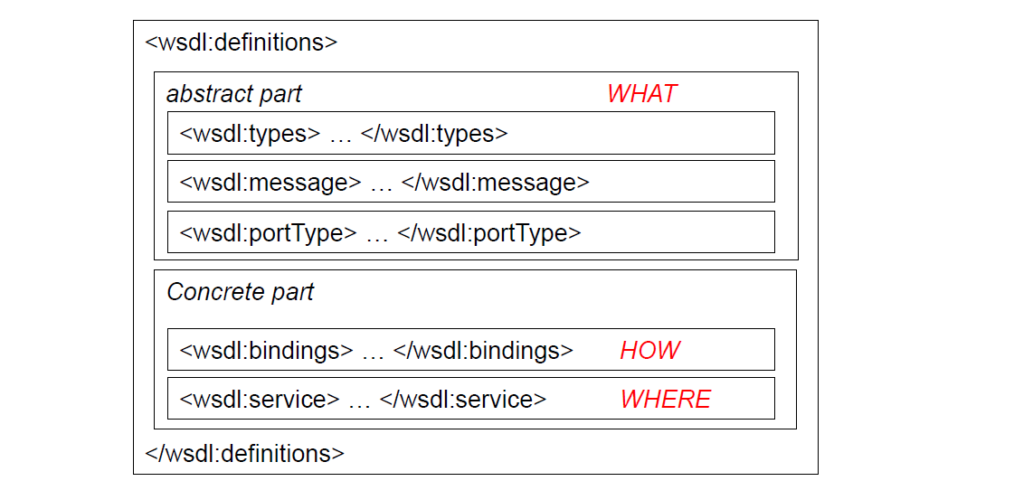

### WSDL Definitions

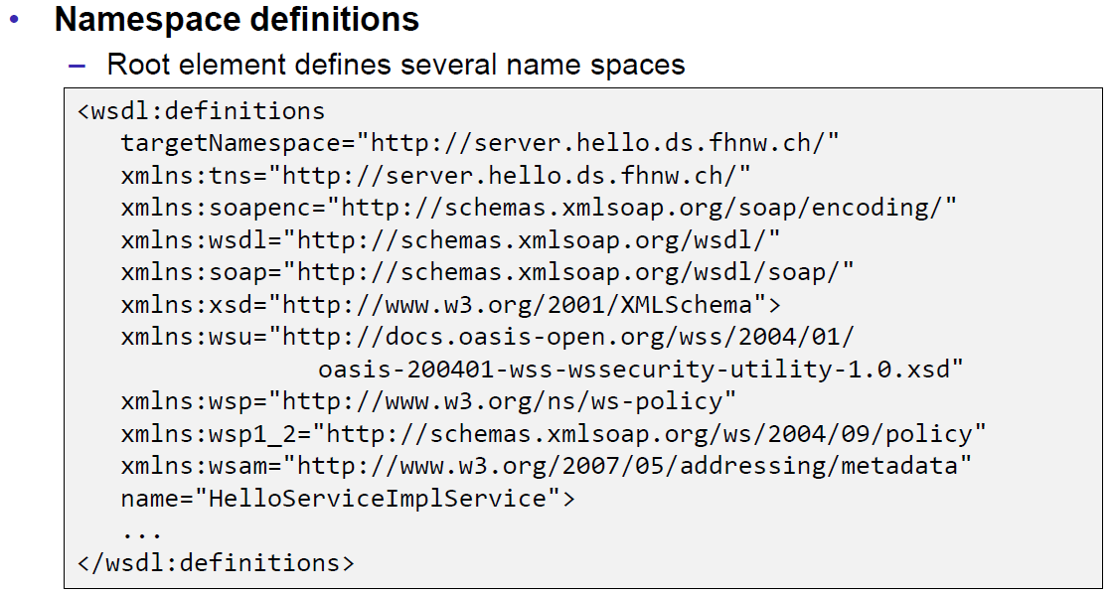

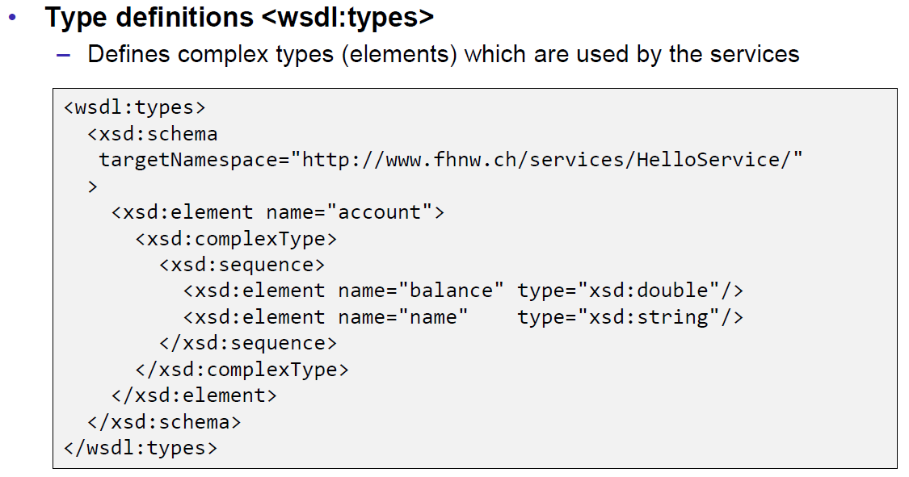

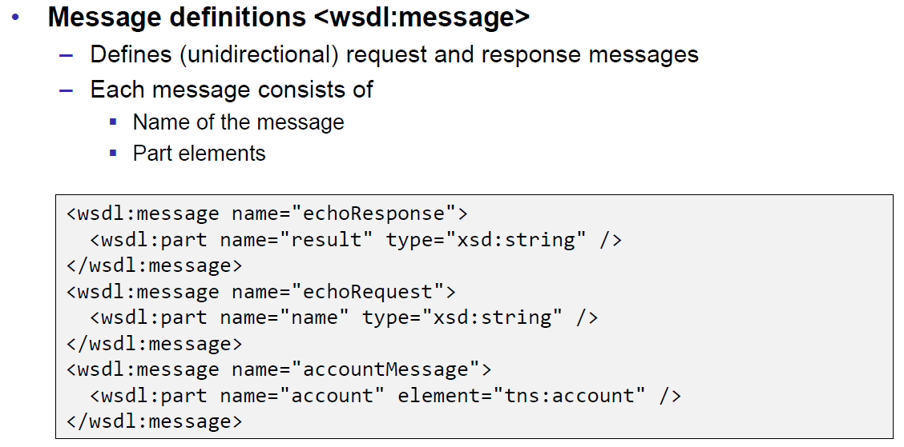

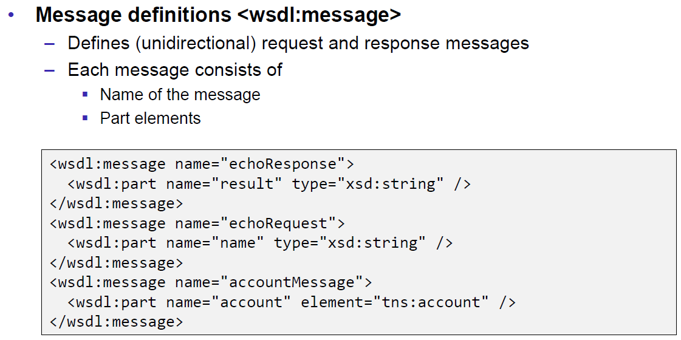

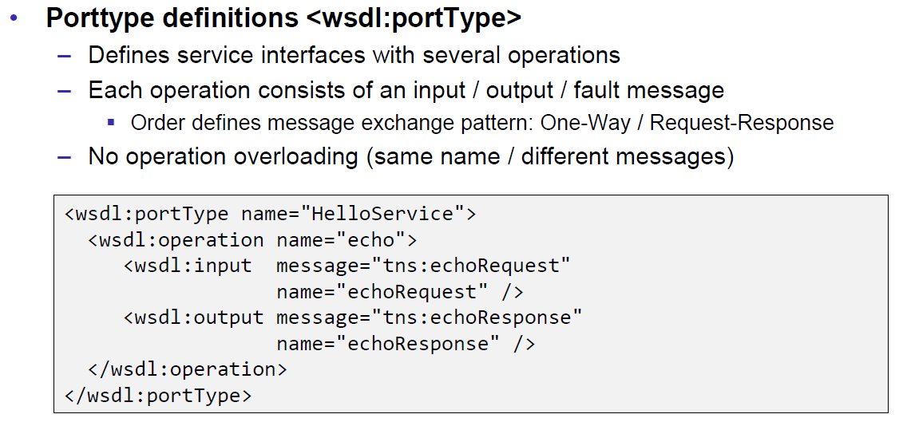

### Message Exchange Patterns (MEP)

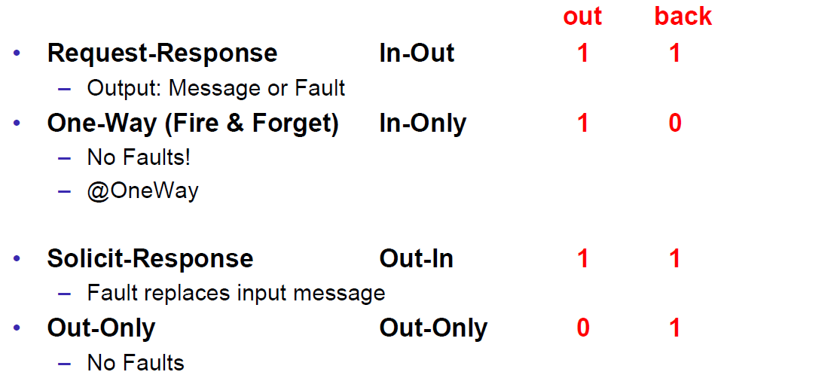

### WSDL Definitions

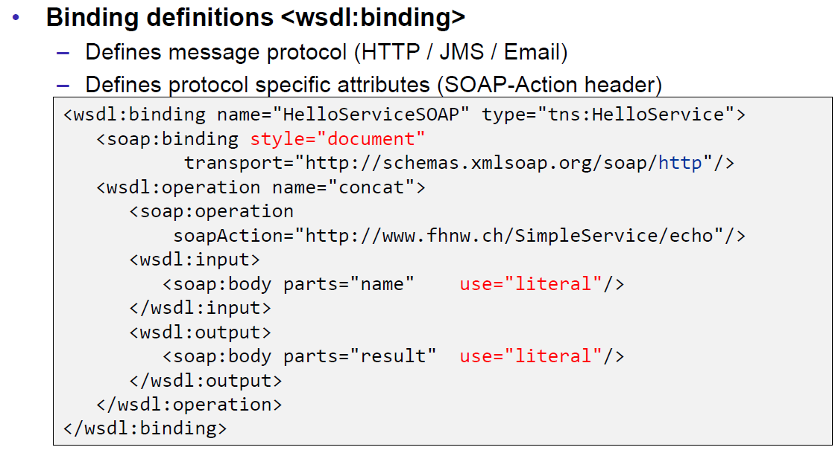

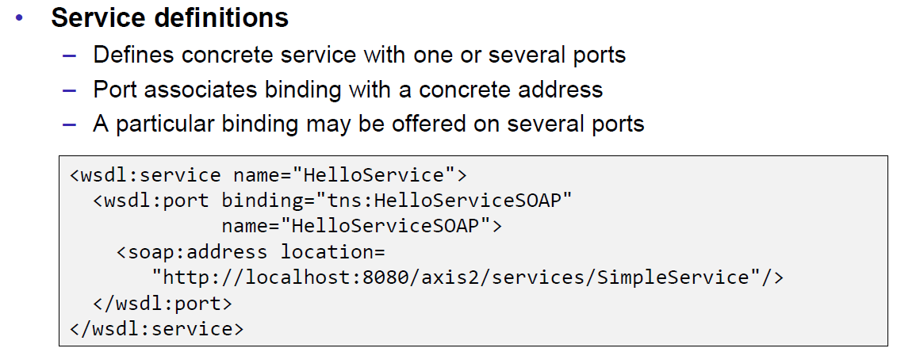

### Web Service Styles

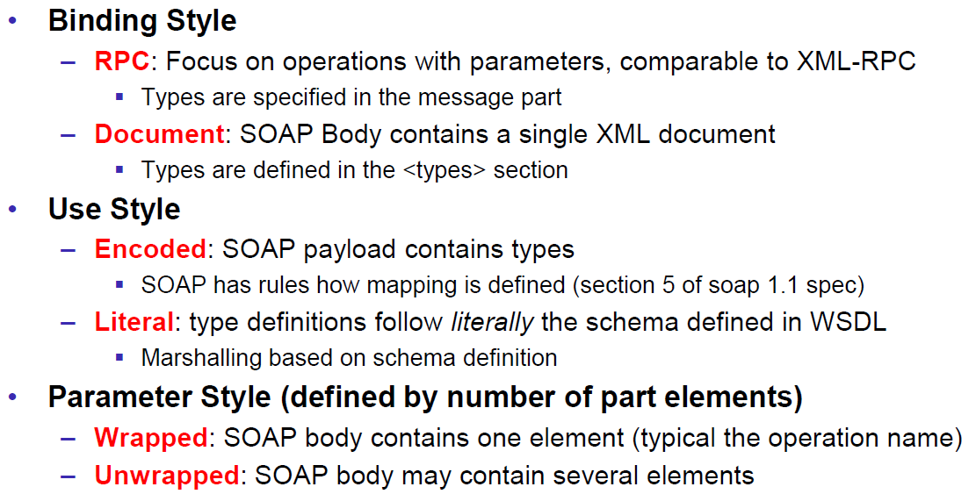

### RPC/Encoded

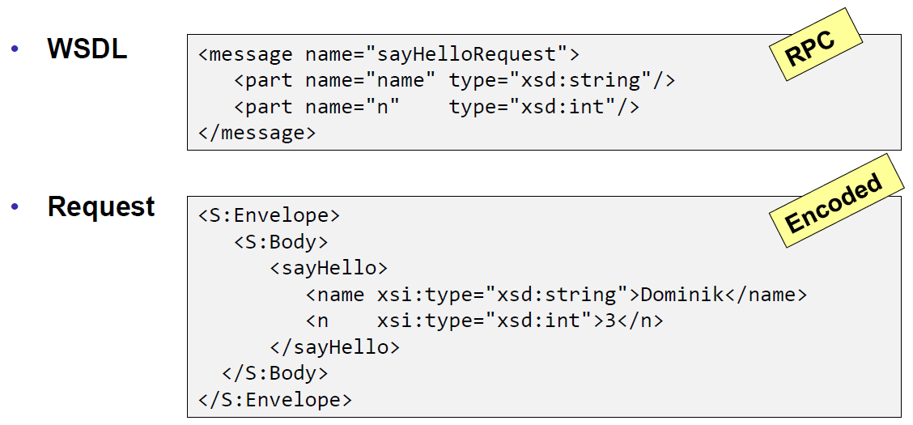

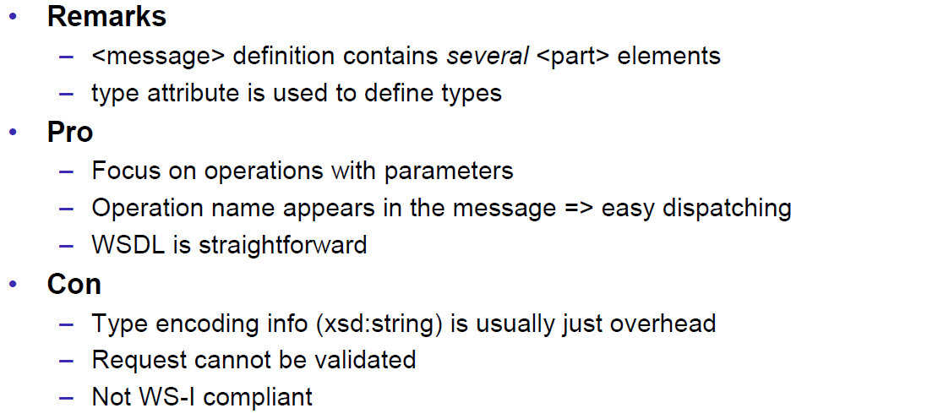

### RPC/Literal

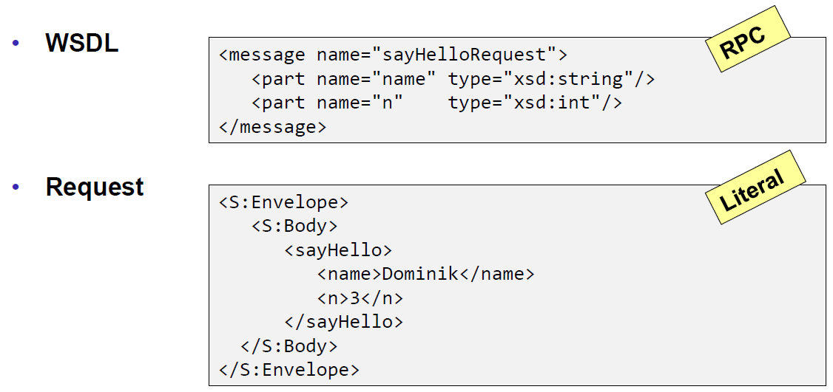

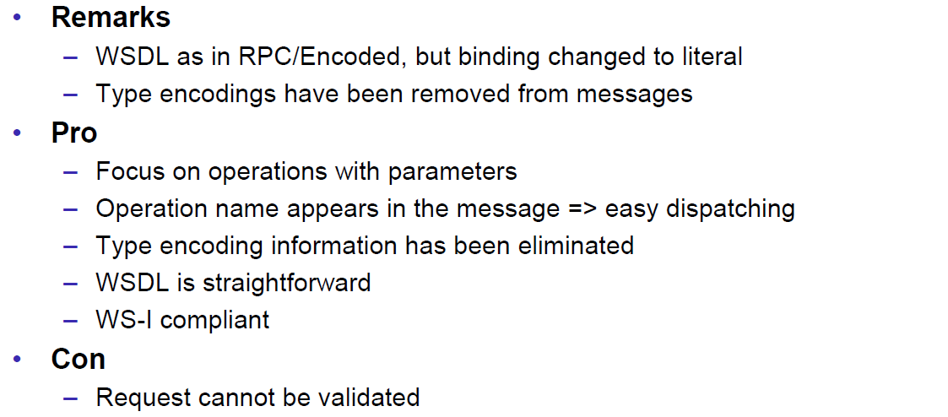

### Document/Literal/Bare

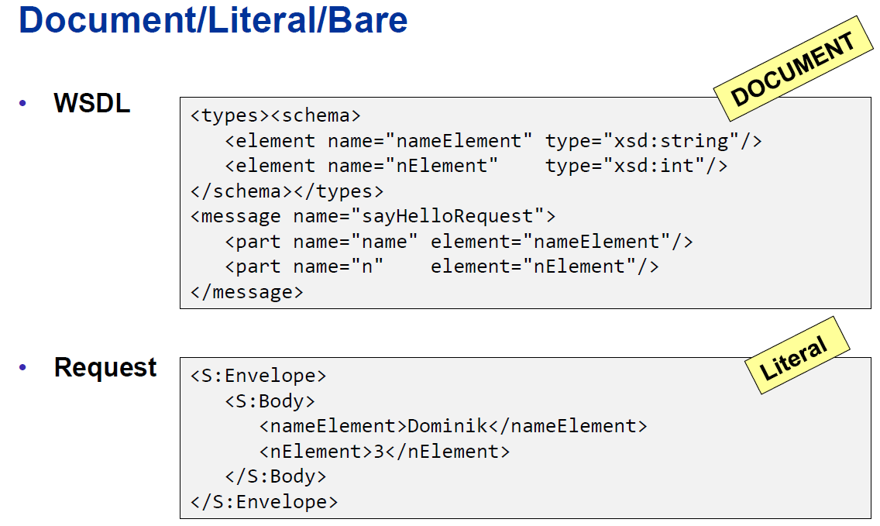

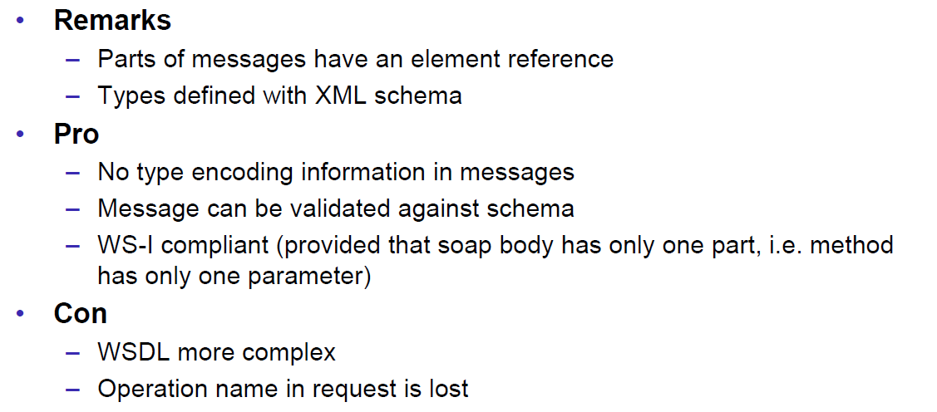

### Document/Literal/Wrapped

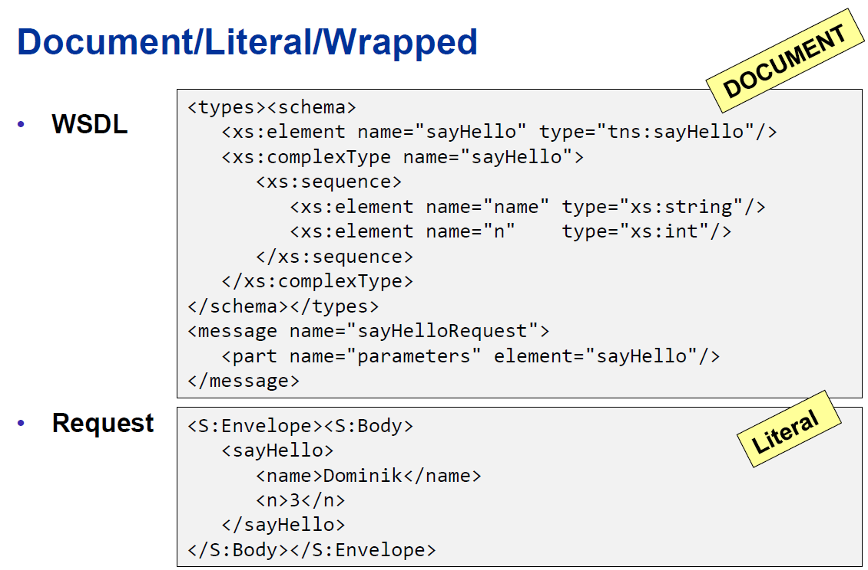

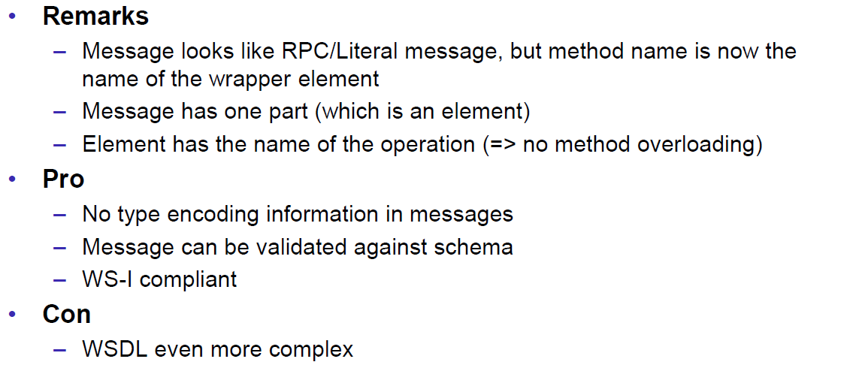

### Web Service Styles

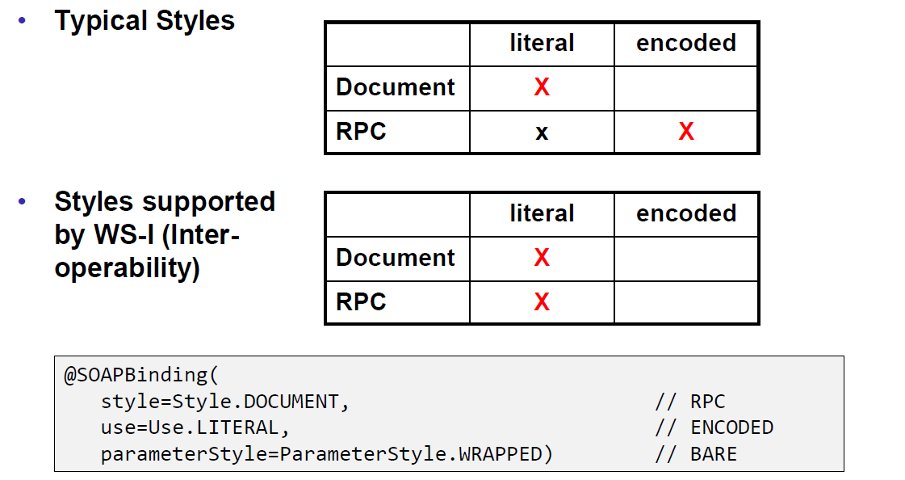

## Resources

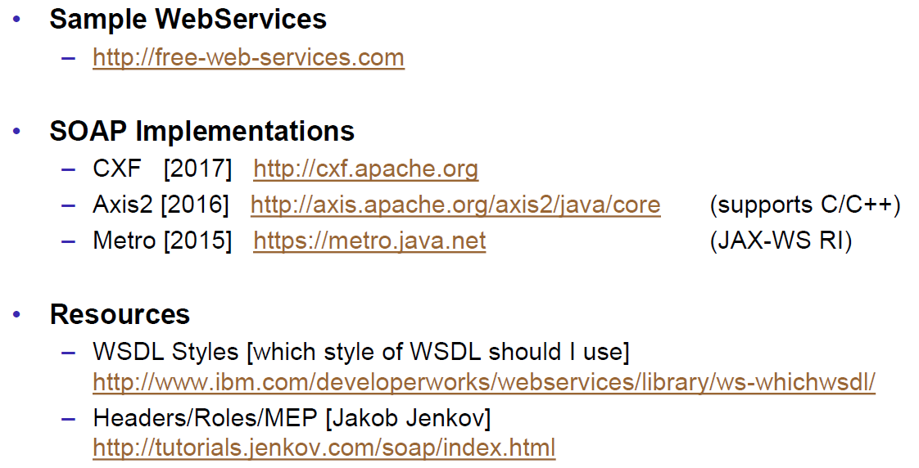

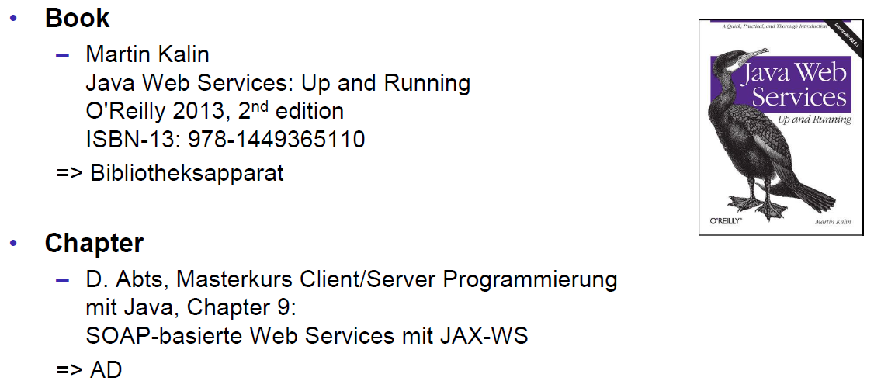

# Woche 6

## REST Concepts

### Representational State Transfer (REST)

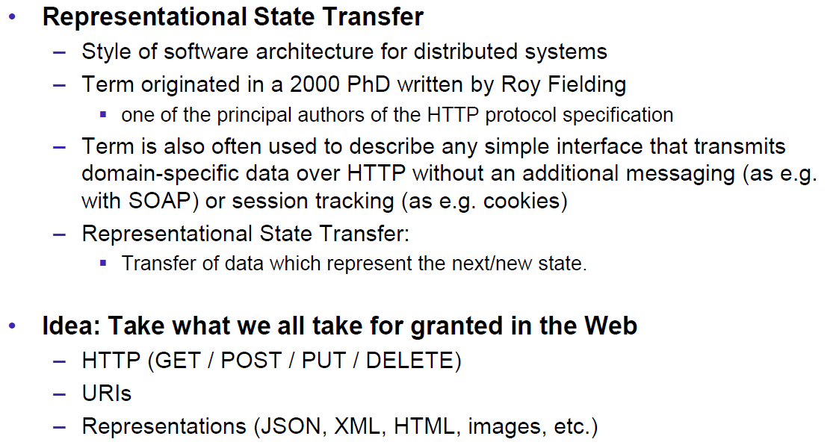

### REST Principles

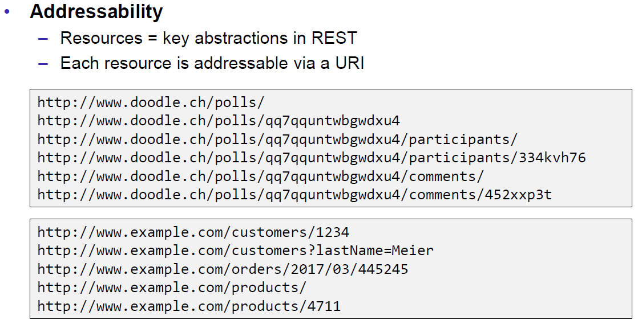

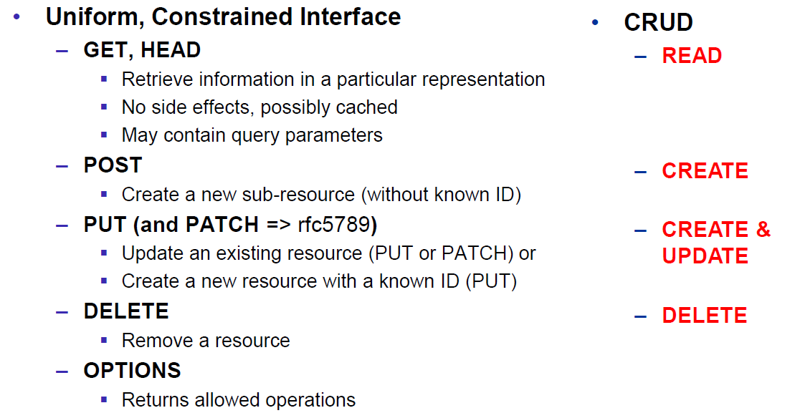

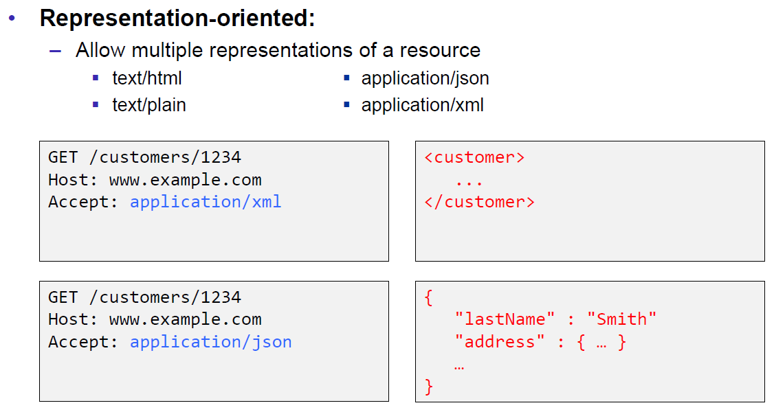

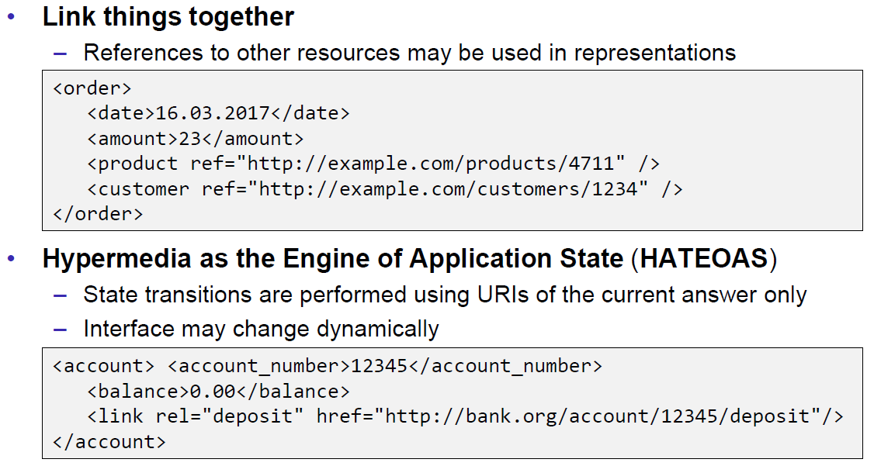

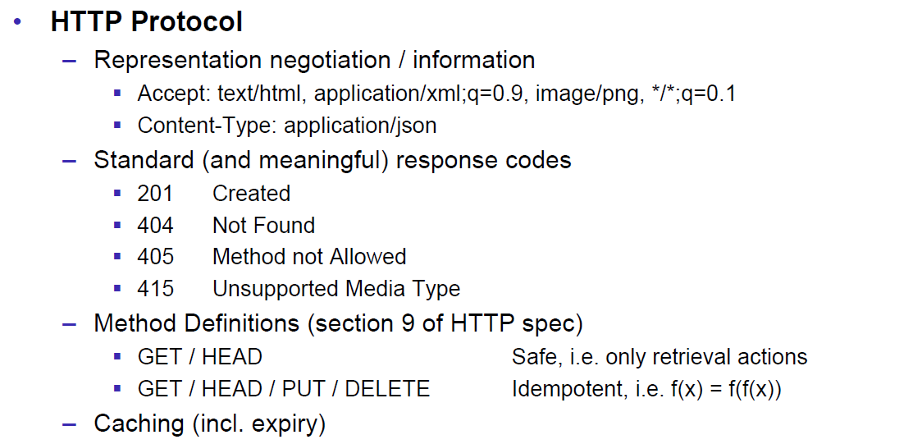

### REST Short Primer

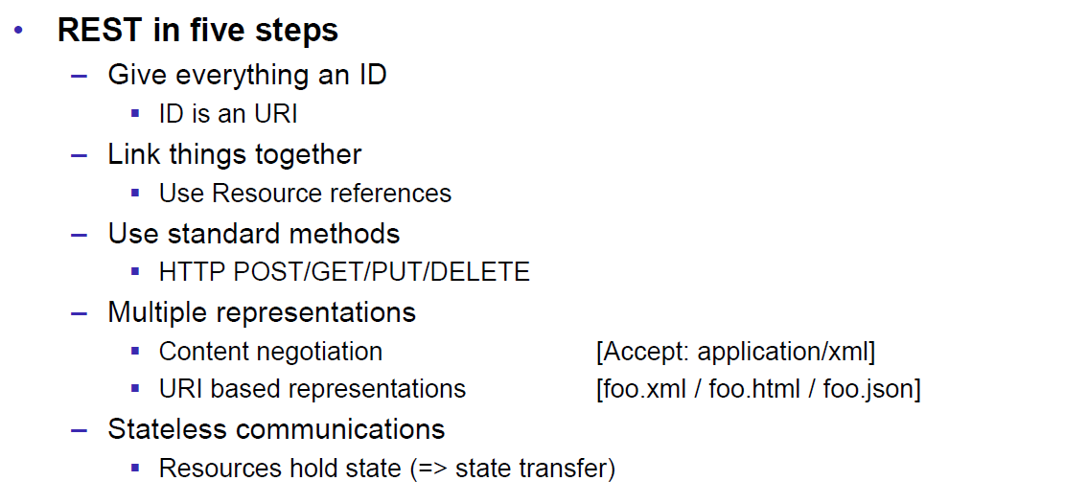

### SOAP versus REST

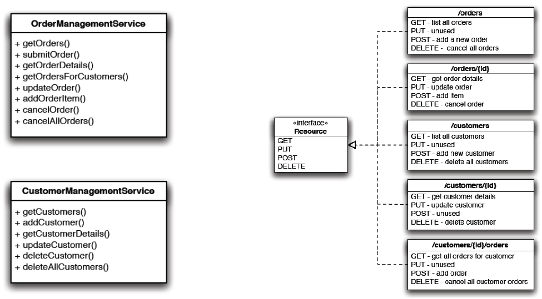

### REST Common Patterns

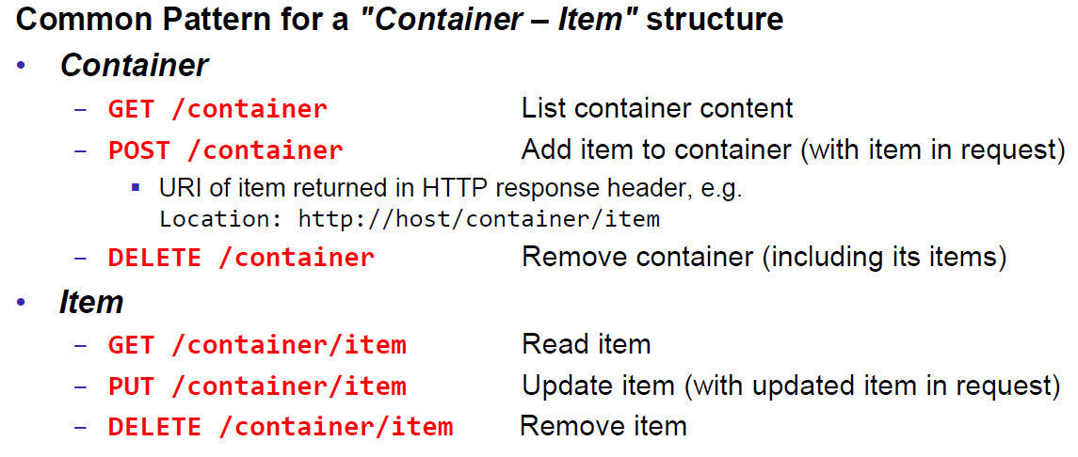

### Example Doodle

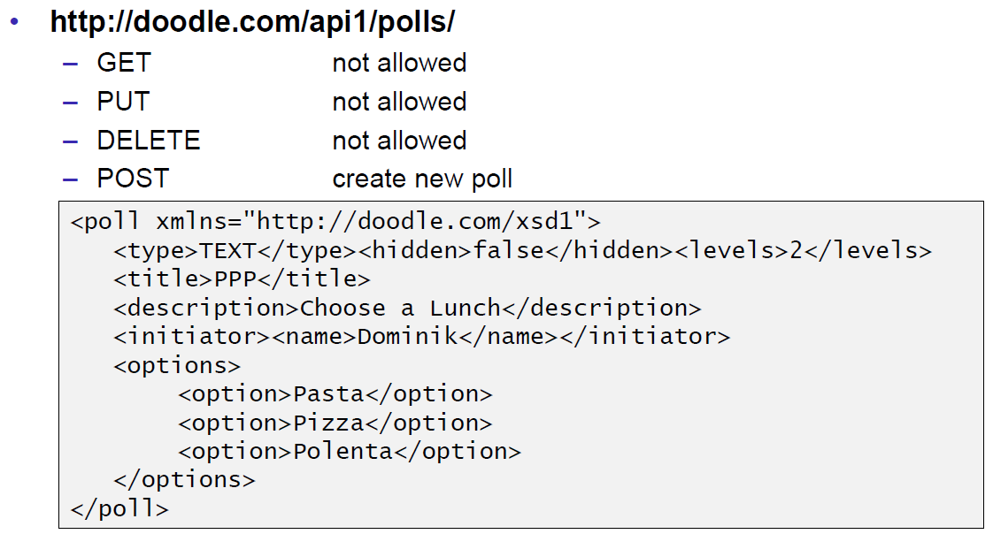

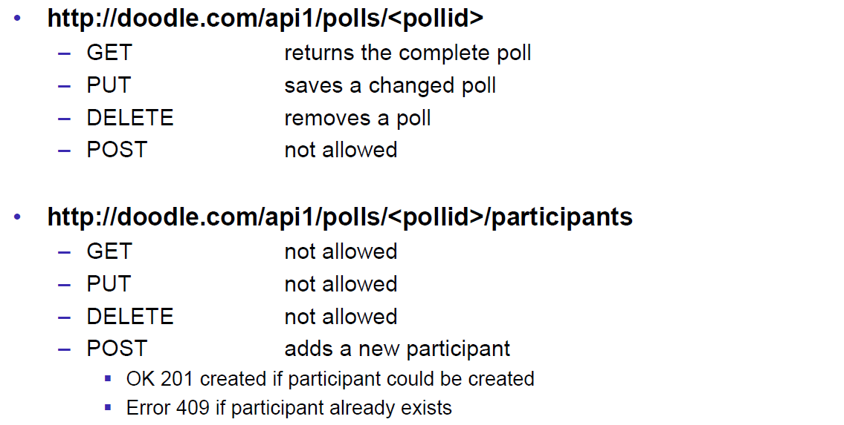

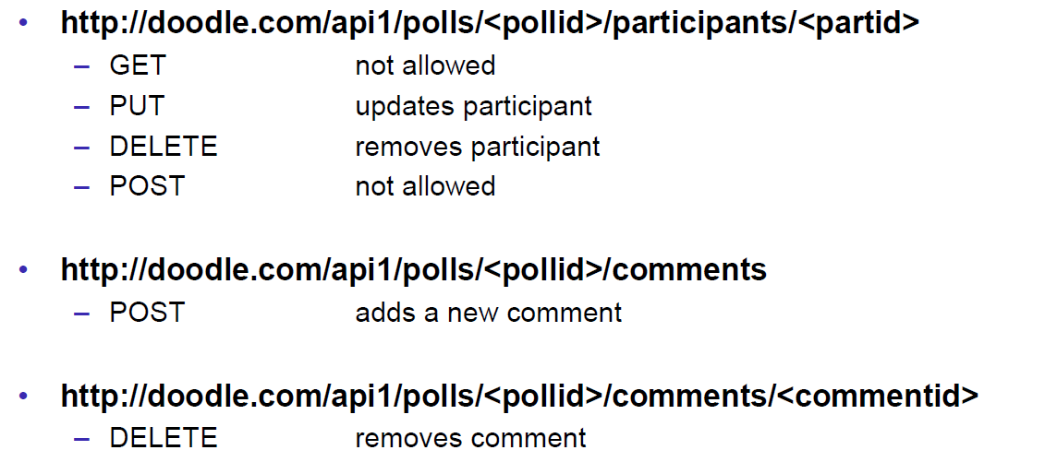

### REST versus SOAP

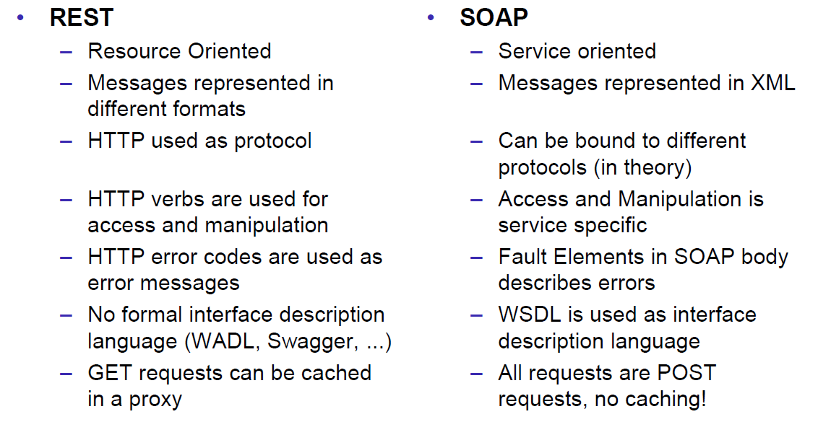

### Client Side

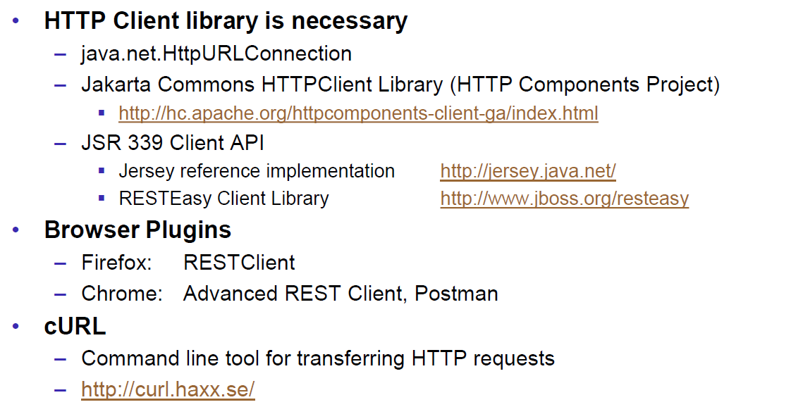

### Web Client Plugins

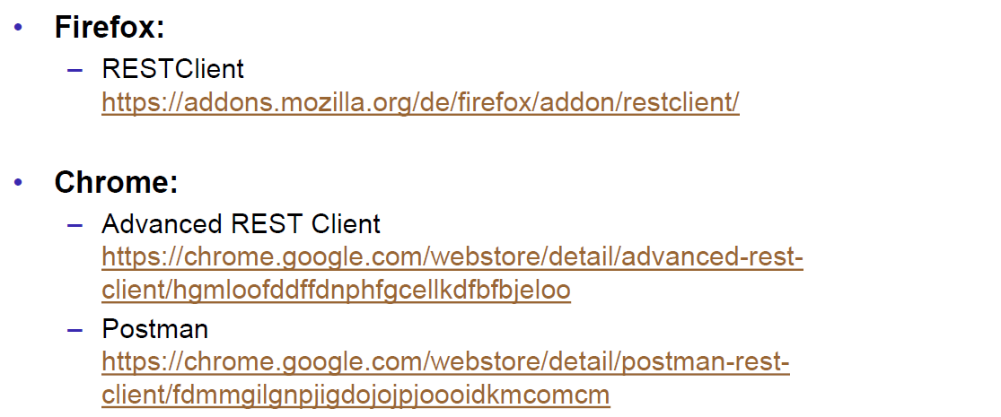

### Client Side via curl

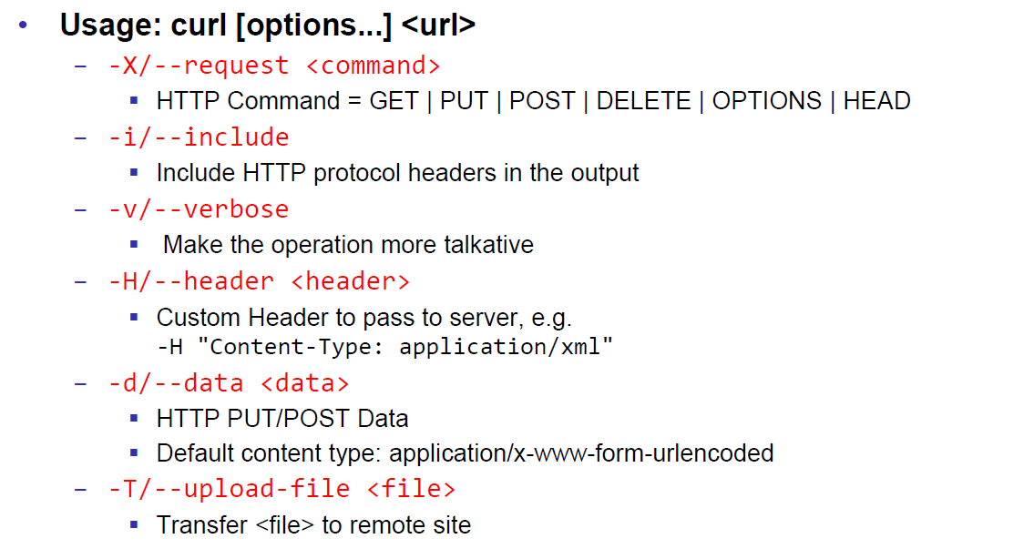

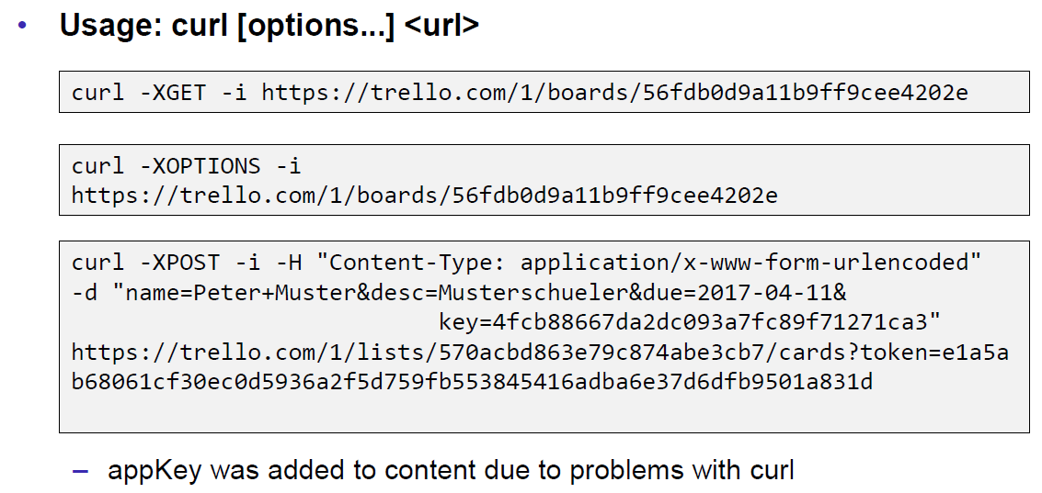

## REST Server Implementations

### Server Side

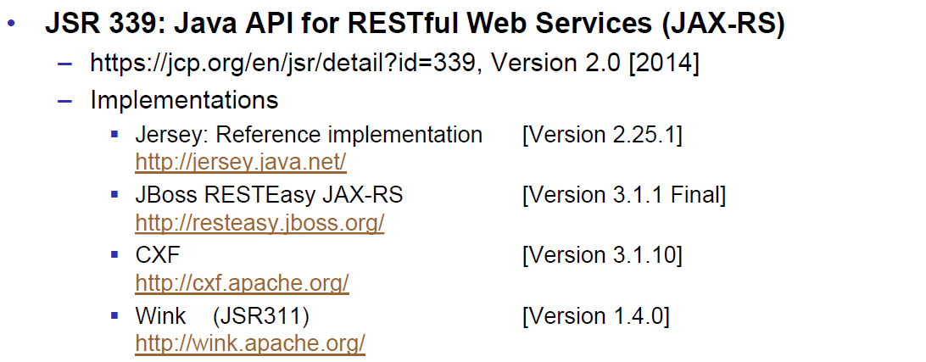

### JAX-RS Services

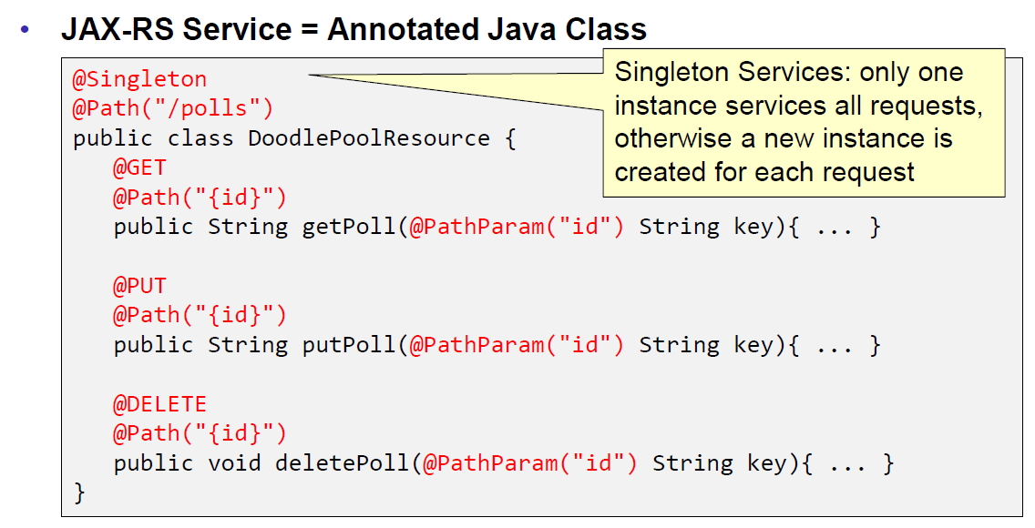

### JAX-RS HTTP Methods

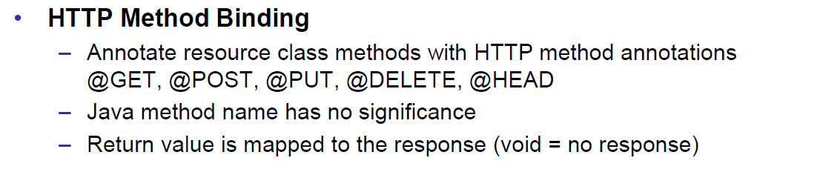

### JAX-RS Injection

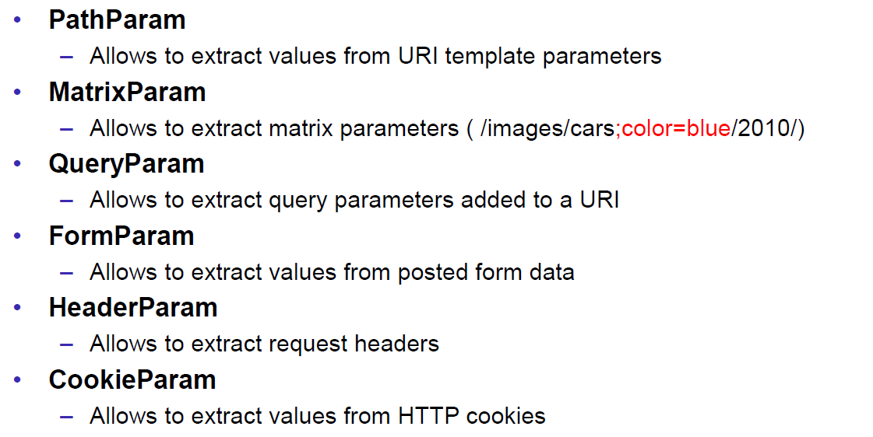

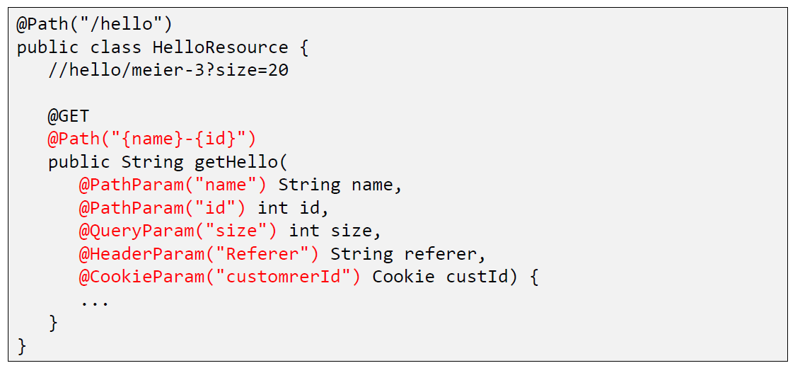

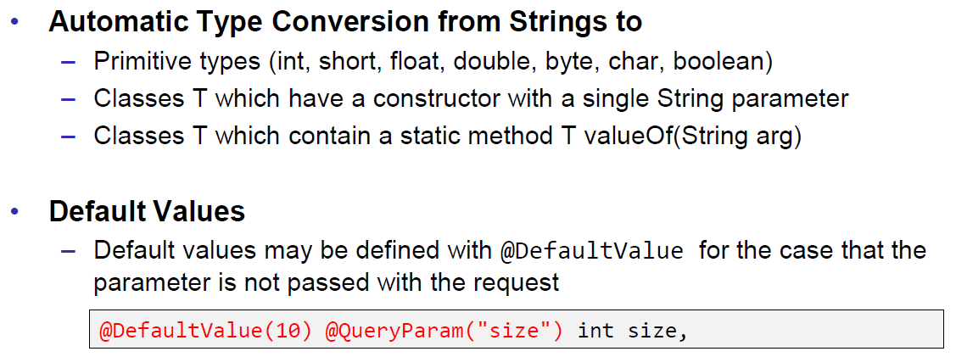

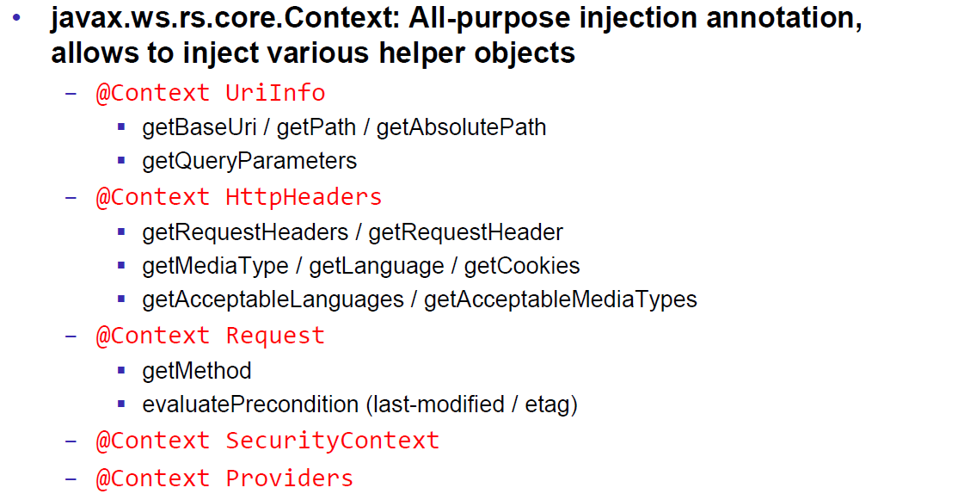

### JAX-RS Content Negotoation

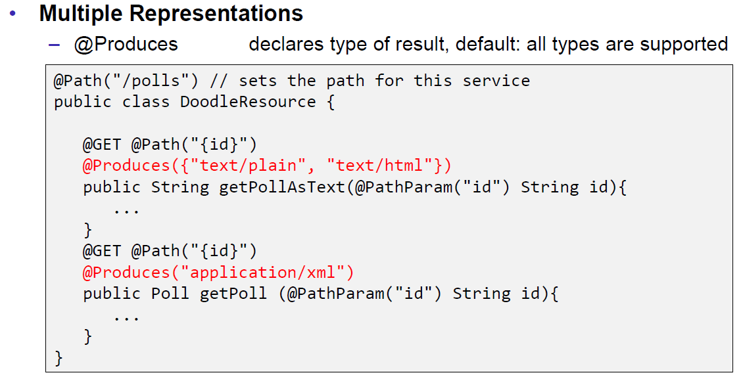

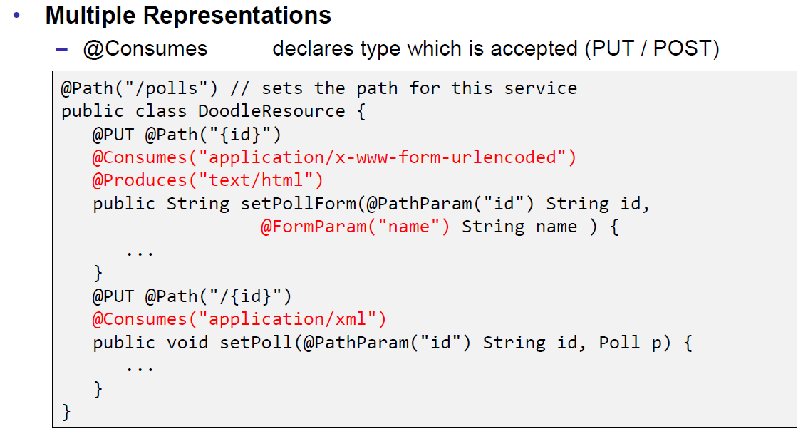

### JAX-RS Content Handlers

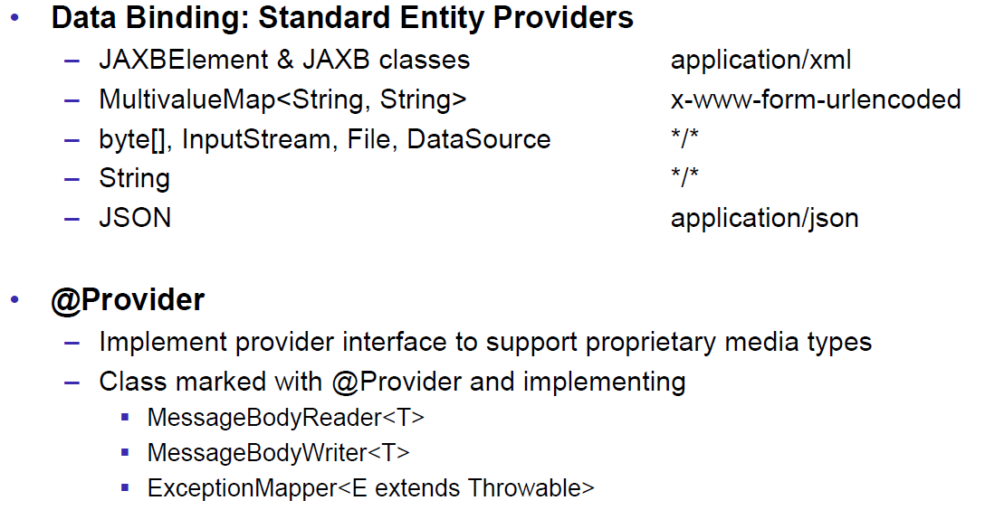

### JAX-RS Responses

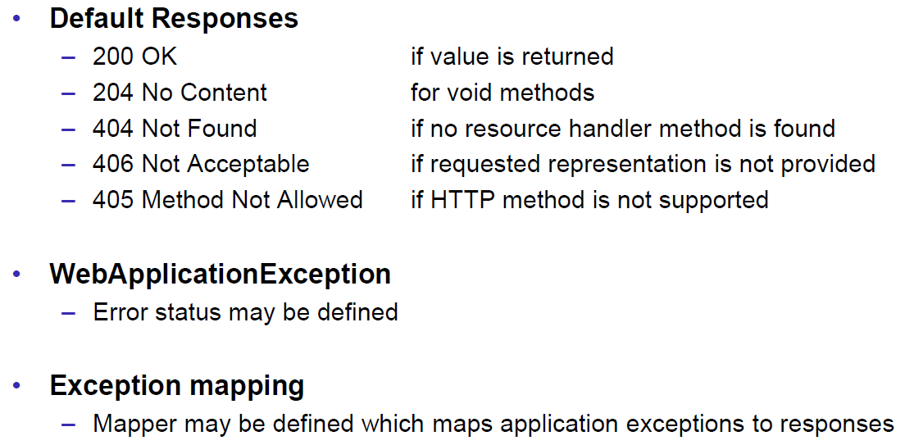

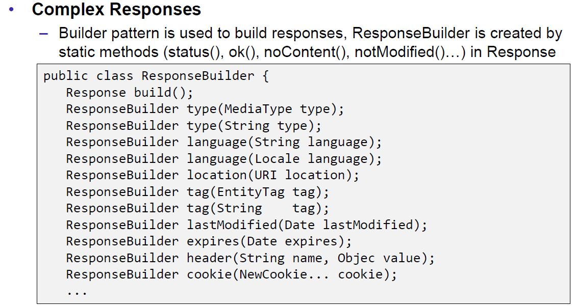

### JAX-RS Conditional GET

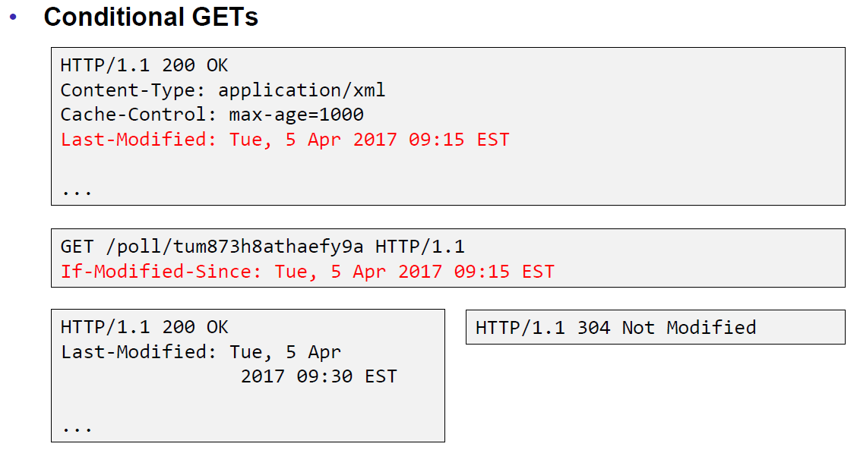

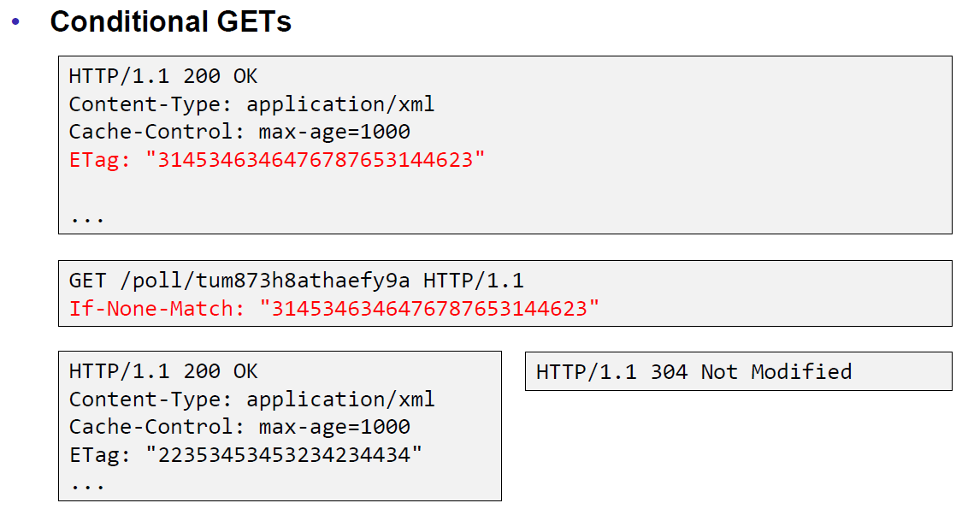

### JAX-RS Cache Control

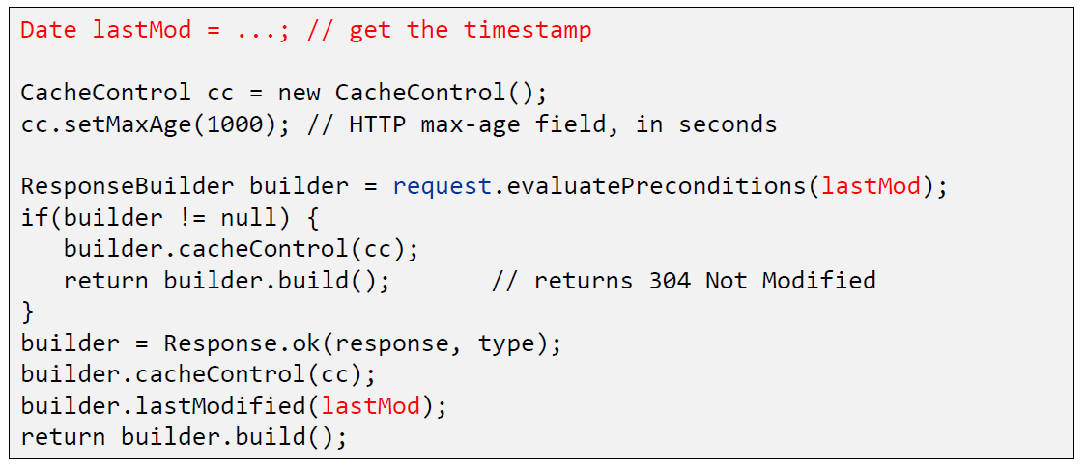

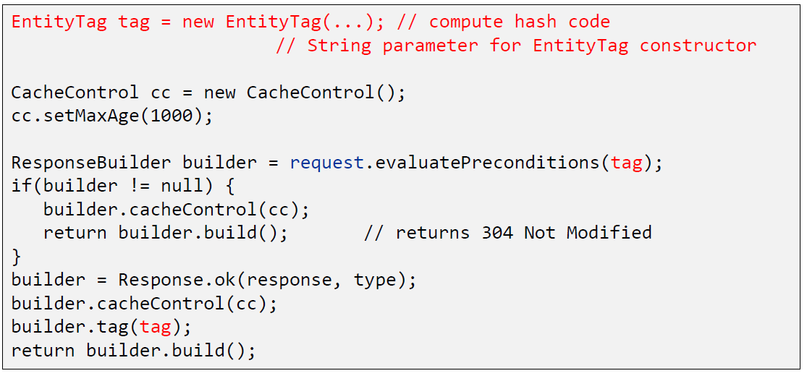

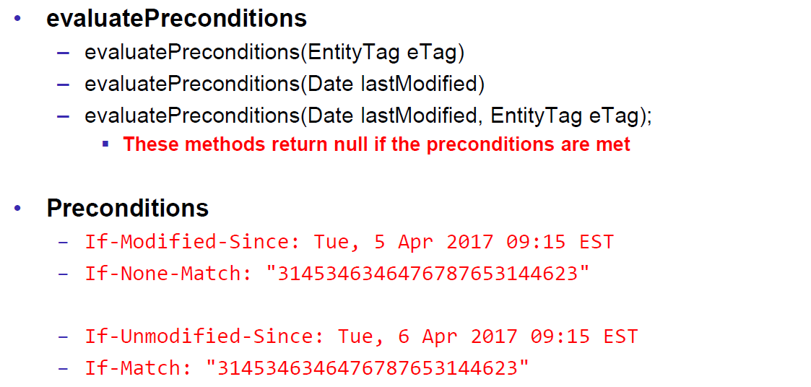

### JAX-RS Optimistic Locking

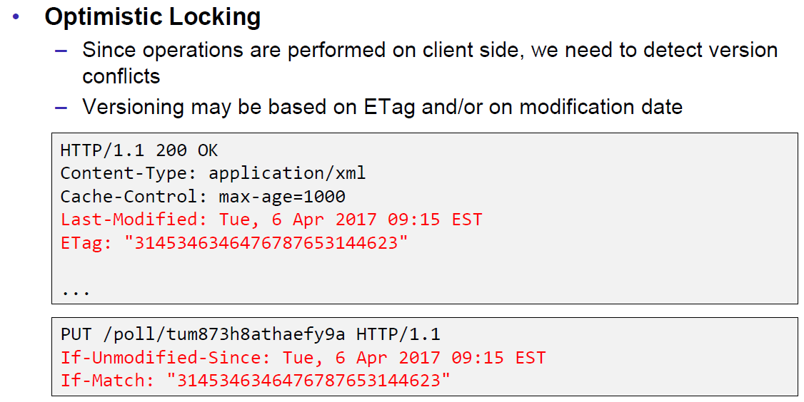

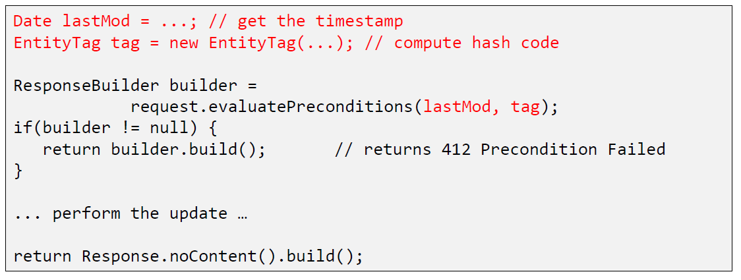

### JAX-RS Deployment

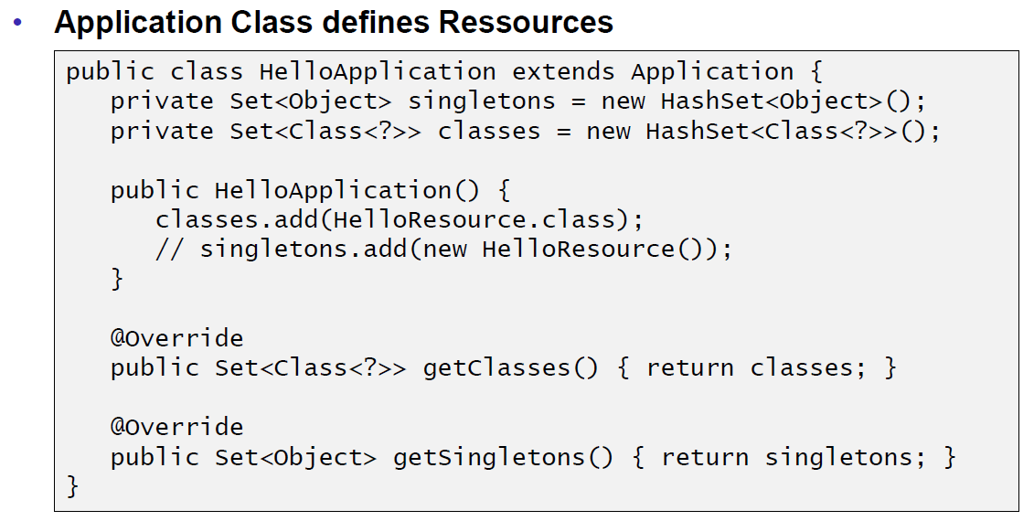

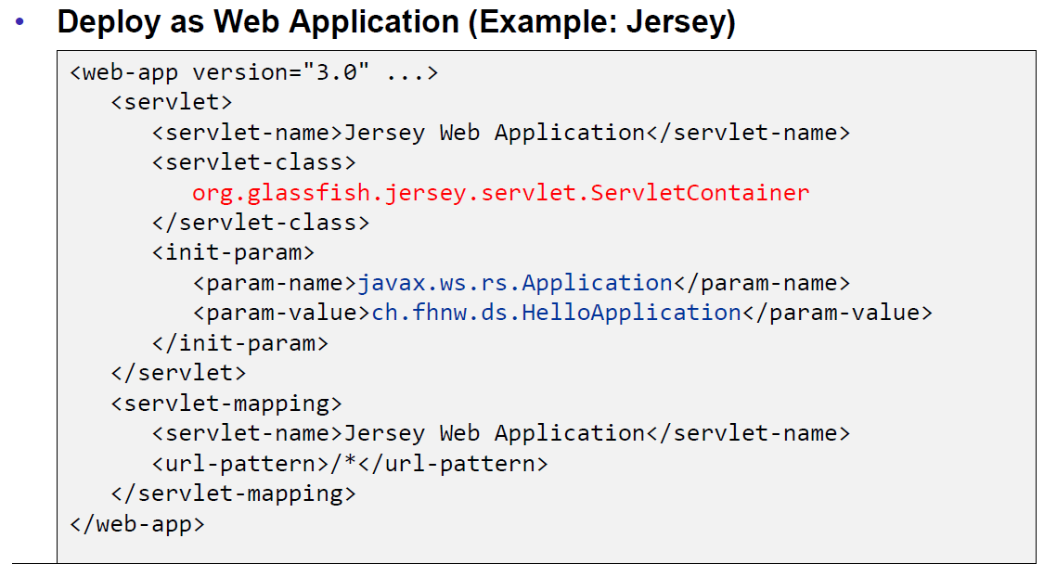

### Deploy Stand Alone via Jersey

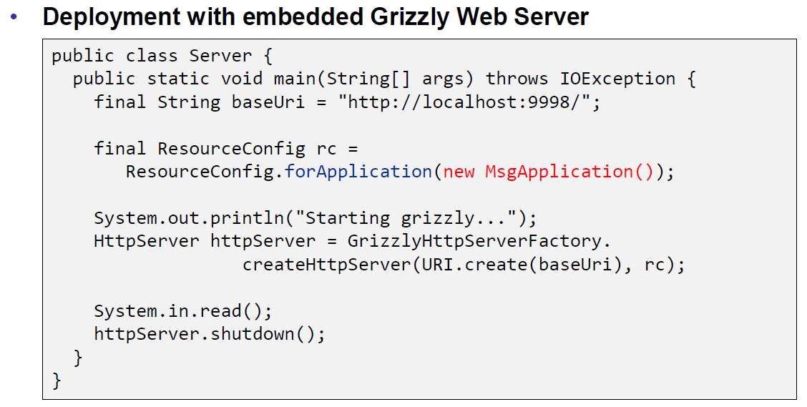

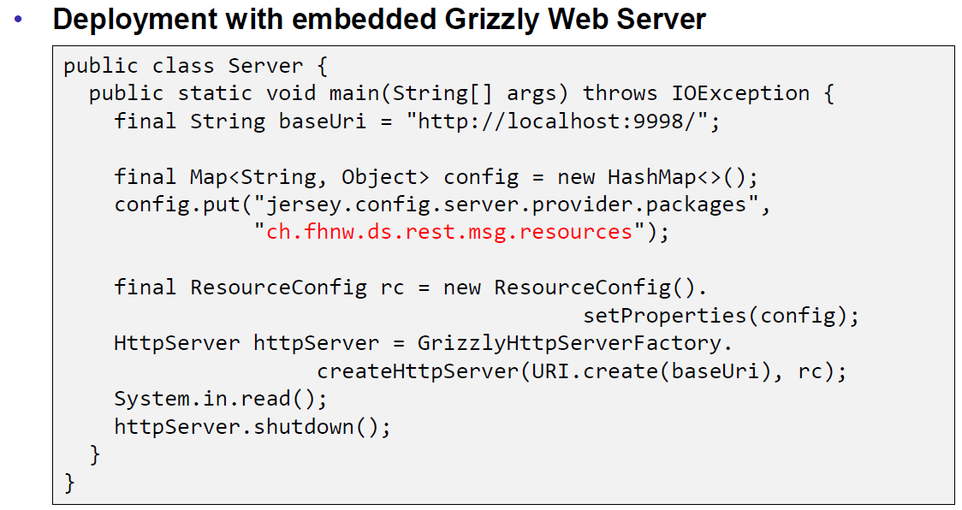

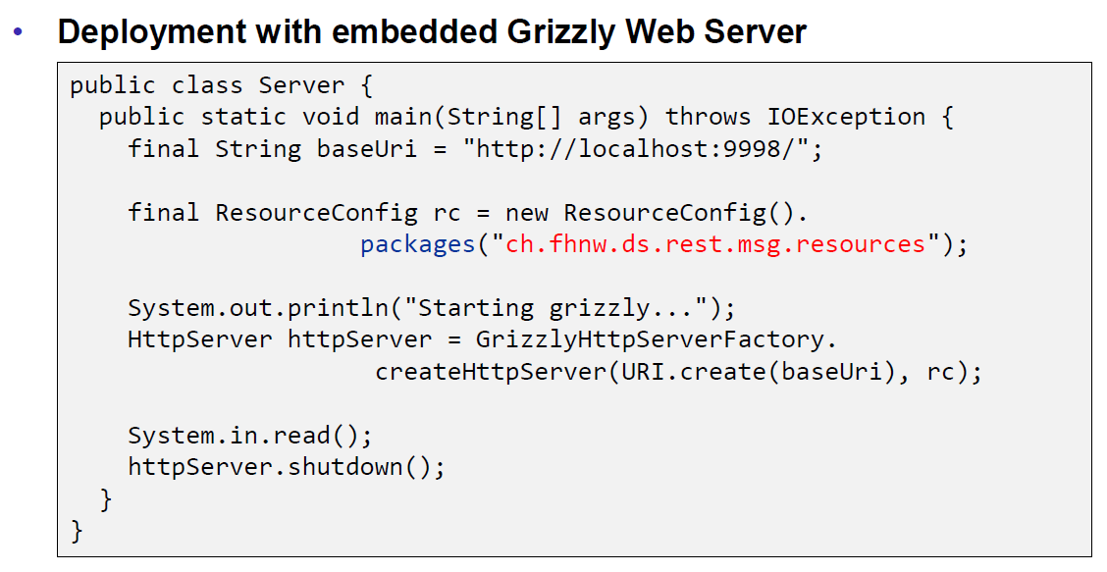

## REST Clients

### JAX-RS Client API

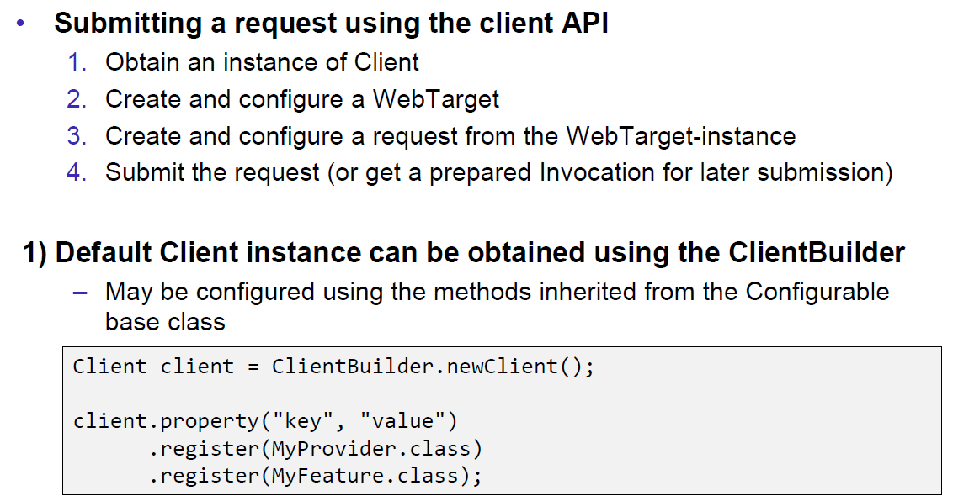

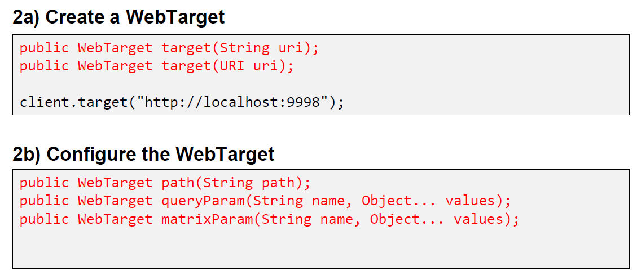

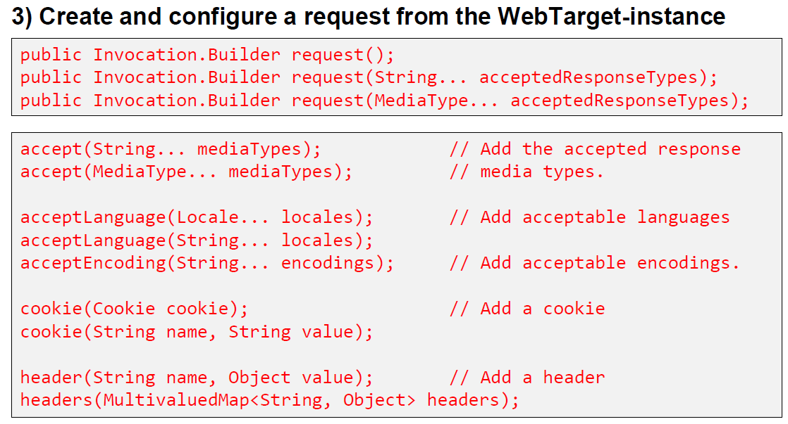

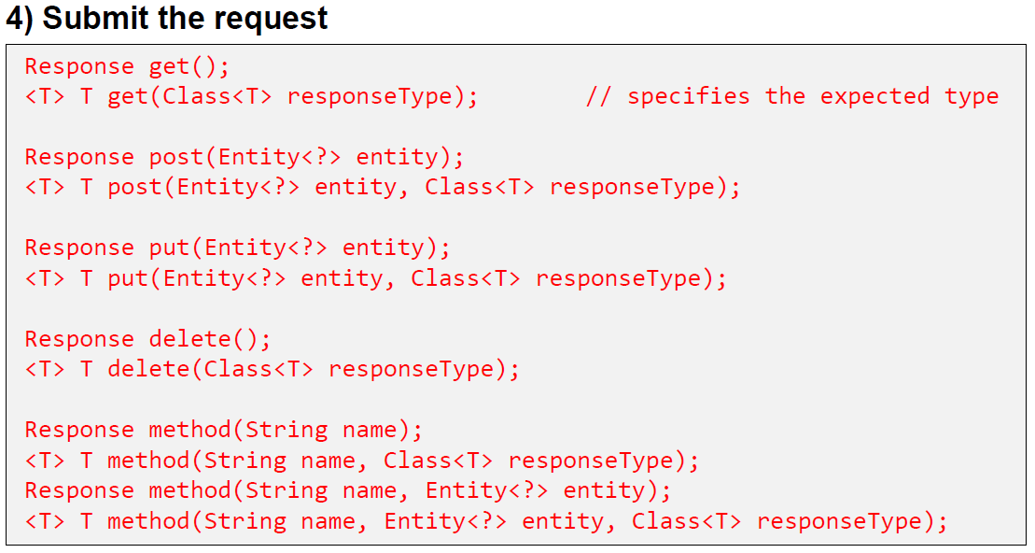

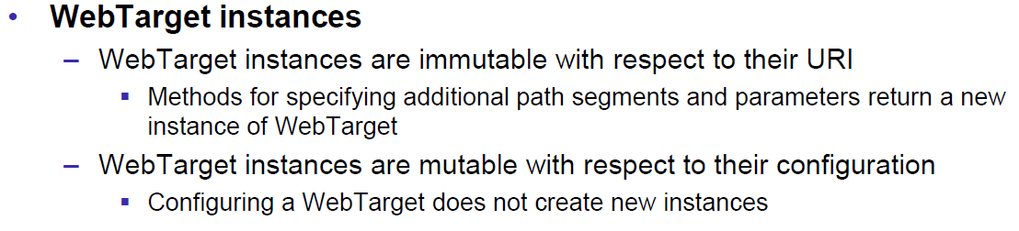

## Resources

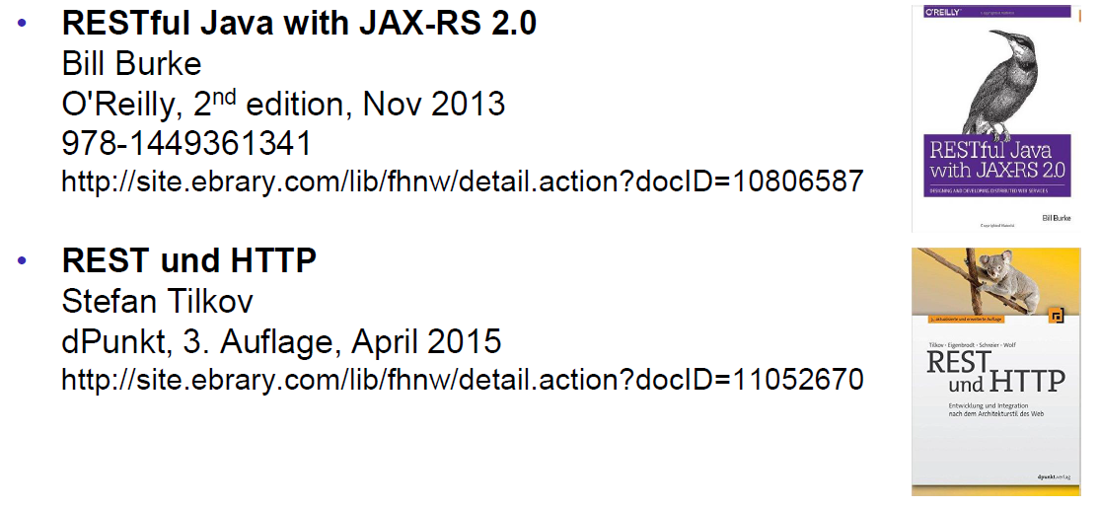

# Woche 7

## REST Data Binding

### JAX-RS Data Binding

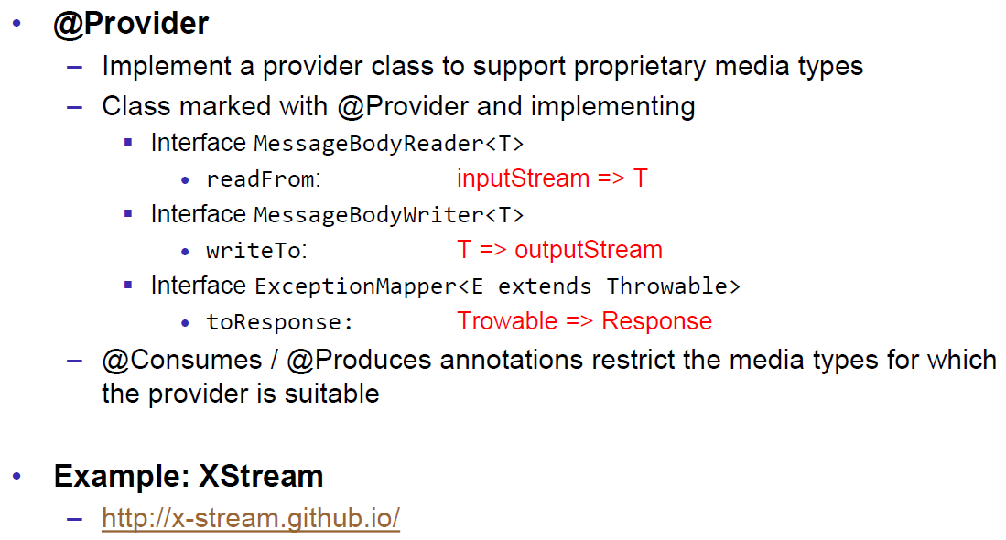

### XStream Provider (Reader)

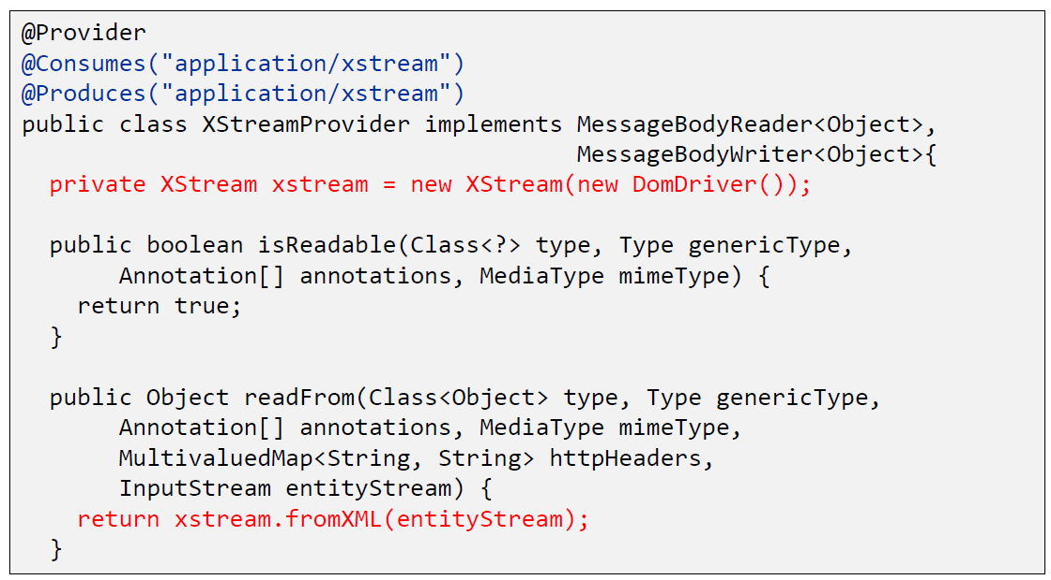

### XStream Provider (Writer)

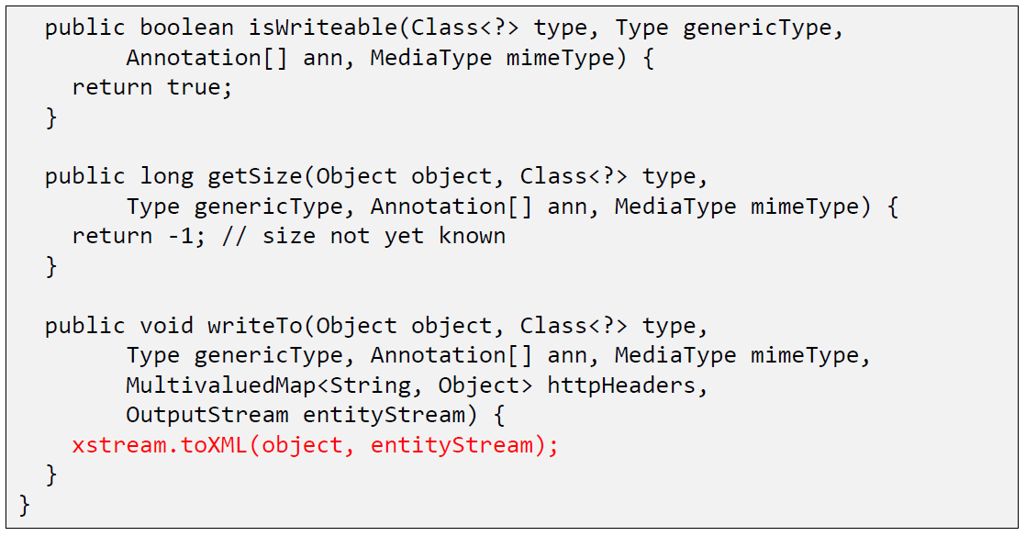

### XStream Example

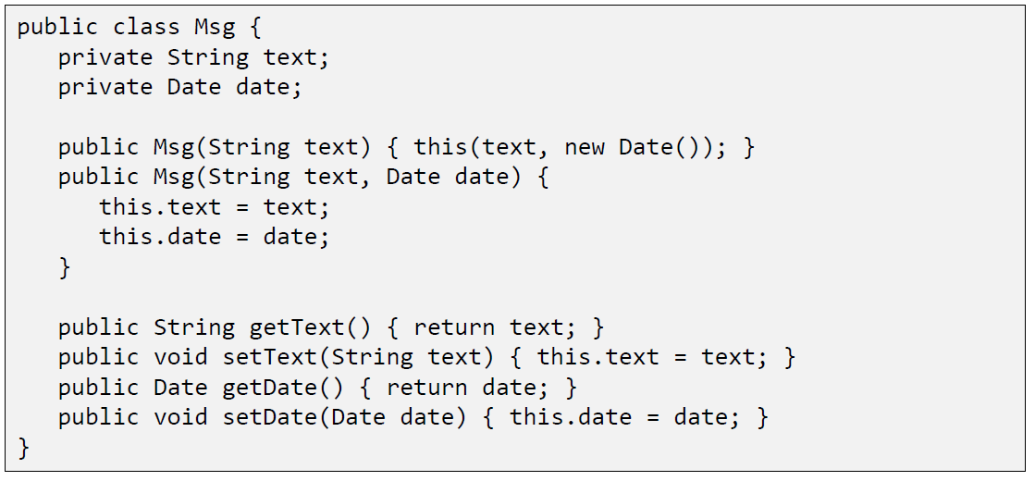

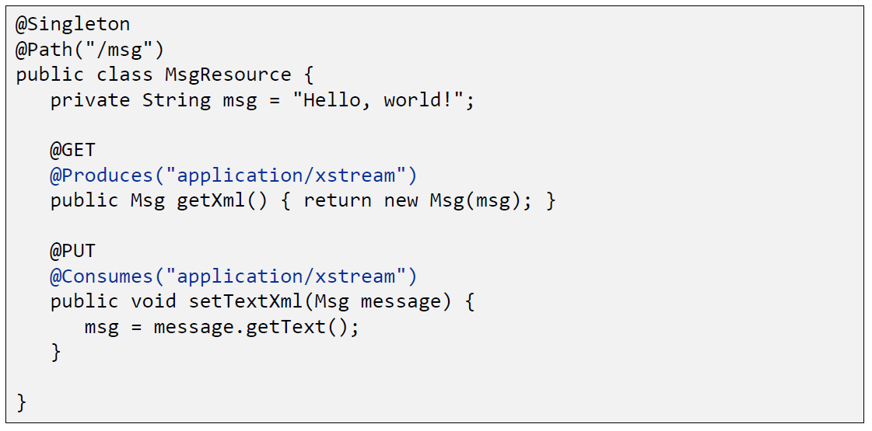

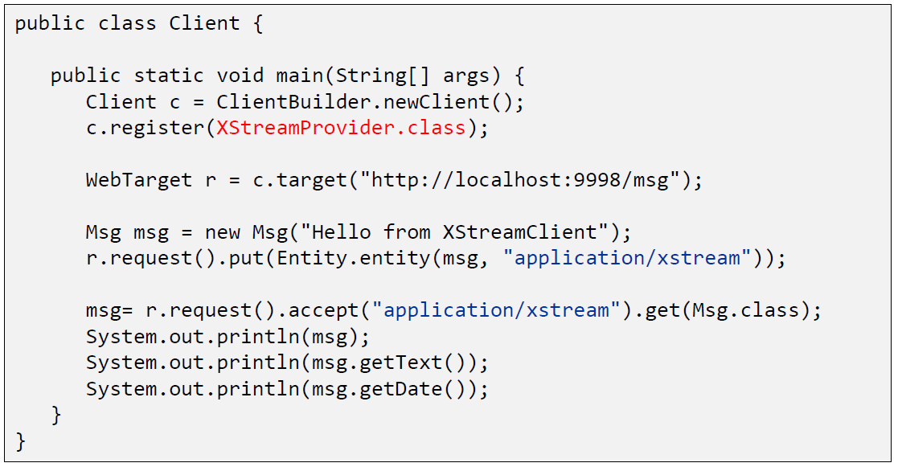

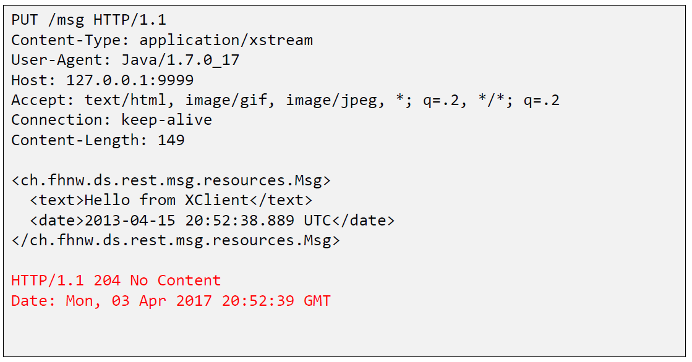

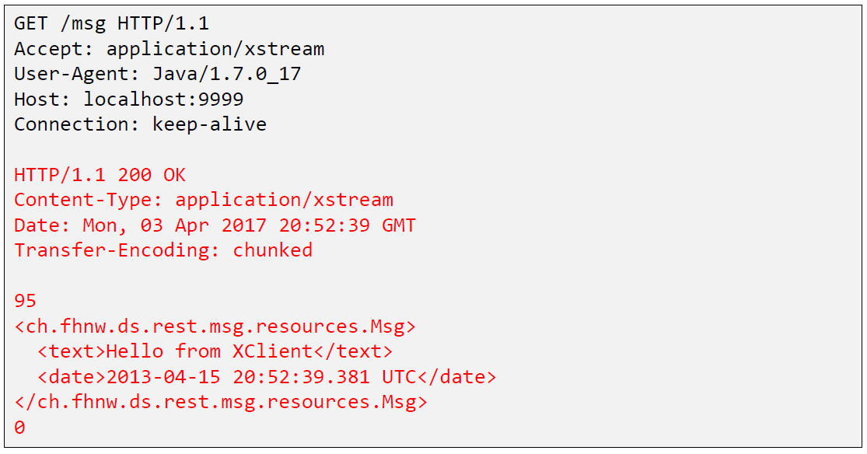

## Java Spark

### Java Spark

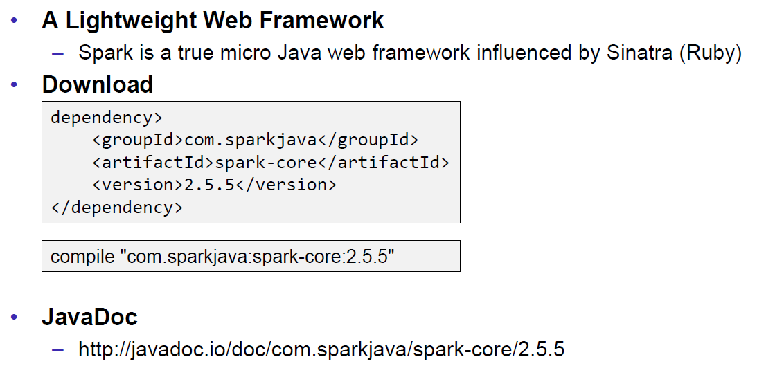

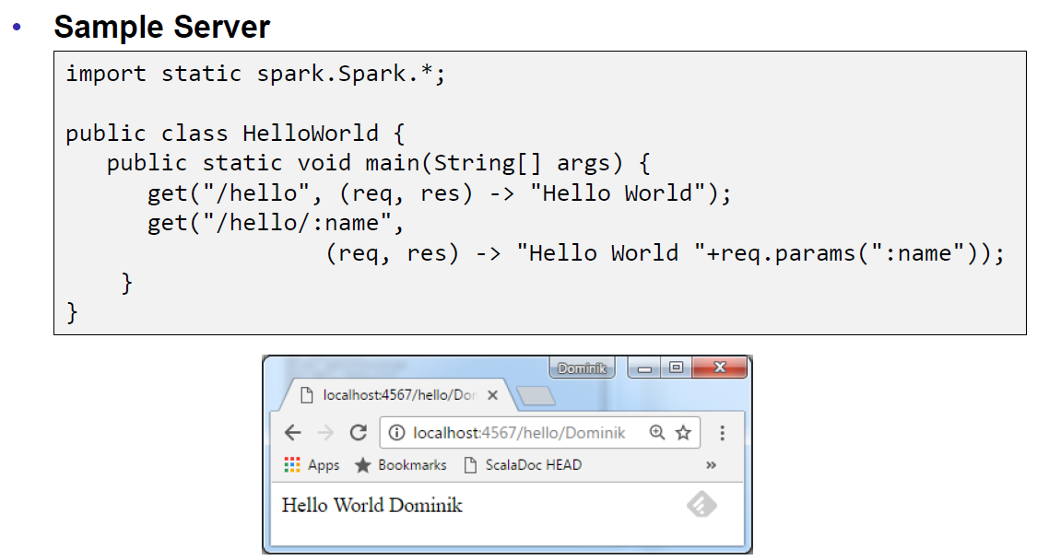

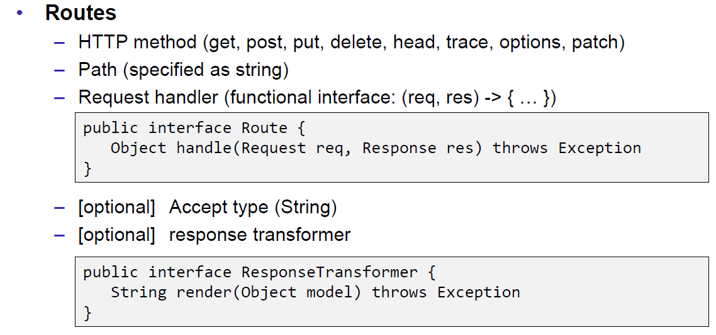

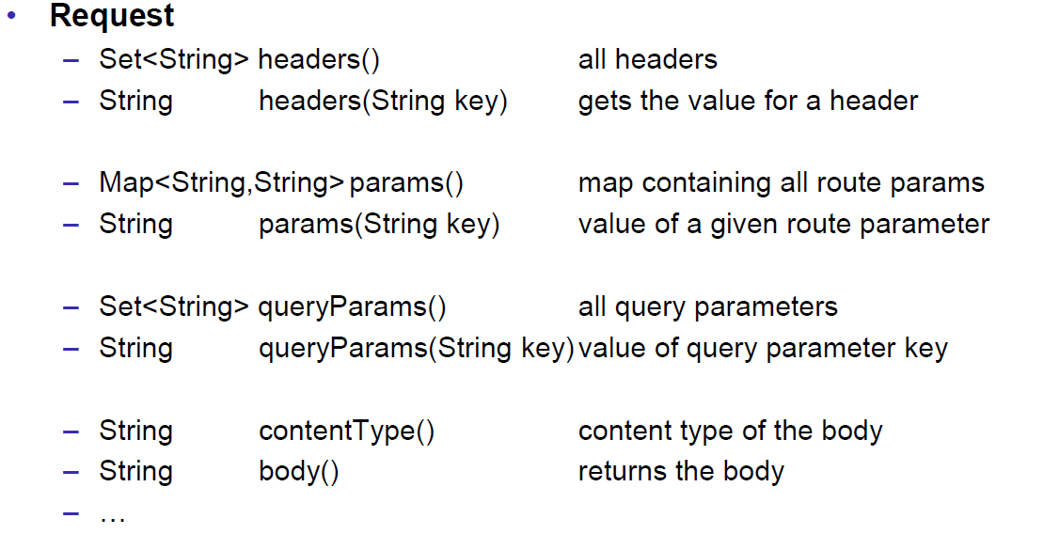

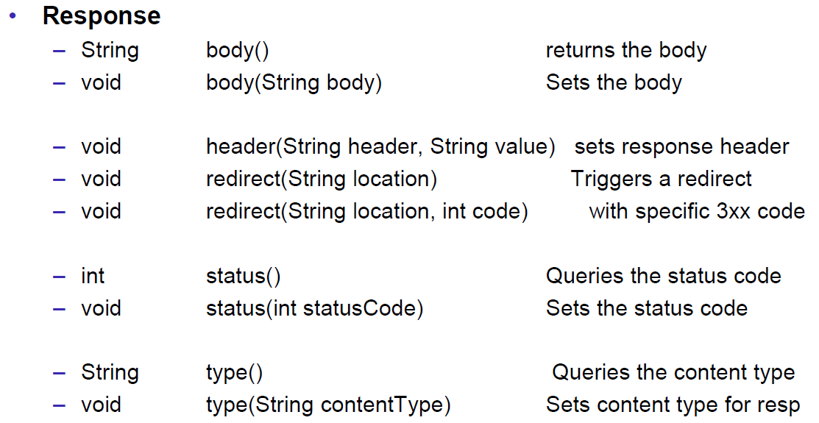

## JAXB

### JAXB Java Architecture for XML Binding

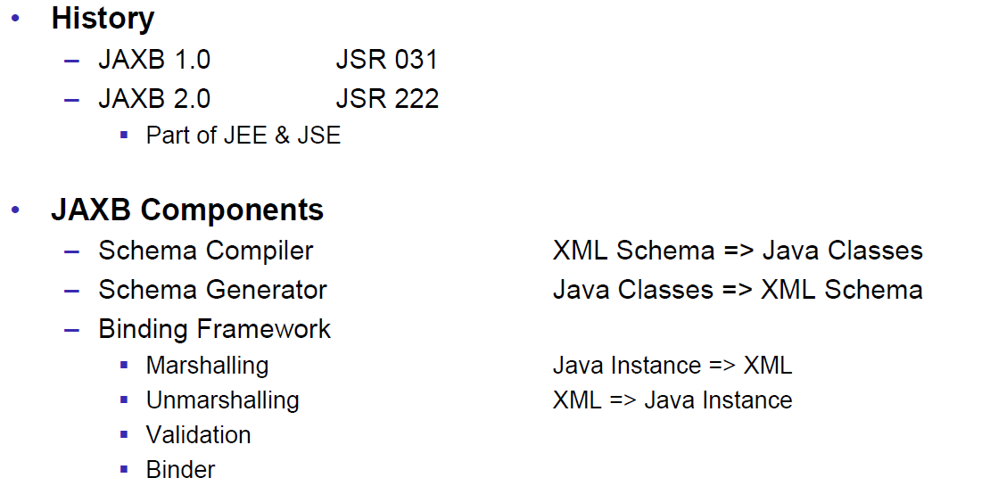

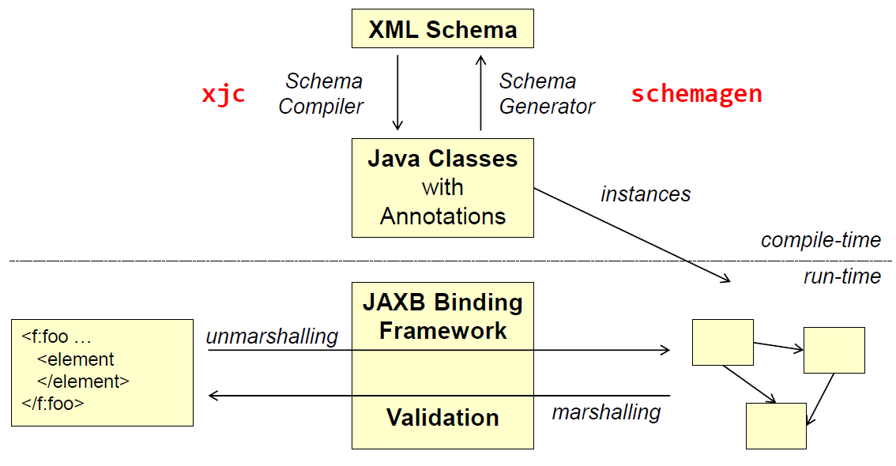

### XML Schema

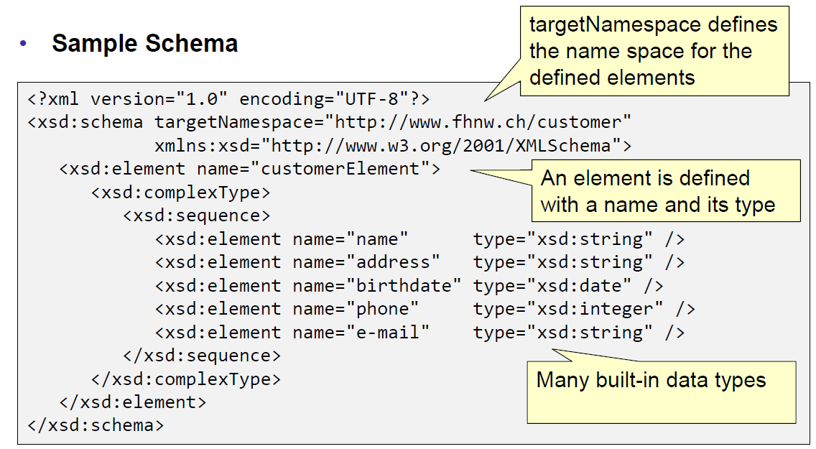

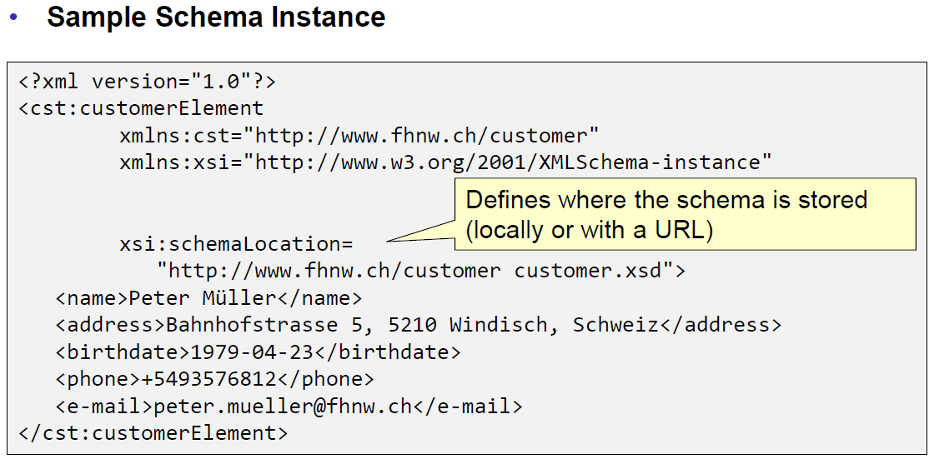

### Schema Compiler & Generator

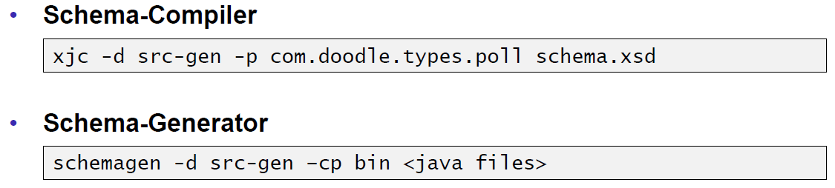

### JAXB Marshaller

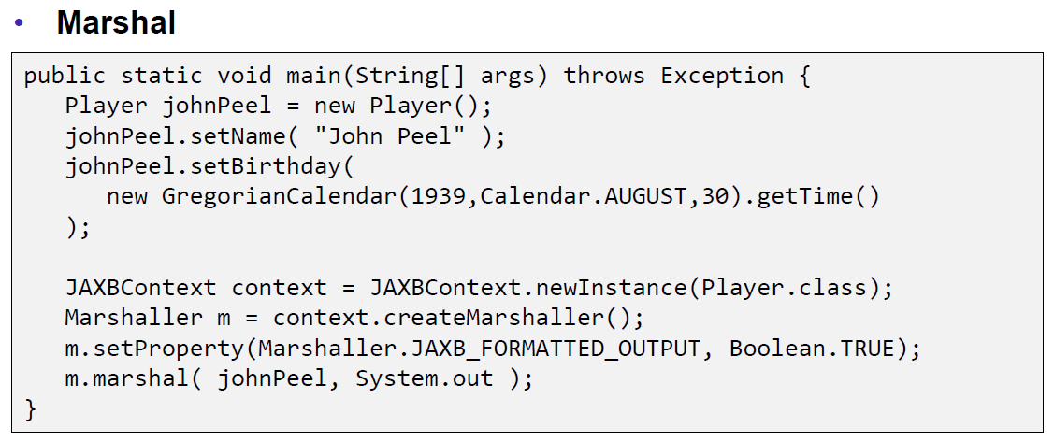

### JAXB Unmarshaller

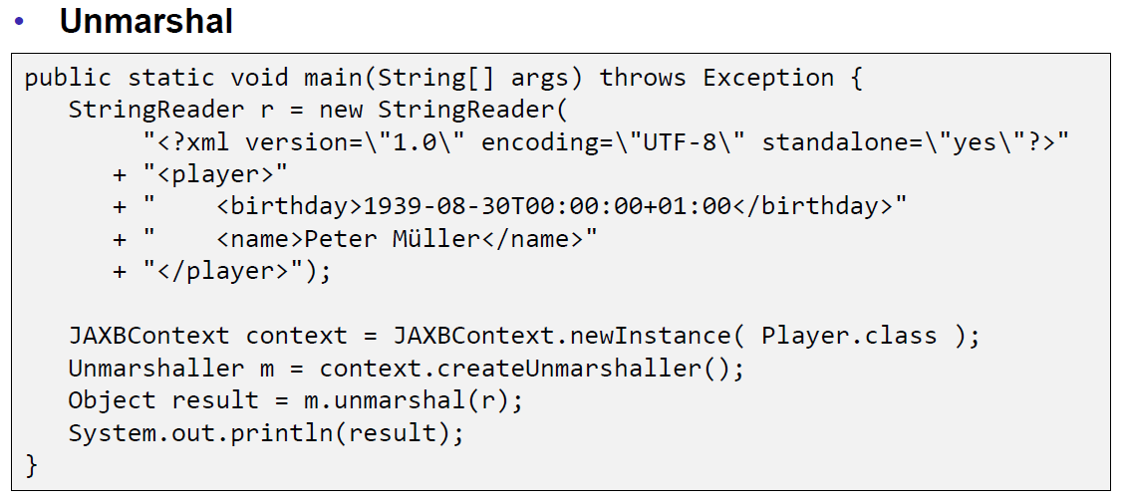

## REST API Description Languages

### Swagger

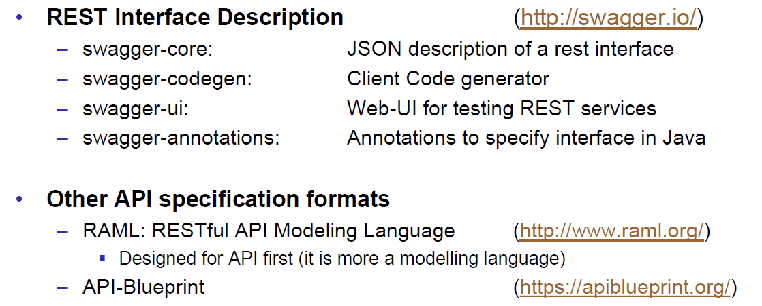

### Swagger Doodle

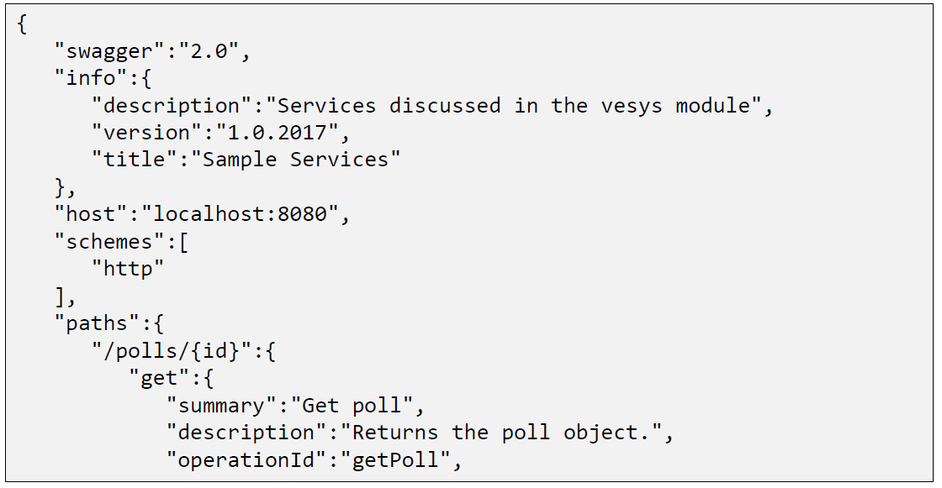

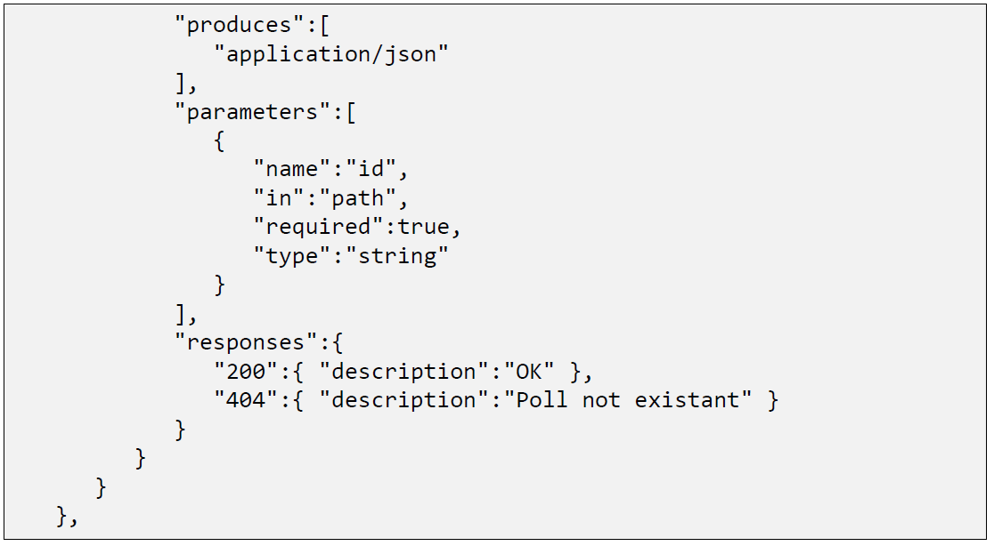

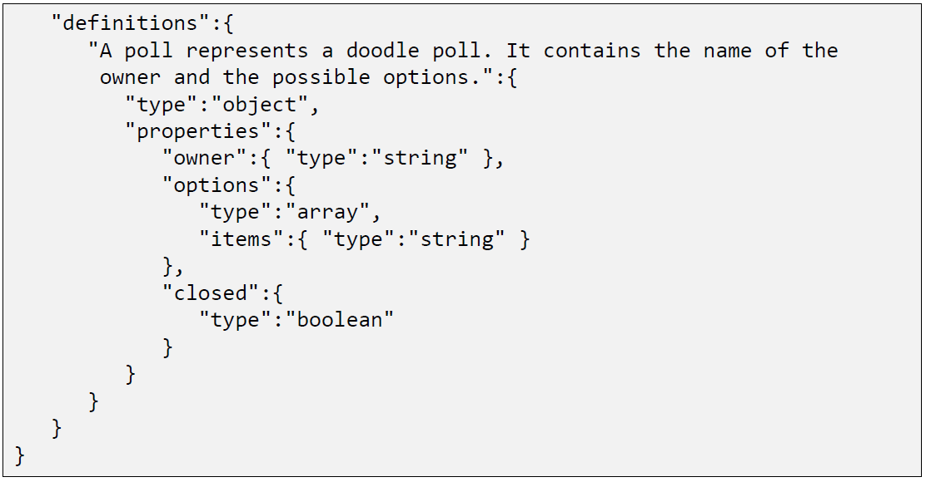

### Swagger Java Annotations

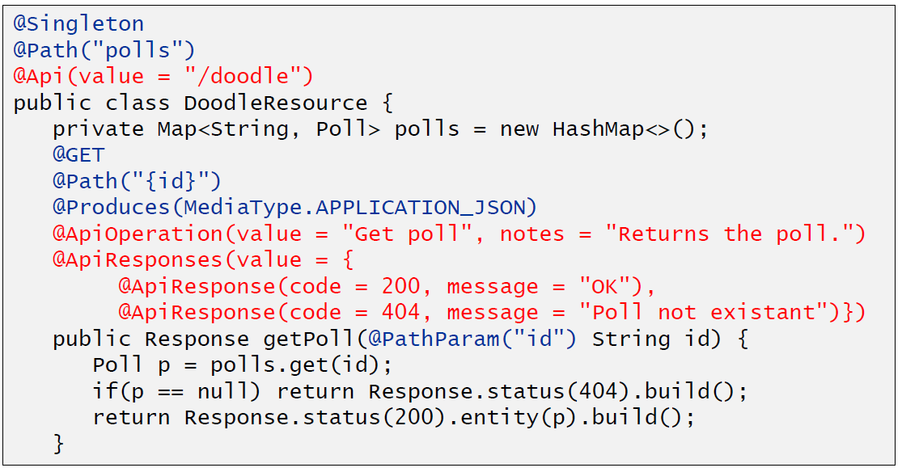

### Swagger GUI

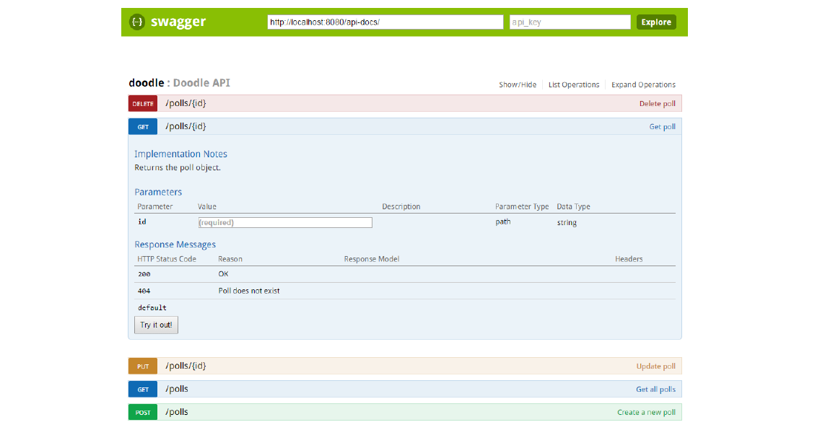

## REST Easy Client Proxy Framework

### RestEasy Client Proxy Framework

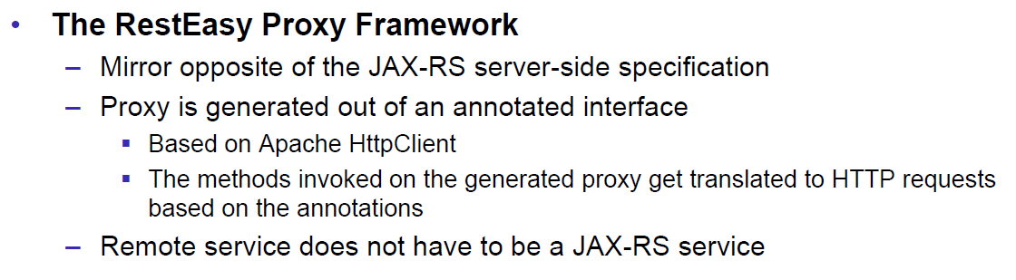

### RestEasy Example

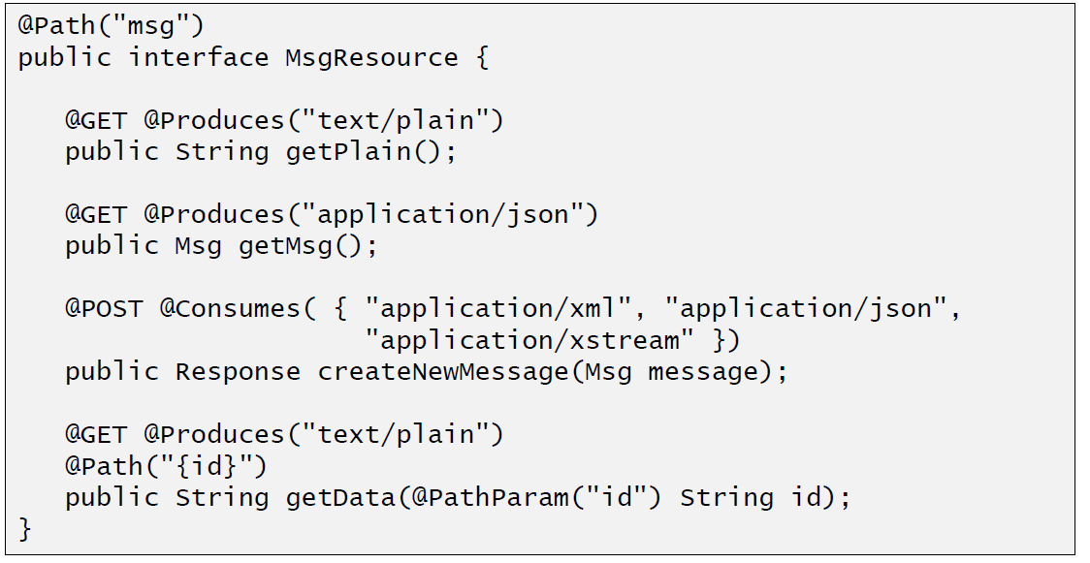

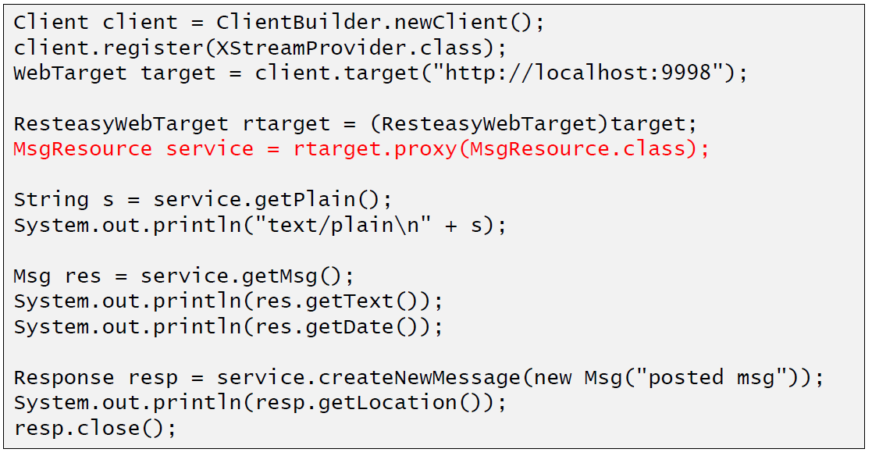

## Resources

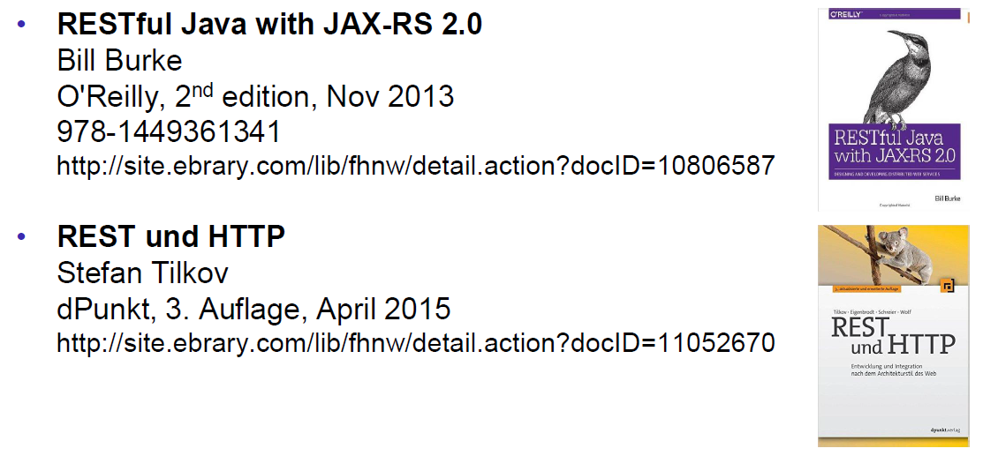

# Woche 8